JewelBug -- Annotating bp 40900 - 50341 (Genes 67 – 78)

# Table of Contents

Contents

Table of Contents 1

Feature 67 2

Feature 68 12

Feature 69 22

Feature 70 28

Feature 71 36

Feature 72 48

Feature 72.5 57

Feature 73 65

Feature 74 72

Feature 75 81

Feature 76 92

Feature 77 102

Feature 78 109

# 

# 

# Feature 67

**Table 1: Feature 67 Data**

|  |  |  |  |  |  |  |  |  |  |
| --- | --- | --- | --- | --- | --- | --- | --- | --- | --- |
| **Feature:** 67 | **3' End:** 41343 | **5' End:** 41591 | | | **Length:** 249 | | **Original Call:** | **Glimmer:** 41591 | |
| **GeneMark:** 41591 | |
| **Start / Stop Codon (SSC):** | | | | | | **Start:** ATG | | | |
| **Stop:** TAA; REV | | | |
| **Longest Open Reading Frame (LO):** 498 bp | | | | | | | | | Not Longest |
| **Shine Dalgarno (SD):** -2.611 / -4.407 | | | | | | | | | Not Highest |
| **Start Choice Source (SCS):** | | | | **Called by Glimmer:** Yes, 41591 | | | | | |
| **Called by GeneMark**: Yes, 41951 | | | | | |
| **Coding Potential (CP):** all covered | | | | | | | | | |
| **Gap / Overlap:** 13 bp overlap with feature 68. | | | | | | | | | |
| **BLASTp:** gp69 [Mycobacterium phage Gladiator]; bp 1 aligns with bp 1 | | | | | | | | | |
| **Function (F):** helix-turn-helix domain | | | | | | | | | |
| **Function Source (FS):** | | | **Phamerator:** no noted functions in similar phages | | | | | | |
| **BLASTp:** gp69 from Gladiator (no known function) | | | | | | |
| **HHPred:** Helix-turn-helix domain; 90.98% probability | | | | | | |
| **Comments:** Gene was called by both programs in the same location. GeneMark complementary sequence 2 verifies that there is coding potential in this location. Though score is not the highest and the ORF is not the longest, the ORF start chosen matches best with the coding potential in GeneMark. Phamerator Map only shows 1 gene at location, though it is a strong match for only three genome maps in this phamily. | | | | | | | | | |

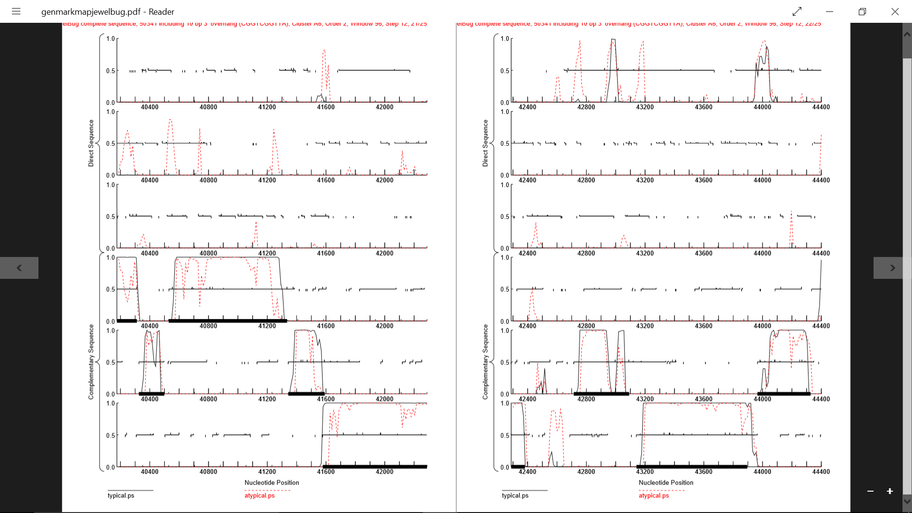

**Figure 1: Feature 67, GeneMark Map**

Between bp 41343 and 41591, there is a high amount of coding potential in the second complementary sequence reading frame.

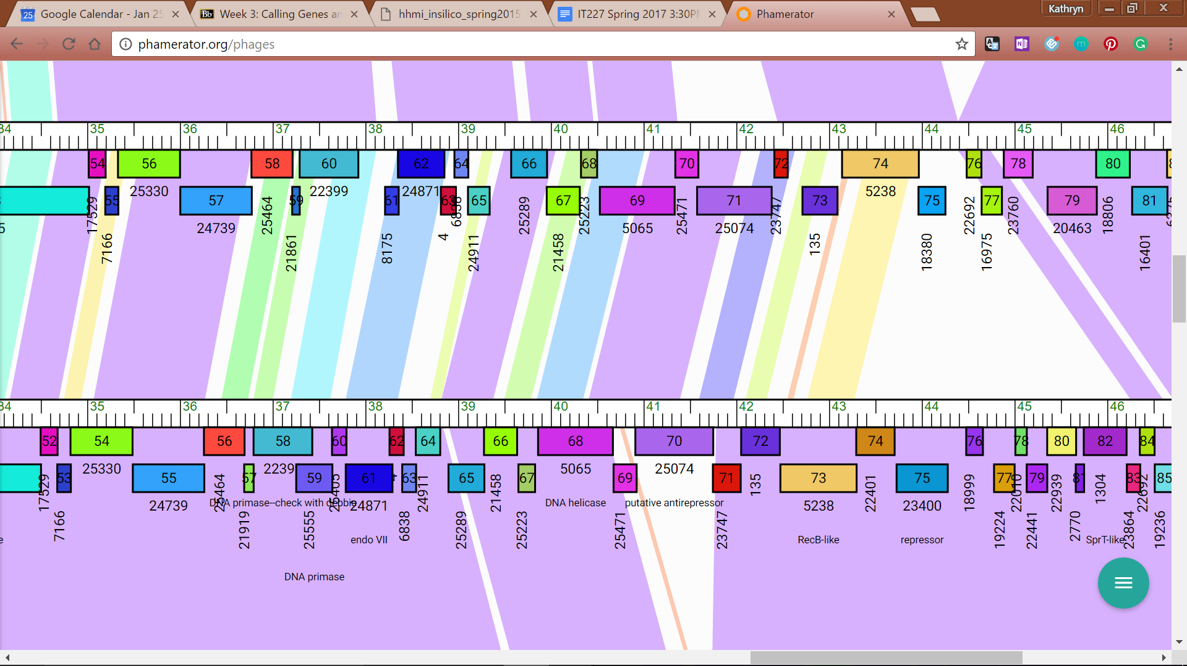

**Figure 2: Feature 67, Phamerator Map: JewelBug vs. Gladiator**

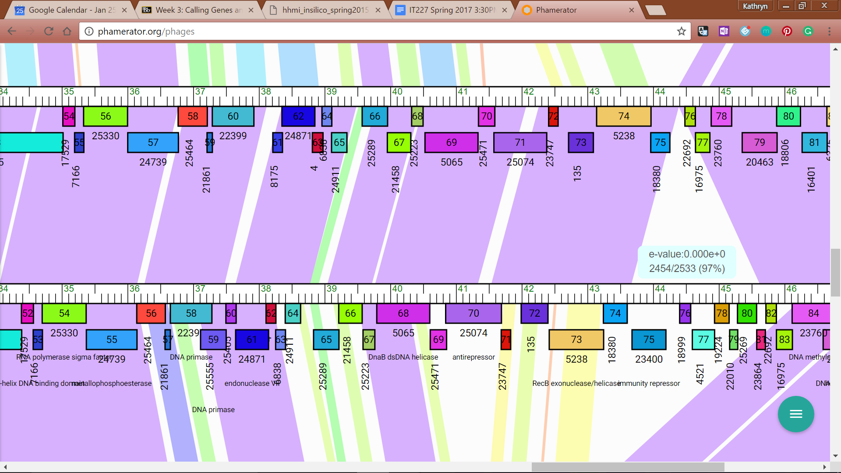

**Figure 3: Feature 67, Phamerator Map: JewelBug vs. McFly**

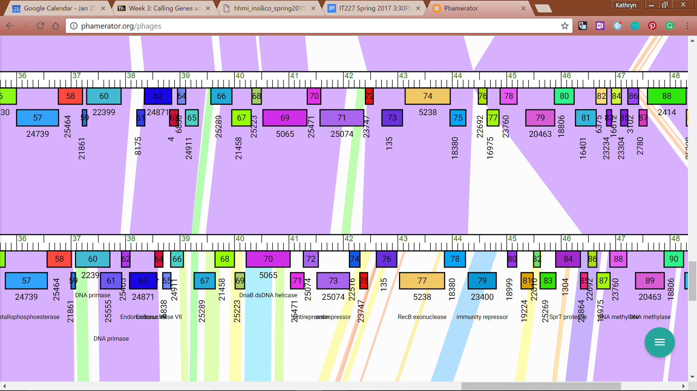

**Figure 4: Feature 67, Phamerator Map: JewelBug vs. Isiphiwo**

Feature 70 on the JewelBug draft map (top line in all images) is a strong match for Gladiator’s Phamerator Map (Figure 2), McFly’s Phamerator Map (Figure 3), and Isiphiwo’s Phamerator Map (Figure 4), but is a poor or non-match for most other genomes.

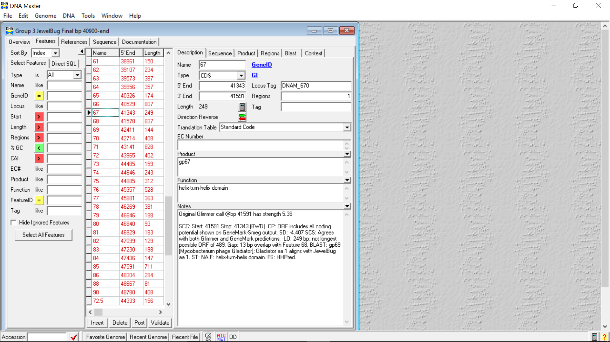

**Figure 5: Feature 67, Feature Window**

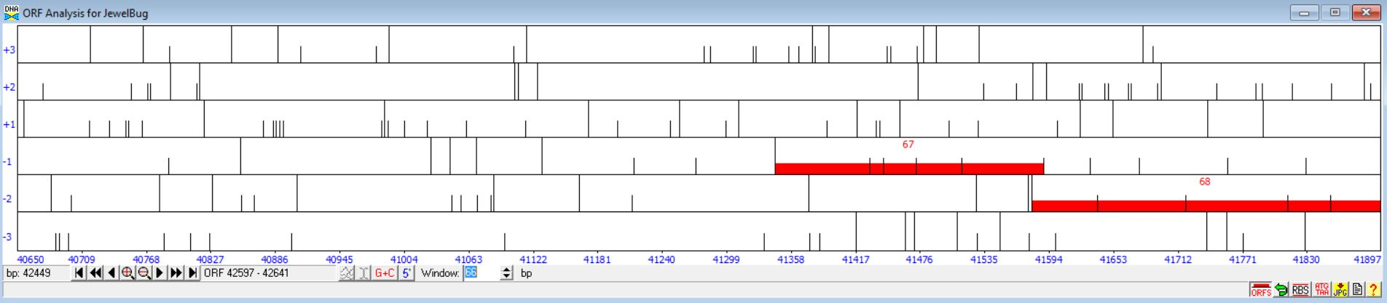

**Figure 6: Feature 67, Frame Window**

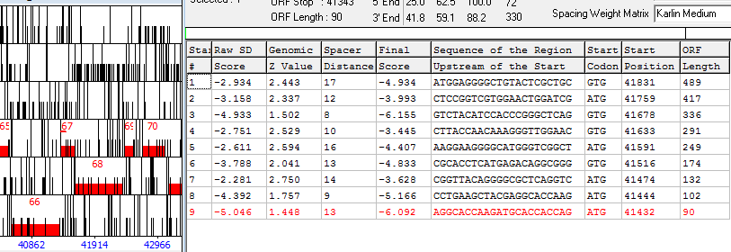

**Figure 7: Feature 67, Choose Start Window**

The feature is found in the fourth frame and based on cross-referencing with GeneMark and the Phamerator Map, the start chosen was the fifth start site with the start position at 41591. In the Genemark map, the coding potential corresponding to gene 67 is precisely wedged between areas of significantly long coding potential in two different reading frames. Start 4 at 41633 was discarded even though it had the best SD score because it encroached more than 30 bp into the the next section of coding potential. Start 6 at 41516 was also discarded because it did not capture all of the available coding potential.

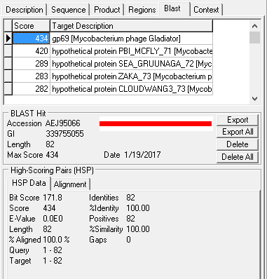

**Figure 8: Feature 67, HSP Data**

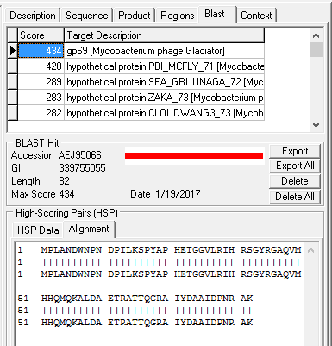

**Figure 9: Feature 67, Alignment: gp69**

[Mycobacterium phage Gladiator] is the first hit, BP1 of Gladiator aligns with BP1 of JewelBug

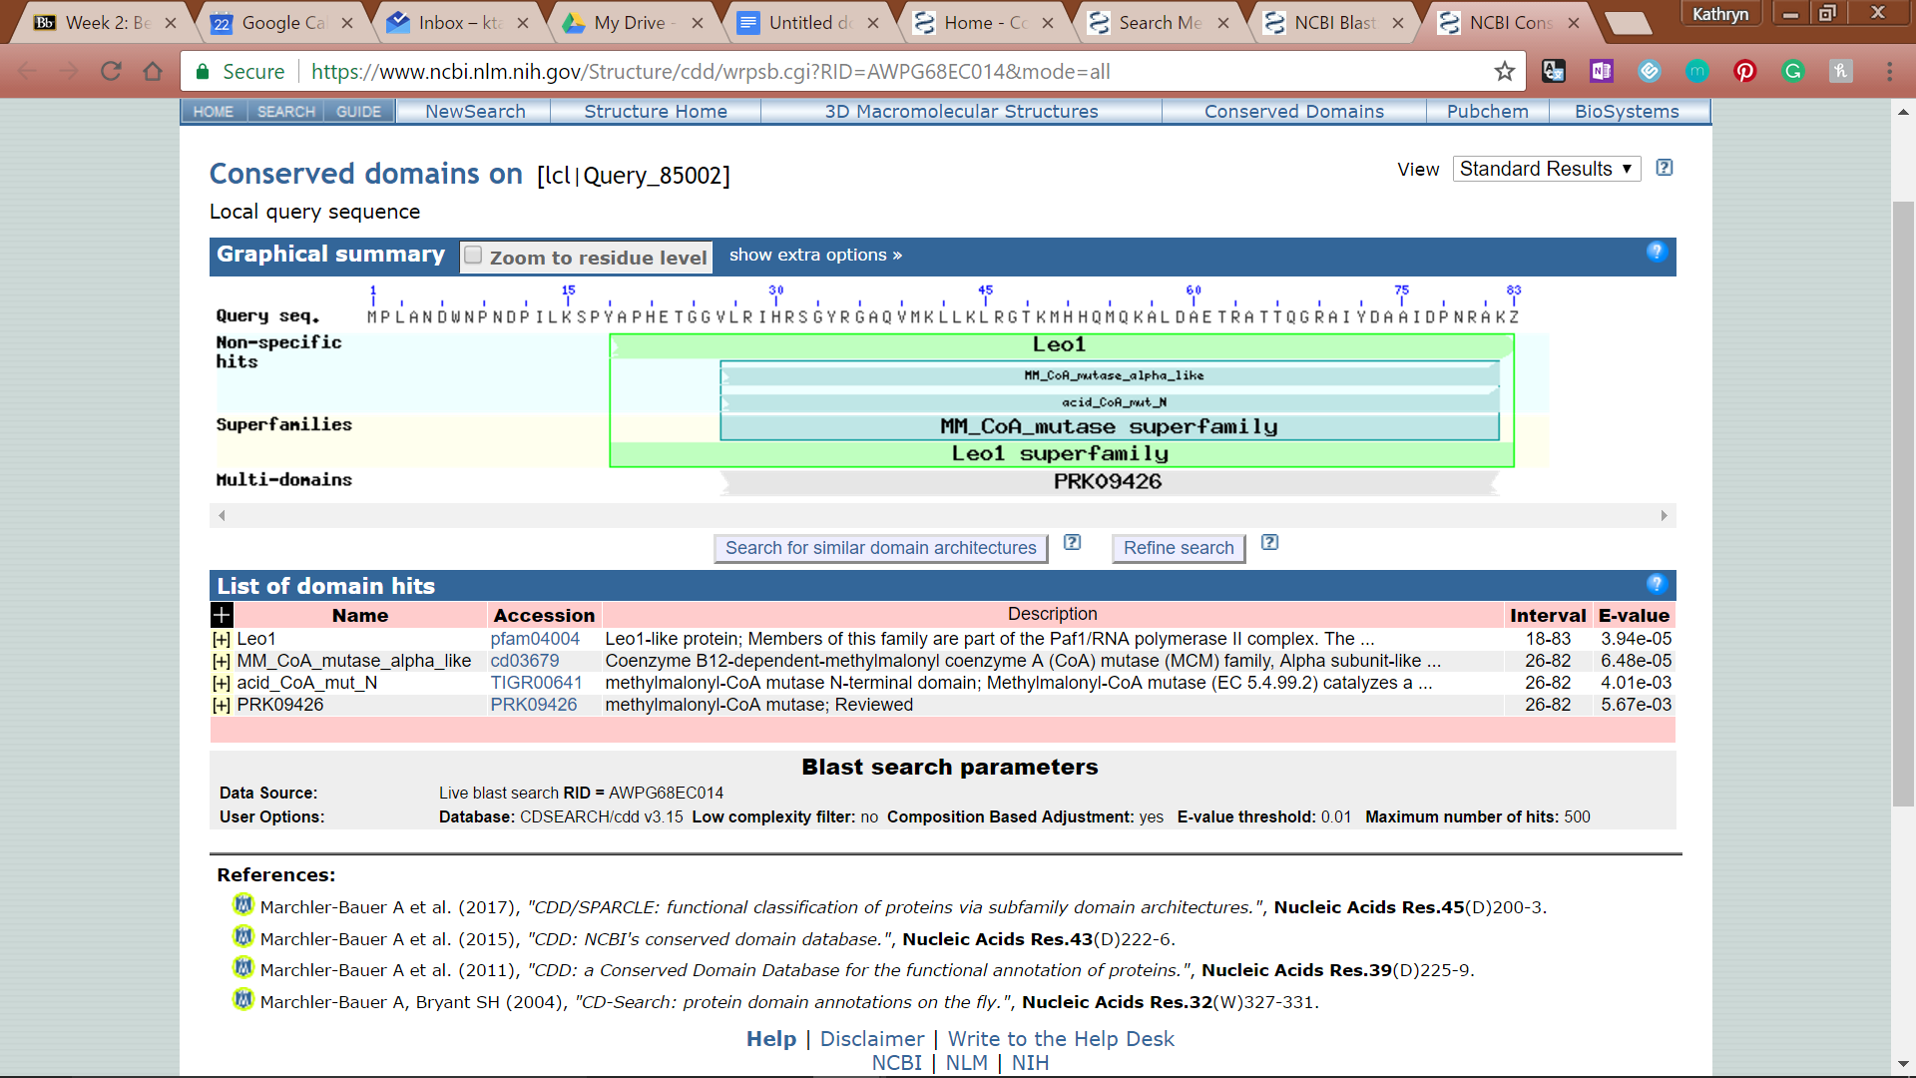

**Figure 10: Feature 67, Conserved Domains**

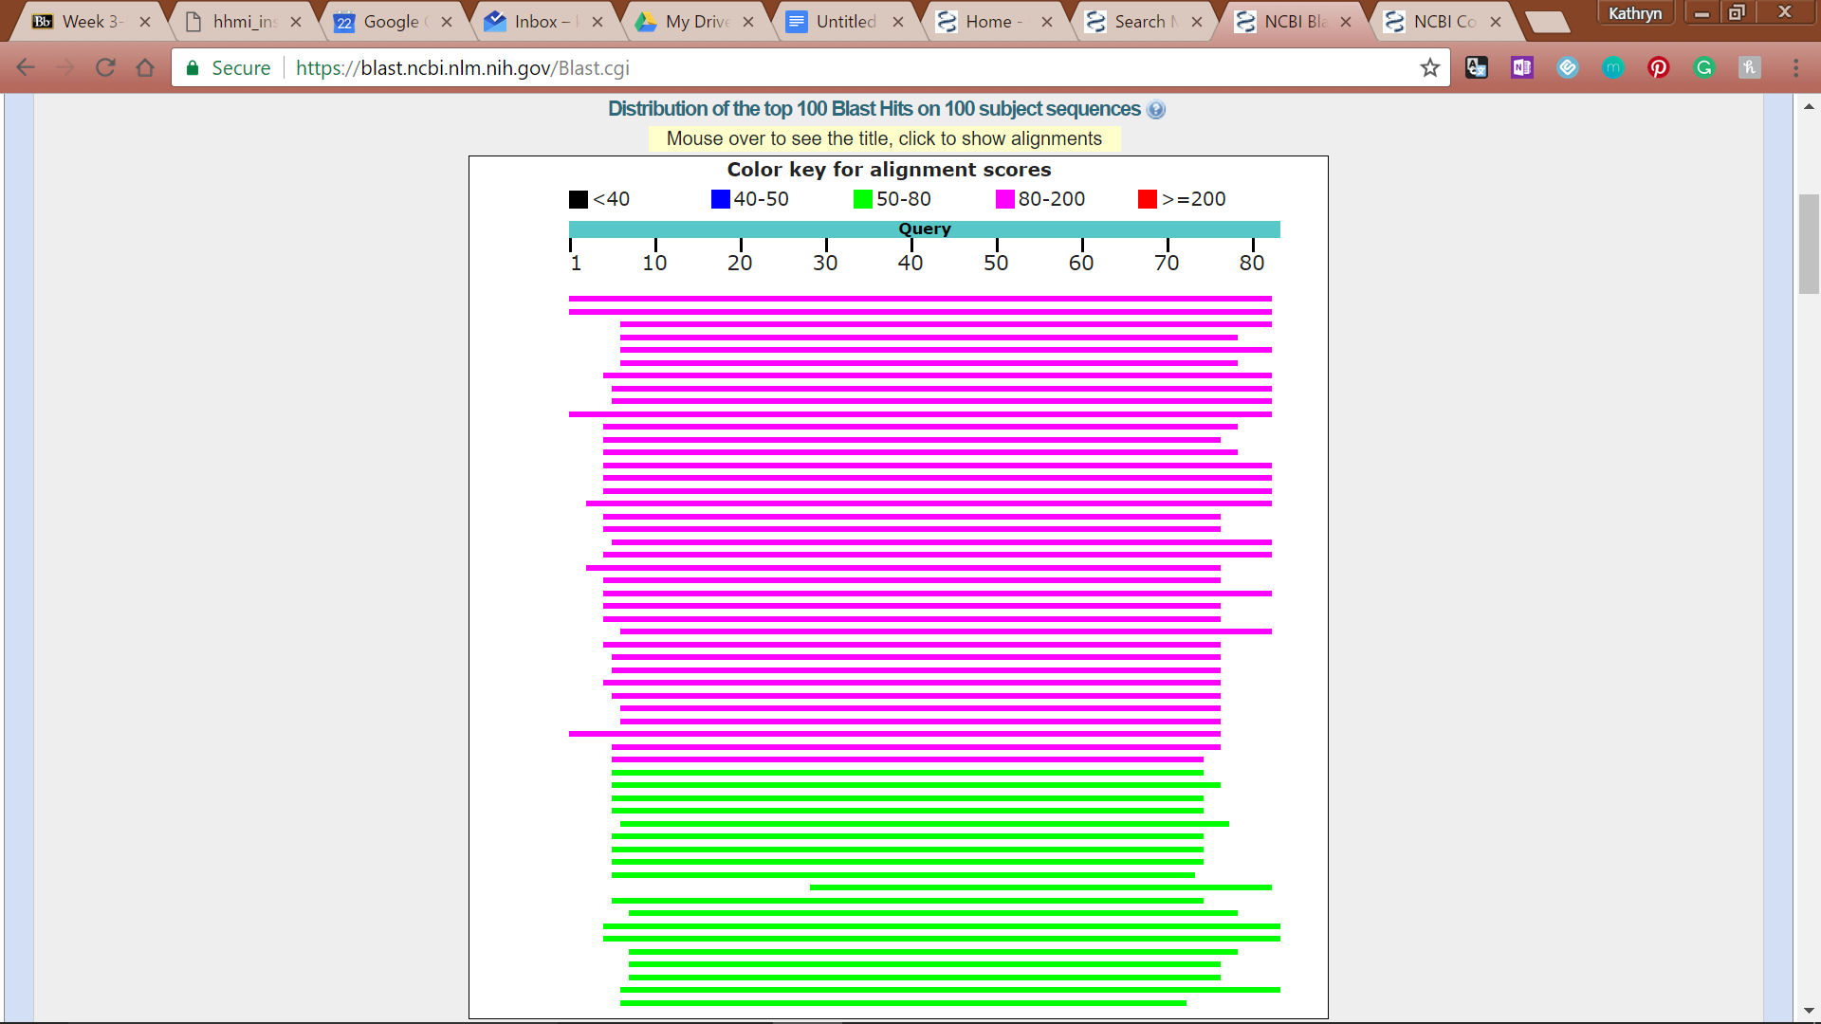

**Figure 11: Feature 67, BLASTp Hits Distribution Table**

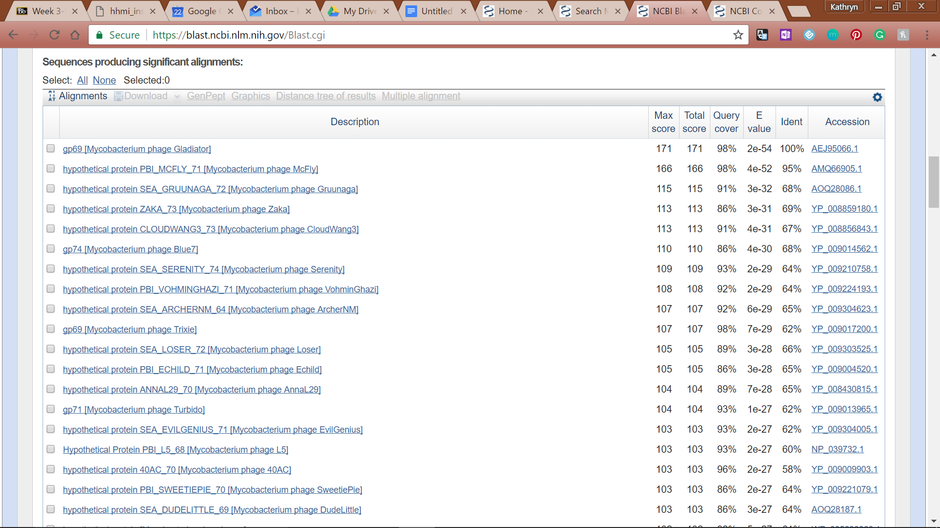

**Figure 12: Feature 67, BLASTp E-Values**

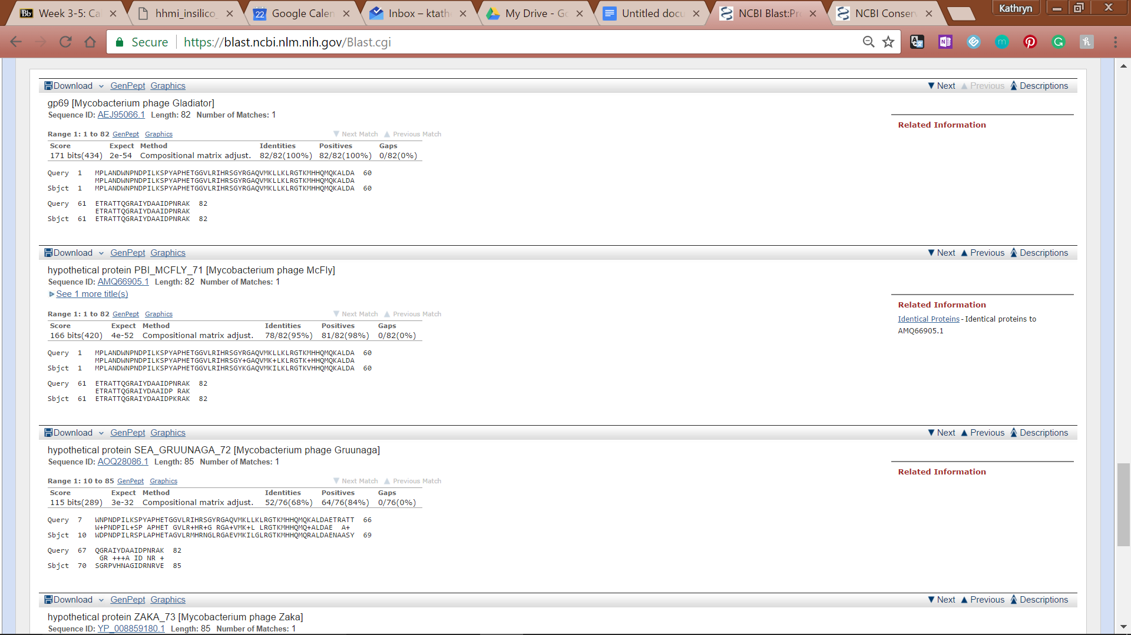

**Figure 13: Feature 67, BLASTp Alignments**

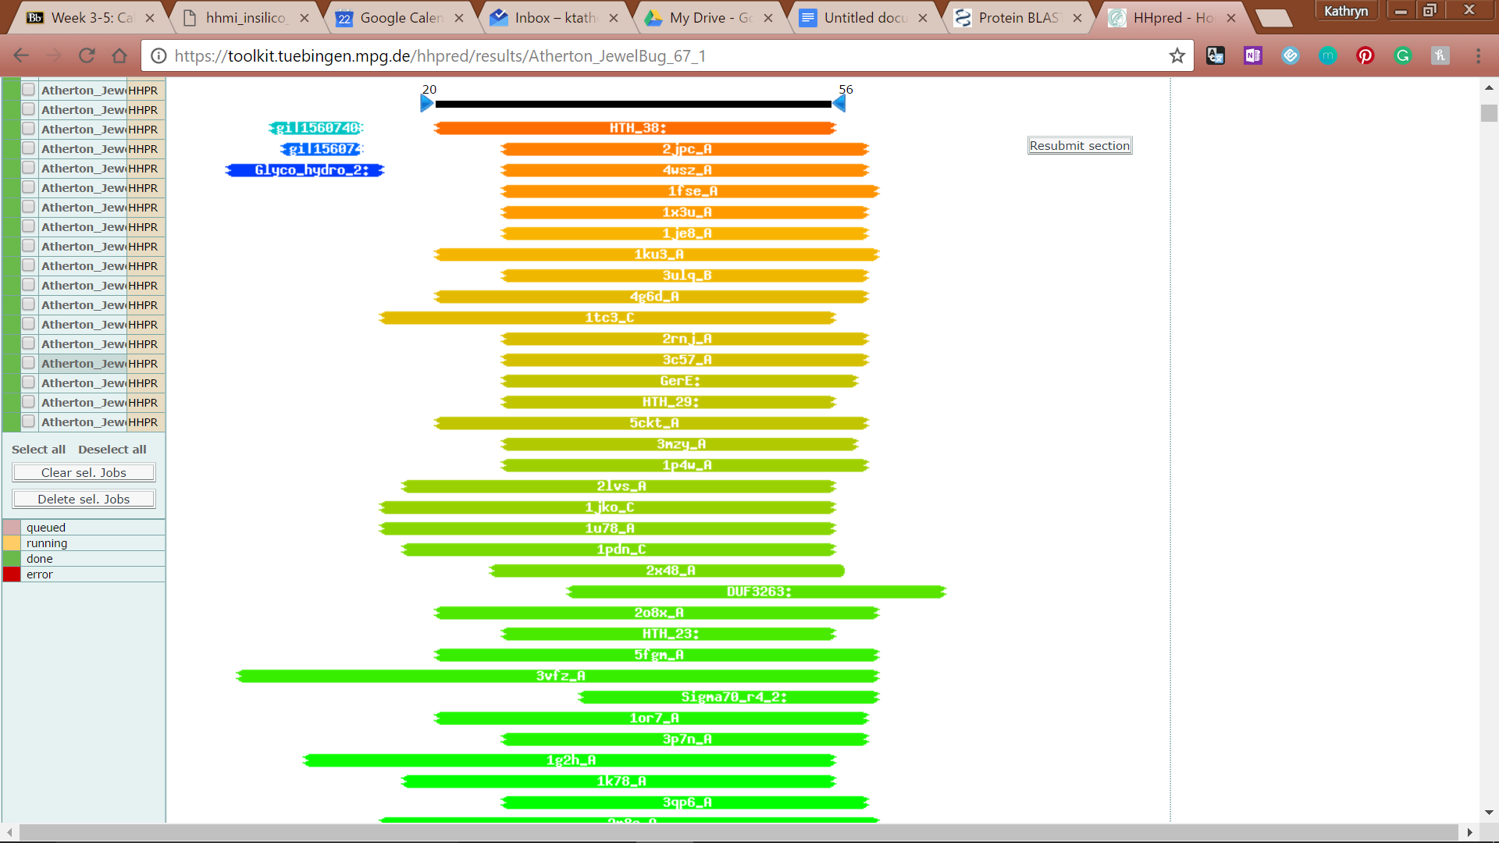

**Figure 14: Feature 67, HHPred Distribution List**

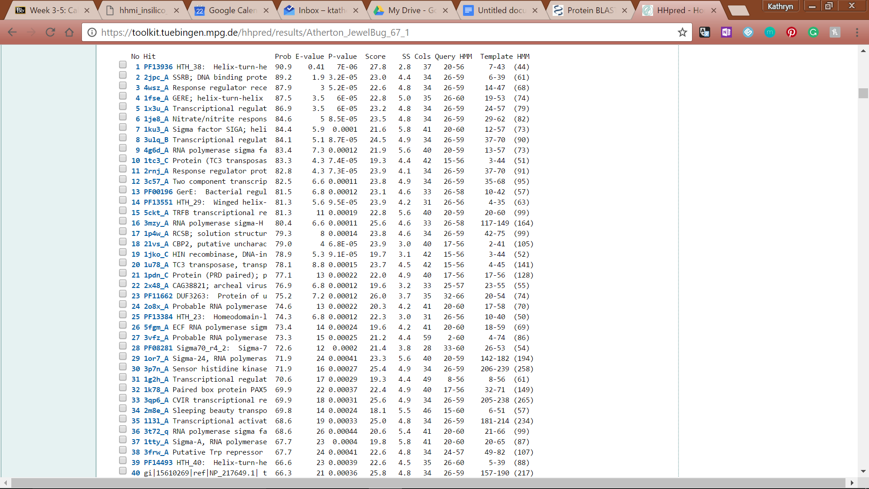

**Figure 15: Feature 67, HHPred Probabilities and Descriptions**

# Feature 68

**Table 2: Feature 68 Data**

|  |  |  |  |  |  |  |  |  |  |
| --- | --- | --- | --- | --- | --- | --- | --- | --- | --- |
| **Feature:** 68 | **3' End:** 41578 | **5' End:** 42414 | | | **Length:** 837 | | **Original Call:** | **Glimmer:** 42381 | |
| **GeneMark:** 42381 | |
| **Start / Stop Codon (SSC):** | | | | | | **Start:** GTG | | | |
| **Stop:** TAA; REV | | | |
| **Longest Open Reading Frame (LO):** 837 bp | | | | | | | | | Longest |
| **Shine Dalgarno (SD):** -2.903 / -4.903 | | | | | | | | | Not Highest |
| **Start Choice Source (SCS):** | | | | **Called by Glimmer:** Yes, 42381 | | | | | |
| **Called by GeneMark**: Yes, 42381 | | | | | |
| **Coding Potential (CP):** all covered | | | | | | | | | |
| **Gap / Overlap:** 3 bp overlap with feature 69 | | | | | | | | | |
| **BLASTp:** gp70 [Mycobacterium phage Gladiator], bp 1 aligns with bp 1 | | | | | | | | | |
| **Function (F):** Antirepressor | | | | | | | | | |
| **Function Source (FS):** | | | **Phamerator:** Isiphiwo feature 70 function (antirepressor) | | | | | | |
| **BLASTp:** gp70 from Gladiator (putative antirepressor) | | | | | | |
| **HHPred:** Phage antirepressor protein KilAC domain; 99.80% probability | | | | | | |
| **Comments:** Gene was called by both programs in the same location. GeneMark Complementary Sequence 3 verifies that there is coding potential in this location. Though the score is not the highest, the ORF is the longest and the ORF start chosen closes gaps between genes called. Phamerator map only shows one gene called at this location.Glimmer and GeneMark called in the same place. After looking at cap between this gene and the next gene, it was found that there would be a sizeable gap, so we tried to extend the ORF. By re-BLASTing the gene in longer ORFs, we were able to close that gap and obtain a better alignment with an analogous gene in the phage Gladiator. | | | | | | | | | |

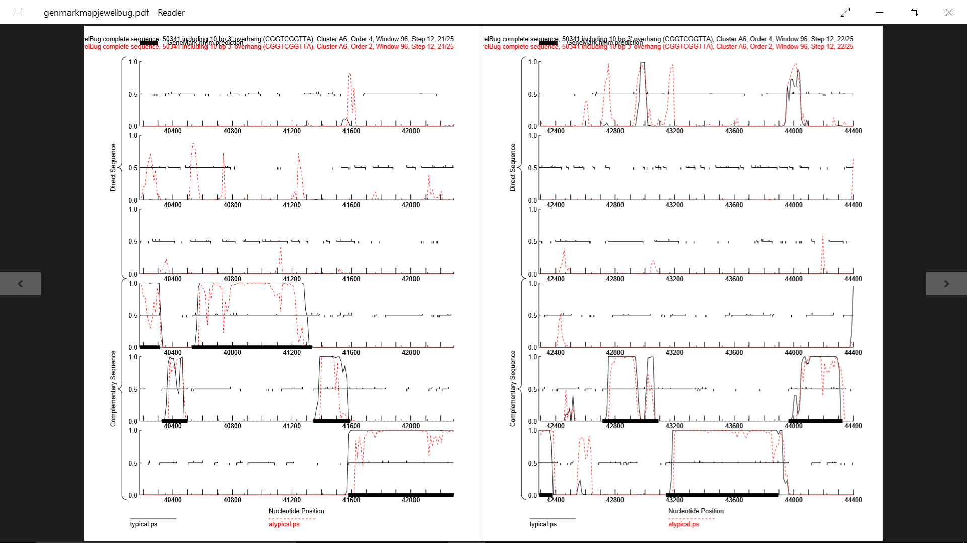

**Figure 16: Feature 68, GeneMark Map**

Between bp 41578 to 42381, there is a high amount of coding potential in the second complementary sequence reading frame. Although there is no coding potential past this point, extending the ORF to 42414 decreases the large gap between this gene and the next possible gene.

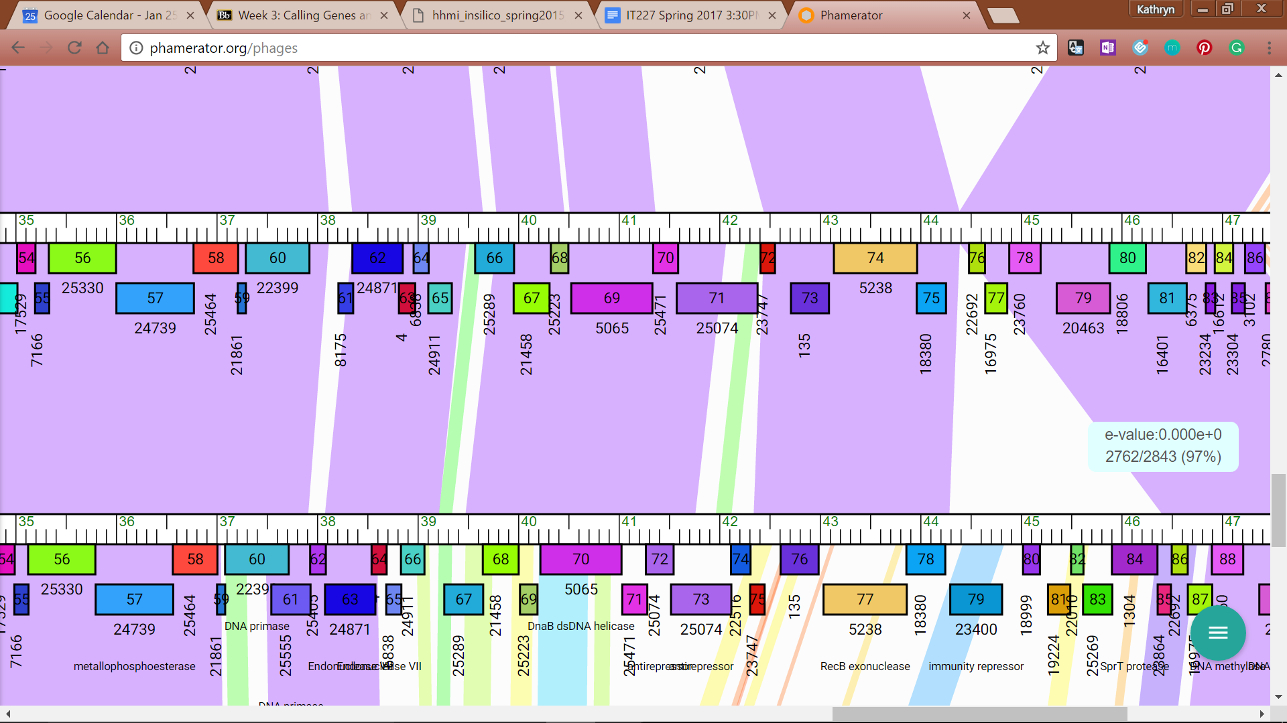

**Figure 17: Feature 68, JewelBug vs. McFly Phamerator Map**

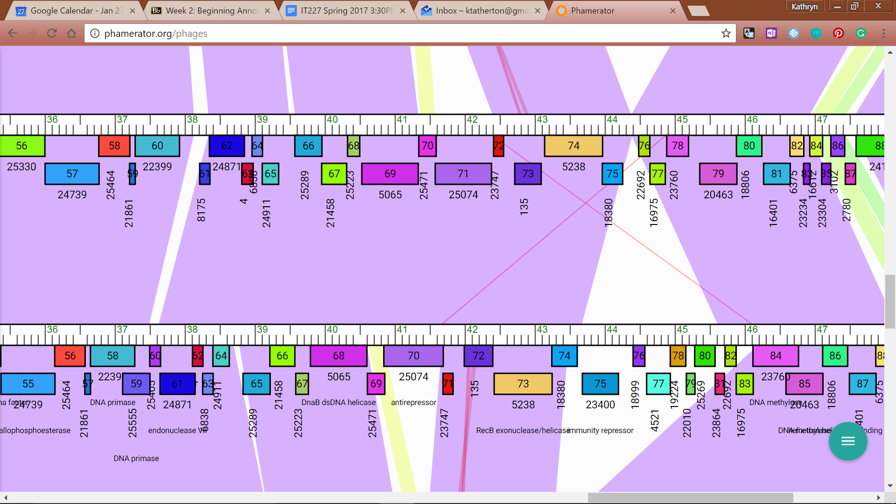

**Figure 18: Feature 68, JewelBug vs. Gladiator Phamerator Map**

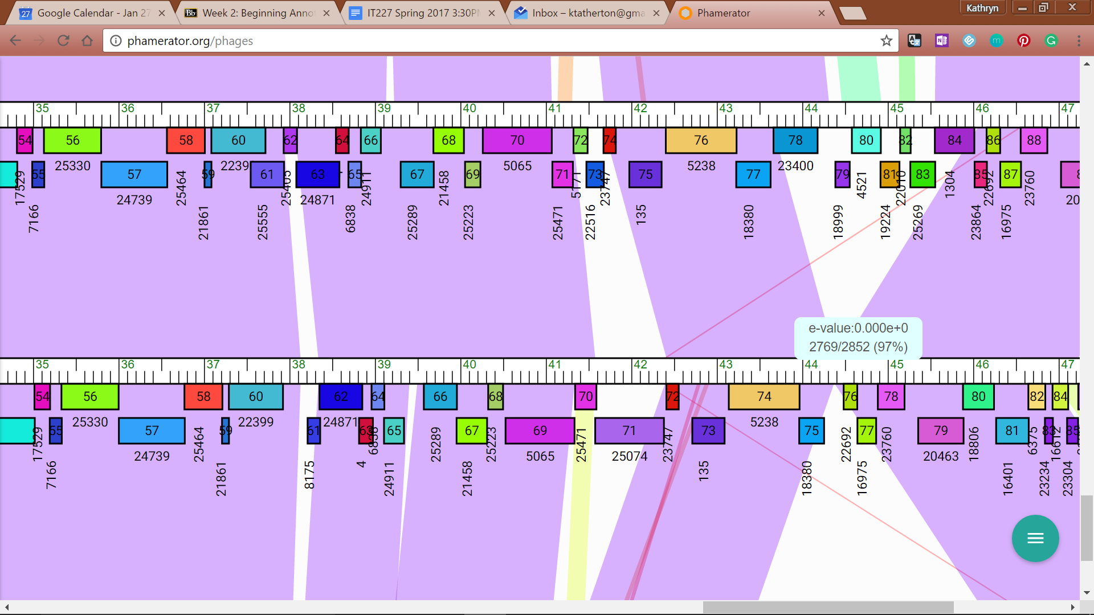

**Figure 19: Feature 68, VohminGhazi (Top) vs. JewelBug (Middle) vs. Zaka (Below, Not Shown)**

JewelBug’s Map shows similarity with McFly’s map in the first half of the 71st gene in the map. However, McFly map shows that two genes were called in about the same frame as JewelBug’s whole map. Comparing to Isiphiwo’s and Gladiator’s maps, only one gene is called, and the entire gene contains similarity to JewelBug’s gene (top line). In most other phage maps (VohminGhazi shown above, Jewel bug middle line, Zaka is below), there is not a match for the section of DNA where this feature is called.

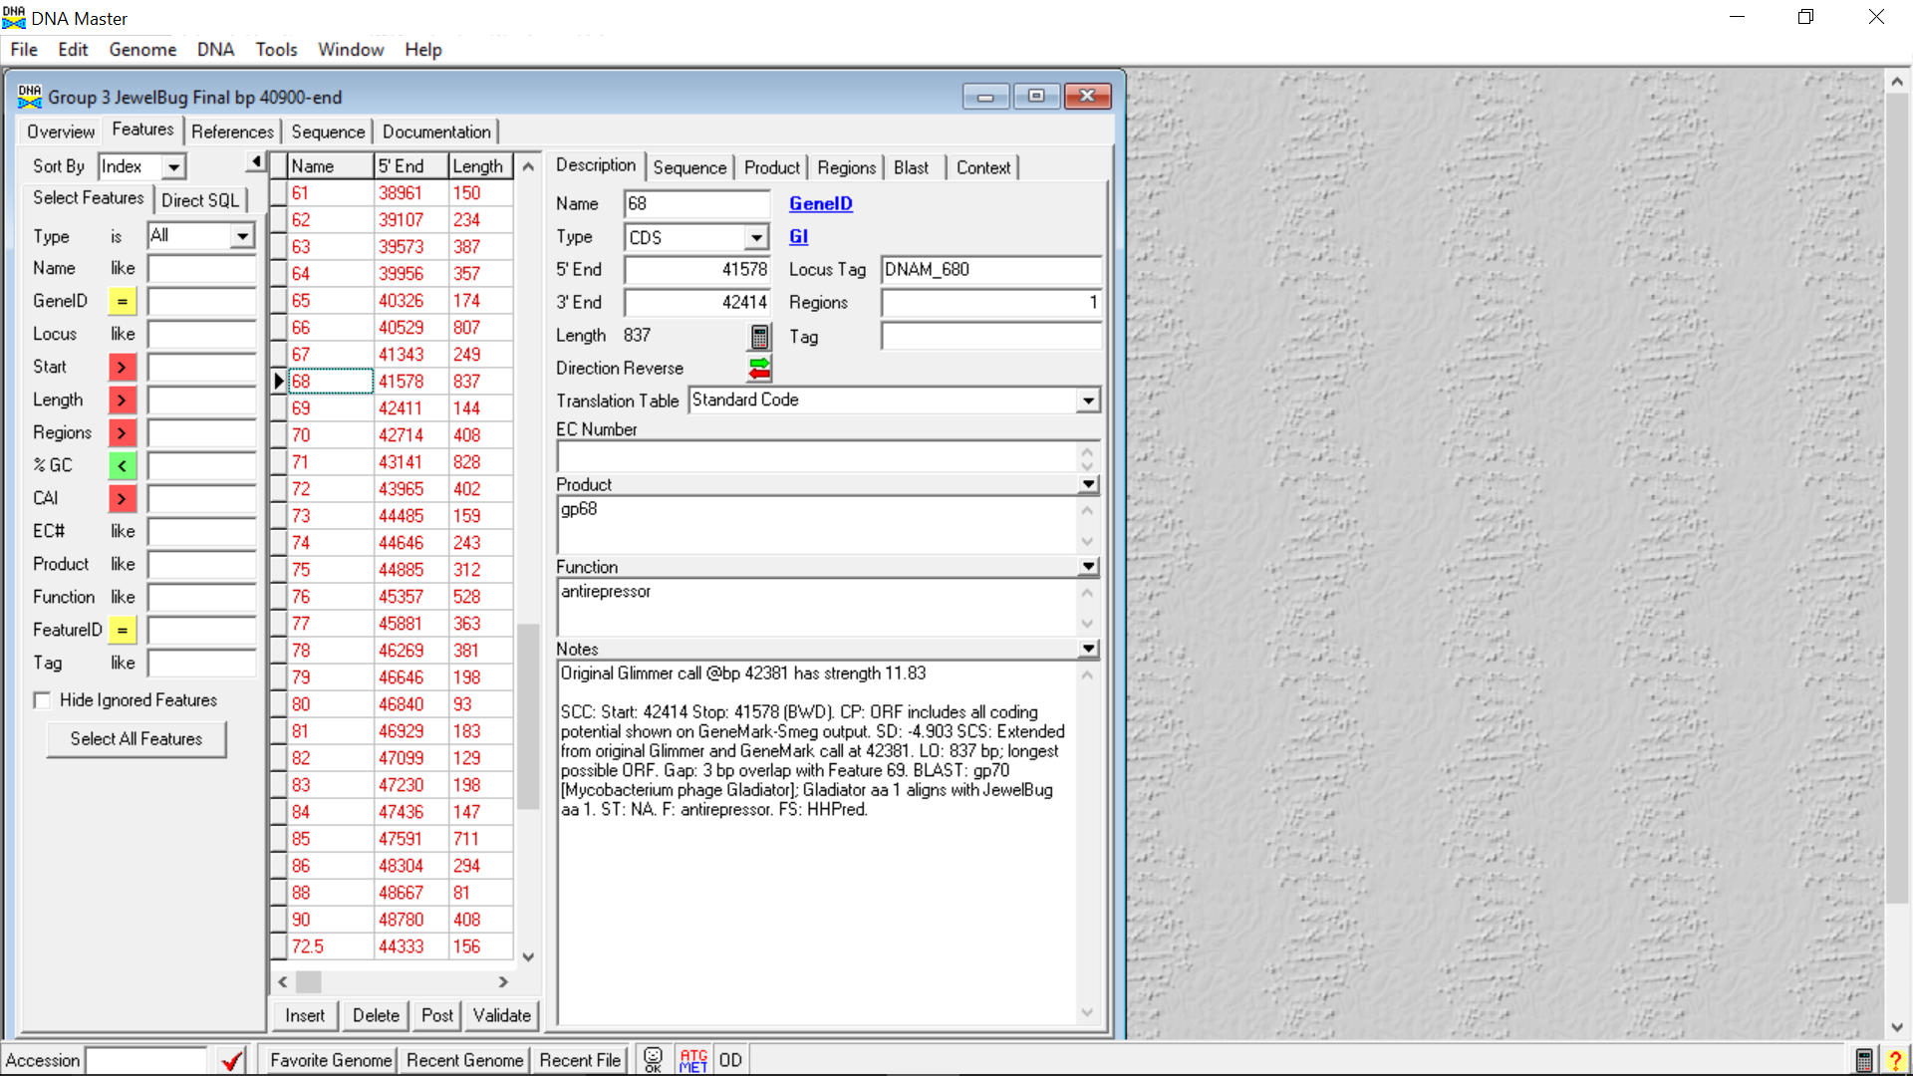

**Figure 20: Feature 68, Feature Window**

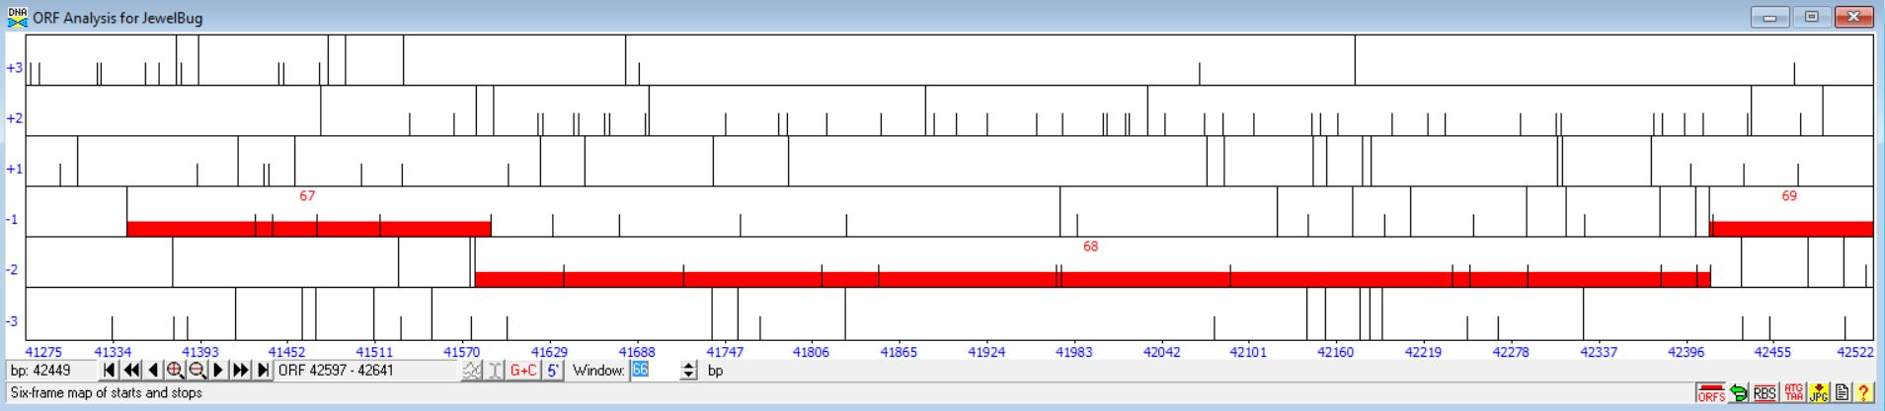

**Figure 21: Feature 68, Frame Window**

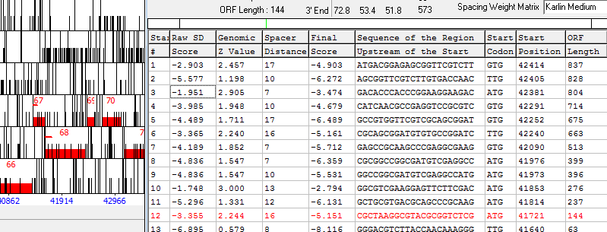

**Figure 22: Feature 68, Choose Start Window**

Feature 68, DNA Master Frames Window and Choose ORF Start Window: The feature is found in the fifth frame and based on cross-referencing with GeneMark and the Phamerator Map, the start chosen was the first start site with the start position at 42414, which has the longest ORF and the fourth lowest Final Score. While both Genemark and Glimmer originally called the gene at 42381, blasting at 42141 allowed 100% alignment with gp70[Mycobacterium phage Gladiator] as opposed to 96.1% and reduced the bp gap between Feature 68 and Feature 69 from 30 bp to an overlap of 3 bp. Start 2 at 42405 was disregarded because it increased alignment, but not to the extent that the start at 42414 did and did not allow as much of a gap reduction as 42414. Stat 10 at 41853 was disregarded because it left out over 500 bp of coding potential, even though it had the lowest SD score.

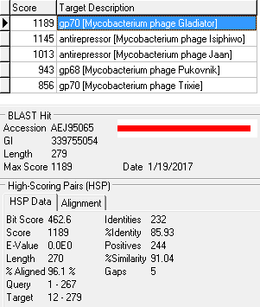

**Figure 23: Feature 68, HSP Data at 42381 bp**

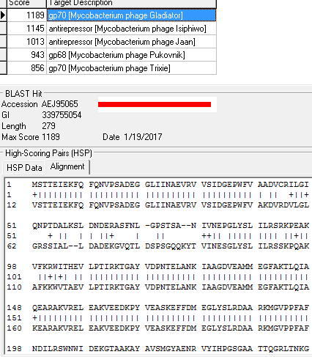

**Figure 24: Feature 68, Alignment**

Alignment data for the original call at 424381. Gladiator BP1 aligns with JewelBug BP 36

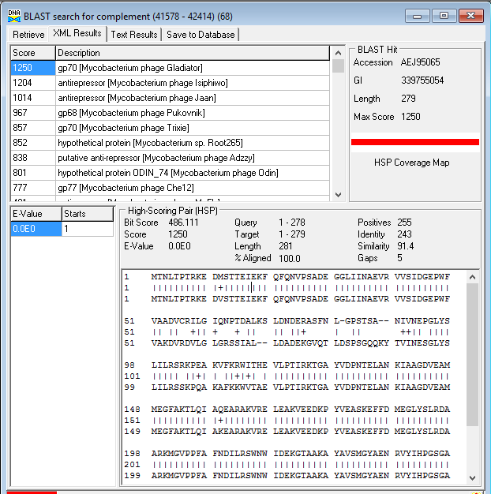

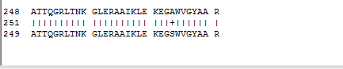

**Figure 25: Feature 68, Alignment and HSP Data**

The revised start at 42141 resulted in an alignment of 100.0 % and increased similarity to 91.4 with gp70 [Mycobacterium phage Gladiator].

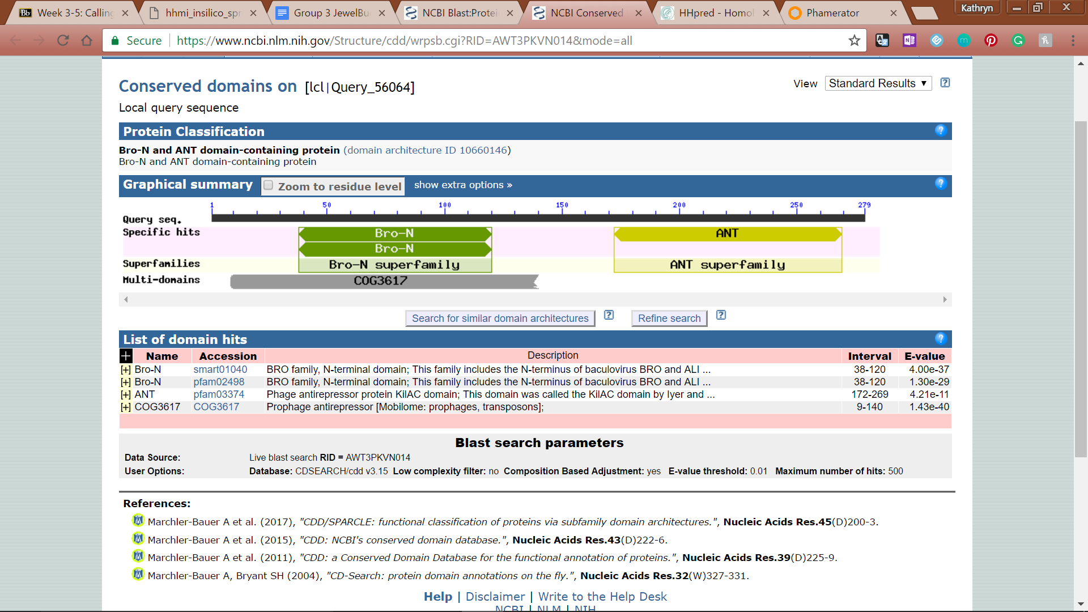

**Figure 26: Feature 68, Conserved Domains**

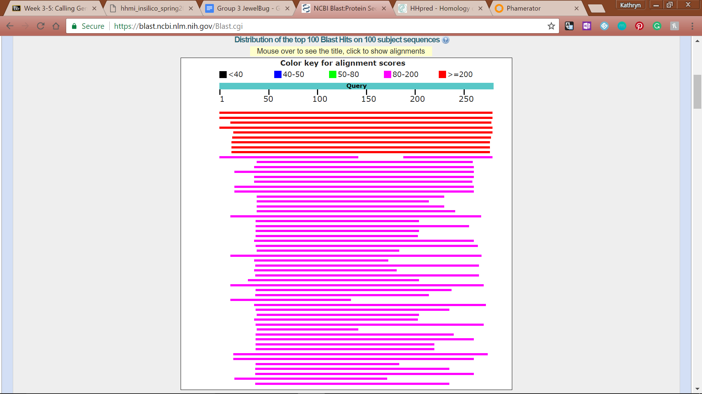

**Figure 27: Feature 68, BLASTp Hits Distribution Table**

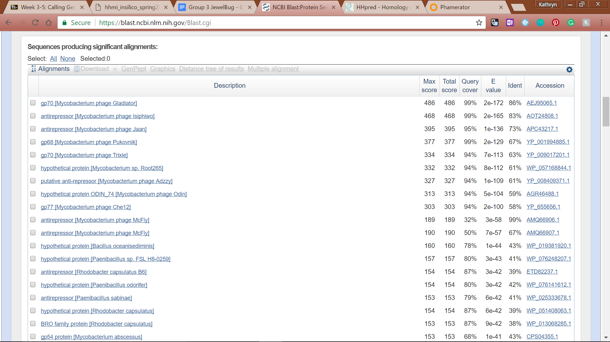

**Figure 28: Feature 68, BLASTp E-Values**

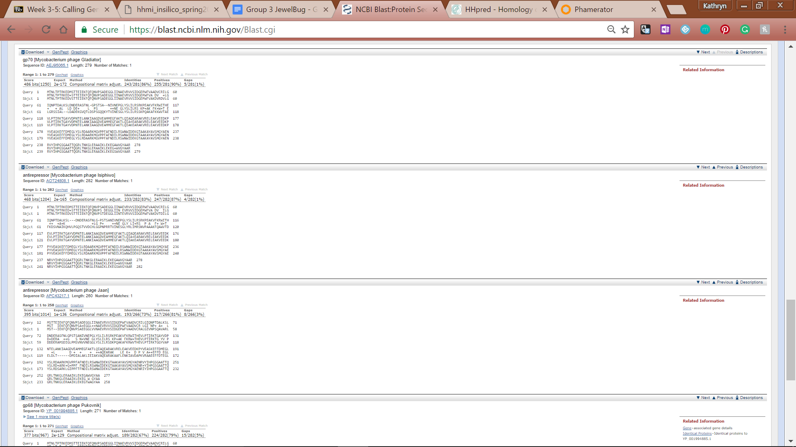

**Figure 29: Feature 68, BLASTp Alignments**

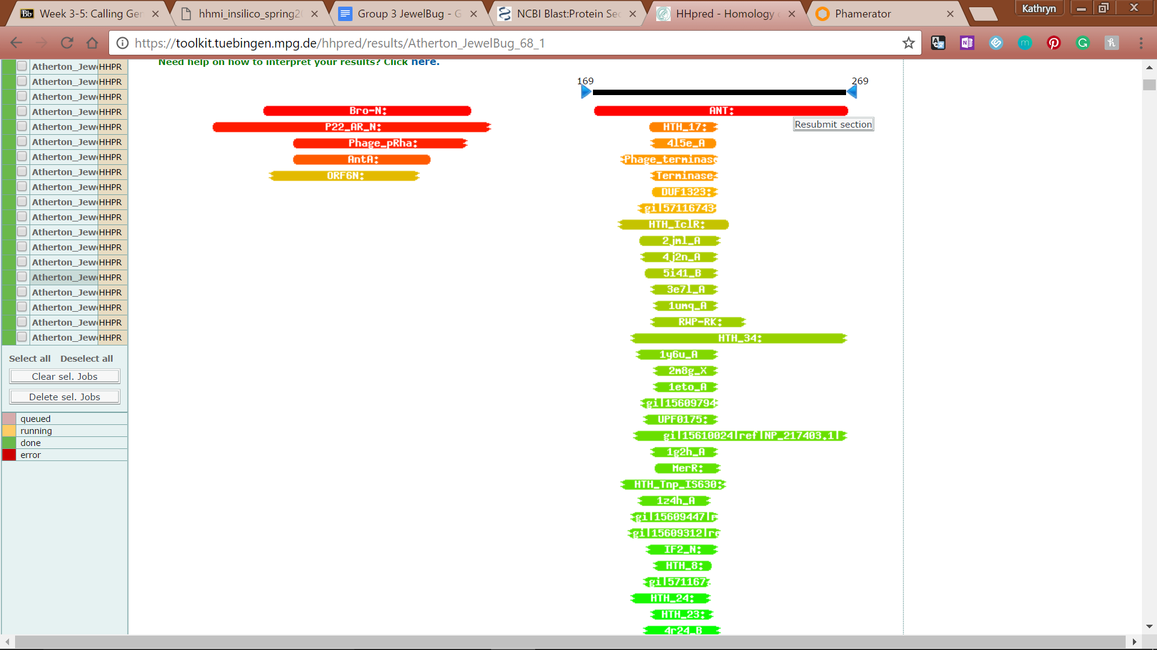

**Figure 30: Feature 68, HHPred Distribution List**

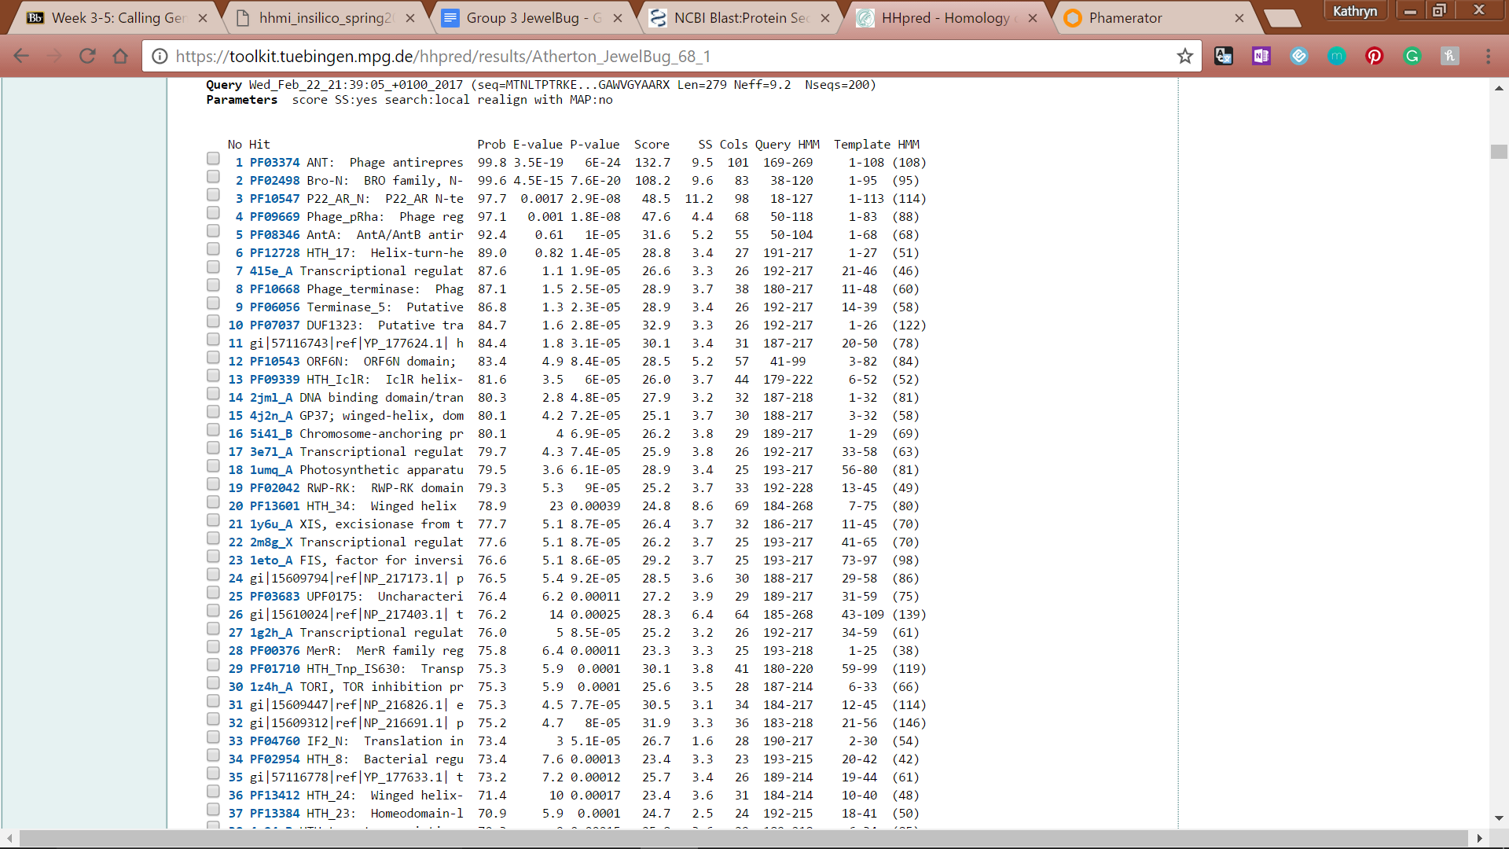

**Figure 31: Feature 68, HHPred Probabilities and Descriptions**

# Feature 69

**Table 3: Feature 69 Data**

|  |  |  |  |  |  |  |  |  |  |
| --- | --- | --- | --- | --- | --- | --- | --- | --- | --- |
| **Feature:** 69 | **3' End:** 42411 | **5' End:** 42578 | | | **Length:** 168 | | **Original Call:** | **Glimmer:** 42554 | |
| **GeneMark:** NA | |
| **Start / Stop Codon (SSC):** | | | | | | **Start:** TTG | | | |
| **Stop:** TGA; REV | | | |
| **Longest Open Reading Frame (LO):** 168 bp | | | | | | | | | Longest |
| **Shine Dalgarno (SD):** -3.286 / -4.613 | | | | | | | | | Not Highest |
| **Start Choice Source (SCS):** | | | | **Called by Glimmer:** Yes, 42554 | | | | | |
| **Called by GeneMark**: No | | | | | |
| **Coding Potential (CP):** all covered and extending beyond | | | | | | | | | |
| **Gap / Overlap:** 160 bp gap following gene | | | | | | | | | |
| **BLASTp:** hypothetical protein PBI_KAZAN_75 [Mycobacterium phage Kazan], bp 1 aligns with bp 199 | | | | | | | | | |
| **Function (F):** No Known Function | | | | | | | | | |
| **Function Source (FS):** | | | **Phamerator:** no noted functions in similar phages | | | | | | |
| **BLASTp:** gp71 from Gladiator (unknown function) | | | | | | |
| **HHPred:** Uncharacterized protein conserved in bacteria; 92.23% probability | | | | | | |
| **Comments:** Although coding potential was not very strong and the feature was not called by genemark, we decided to call it because it was found in Phamerator and we wanted to prevent a large gap between the feature preceding and immediately following this gene. The top BLAST result is very poor. However, The top BLAST score for the next best call is improved upon with this call. This call also extends the ORF even further and closes the large gap between features 69 and 70 even more. | | | | | | | | | |

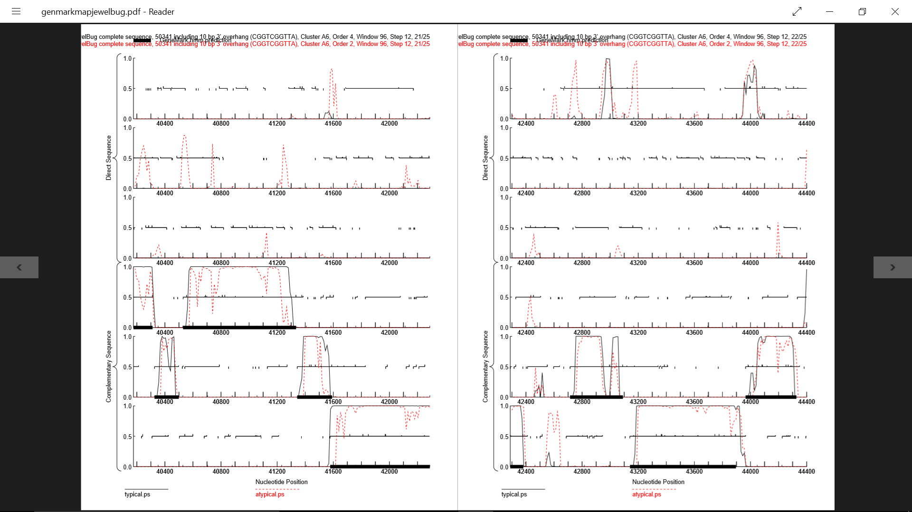

**Figure 32: Feature 69, GeneMark Map**

the coding potential runs from about 42260 - 42520; however no start sequences align with a start in that location. The nearest start site that covers all of the potential and is of decent length is at 42554. In order to increase gene density and cover coding potential this starting position was selected even though it extends beyond the coding potential.

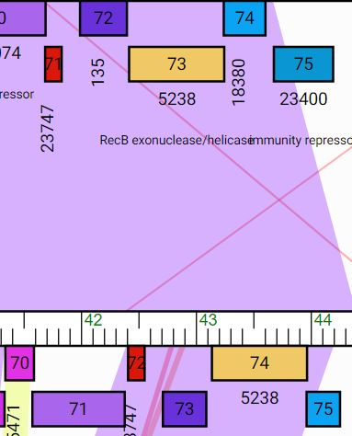

**Figure 33: Feature 69, Isiphiwo vs. JewelBug Phamerator Map**

Both genomes have a similar sized (144bp) gene. In the bottom row, 72 is Feature 69; top, 71.

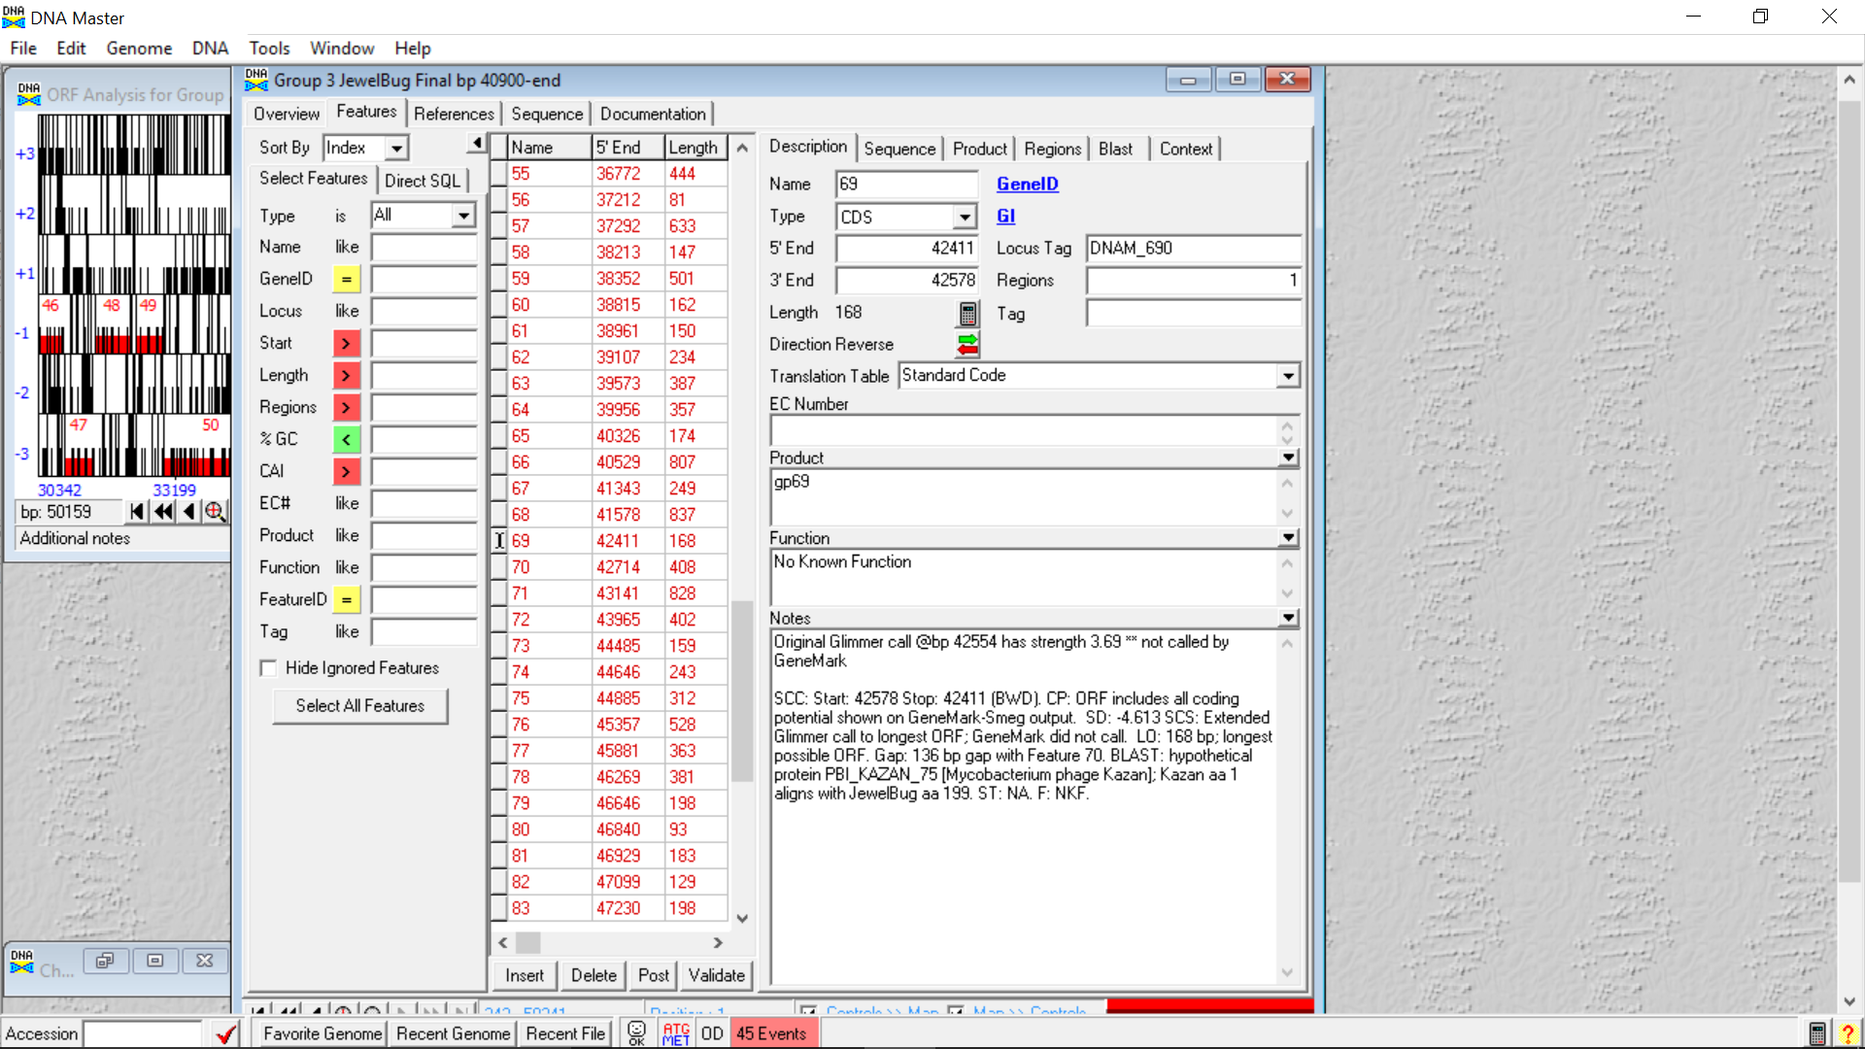

**Figure 34: Feature 69, Feature Window**

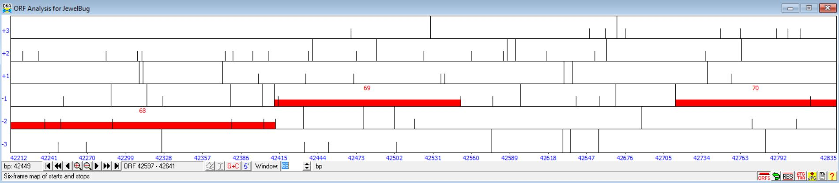

**Figure 35: Feature 69, Frame Window**

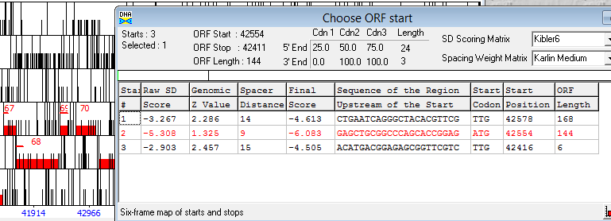

**Figure 36: Feature 69, Choose Start Window**

The feature is found in the fourth frame and based on cross-referencing with GeneMark and the Phamerator Map, the start chosen was the second start site with the start position at 42554.

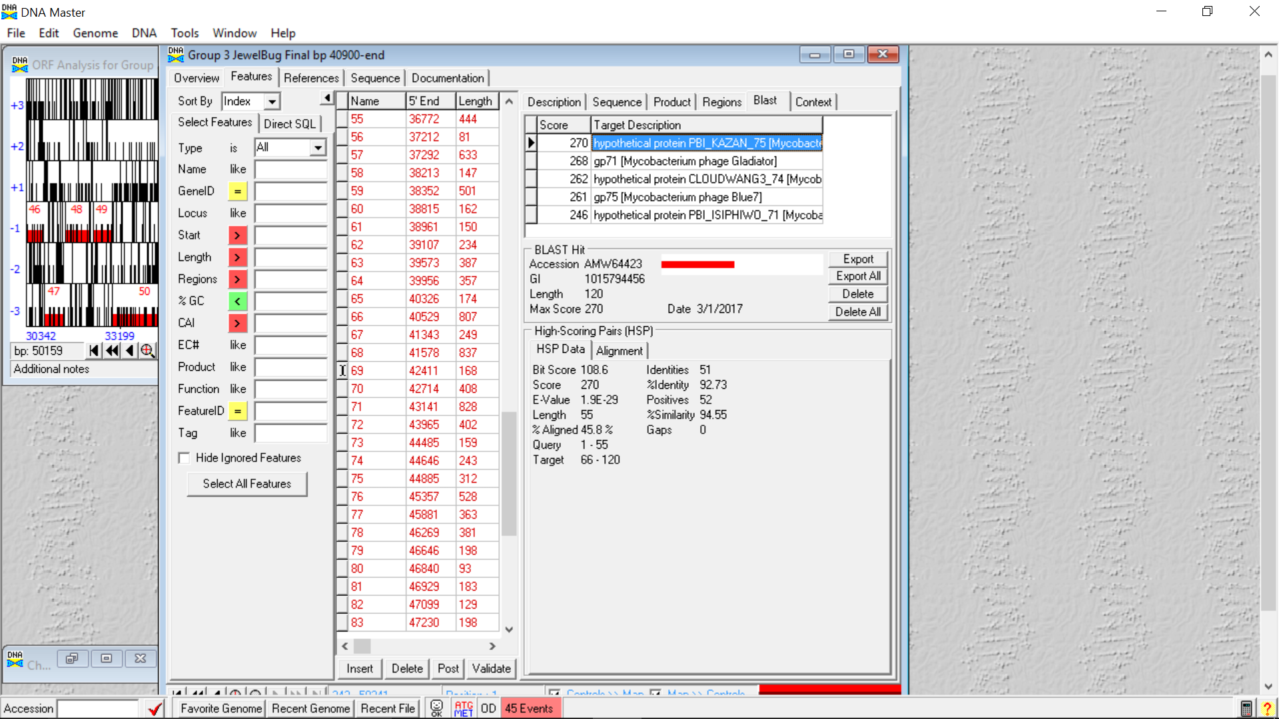

**Figure 37: Feature 69, HSP Data**

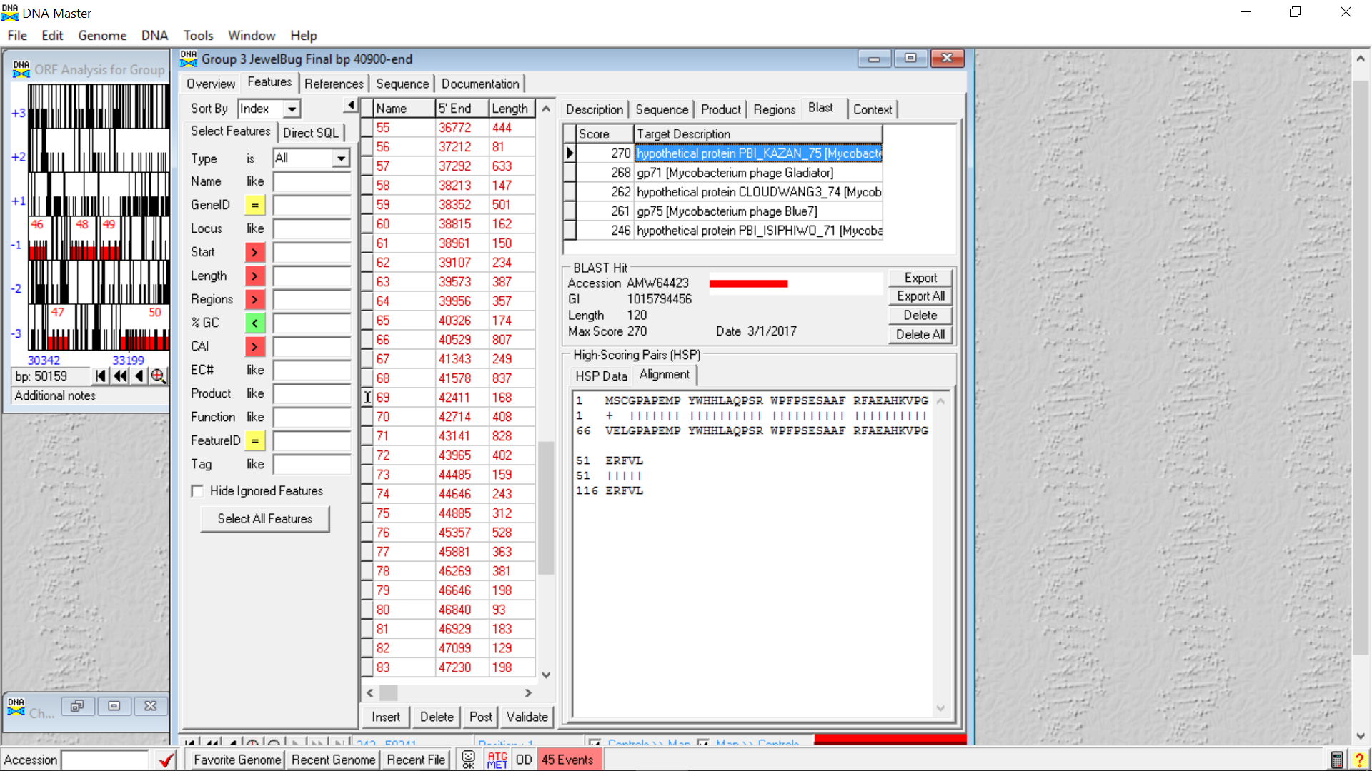

**Figure 38: Feature 69, Alignment**

hypothetical protein PBI_KAZAN_75 [Mycobacterium phage Kazan] BP1 of JewelBug 69 aligns with BP199 with of 71 of Isiphiwo.

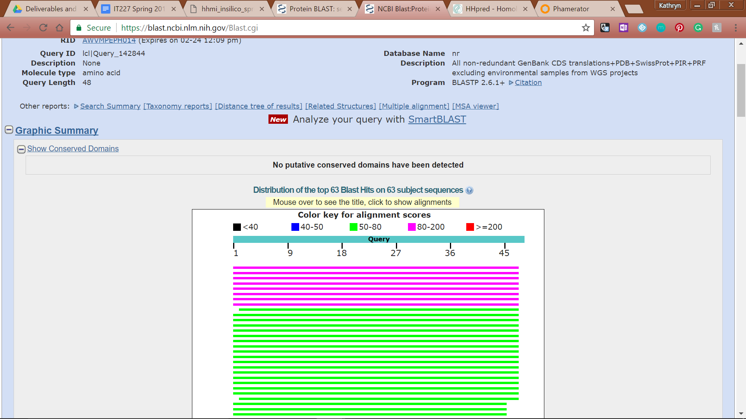

**Figure 39: Feature 69, Conserved Domain**

**Figure 40: Feature 69, BLASTp Hits Distribution Table**

**Figure 41: Feature 69, BLASTp E-Values**

**Figure 42: Feature 69, BLASTp Alignments**

**Figure 43: Feature 69, HHPred Distribution List**

**Figure 44: Feature 69, HHPred Probabilities and Descriptions**

# Feature 70

**Table 4: Feature 70 Data**

|  |  |  |  |  |  |  |  |  |  |
| --- | --- | --- | --- | --- | --- | --- | --- | --- | --- |
| **Feature:** 70 | **3' End:** 42714 | **5' End:** 43133 | | | **Length:** 420 | | **Original Call:** | **Glimmer:** 43091 | |
| **GeneMark:** 43091 | |
| **Start / Stop Codon (SSC):** | | | | | | **Start:** TTG | | | |
| **Stop:** TAG; REV | | | |
| **Longest Open Reading Frame (LO):** 630 bp | | | | | | | | | Not Longest |
| **Shine Dalgarno (SD):** -3.788 / -4.545 | | | | | | | | | Highest |
| **Start Choice Source (SCS):** | | | | **Called by Glimmer:** Yes, 43091 | | | | | |
| **Called by GeneMark**: Yes, 43091 | | | | | |
| **Coding Potential (CP):** All covered and extending past | | | | | | | | | |
| **Gap / Overlap:** 8 bp gap following gene | | | | | | | | | |
| **BLASTp:** gp73 [Mycobacterium phage DaVinci] bp1 aligns with bp 5 | | | | | | | | | |
| **Function (F):** resuscitation-promoting factor RpfA | | | | | | | | | |
| **Function Source (FS):** | | | **Phamerator:** No noted functions in similar phages | | | | | | |
| **BLASTp:** gp73 from DaVinci (unknown function) | | | | | | |
| **HHPred:** resuscitation-promoting factor RpfA [Mycobacterium tuberculosis H37Rv]; 89.47% similarity | | | | | | |
| **Comments:** Moved 3’ end start from 43091 to 43133. Evidence for new start site includes improved blast results. Blast score increased from 378 to 430 and alignment from 83 % to 90.4 %. In addition the gap between feature 70 and 71 is decreased by moving the start site. Also the Shine Dalgarno score was improved by moving the start site and the length of the ORF increased. | | | | | | | | | |

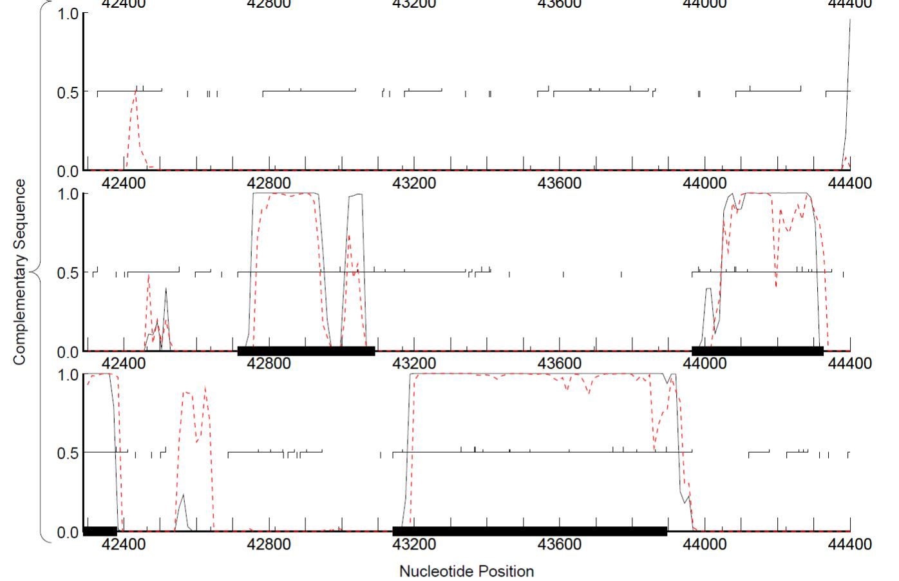

**Figure 45: Figure 70, GeneMark Map**

Coding potential exists beginning around a start of 43090, but we extended the start beyond the coding potential to 43121.

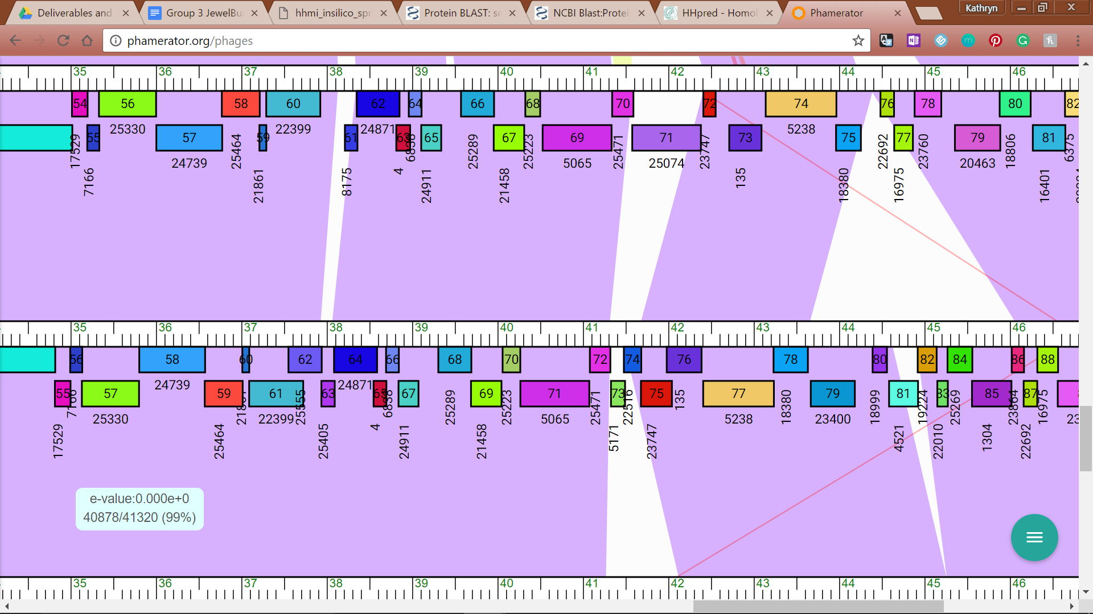

**Figure 46: Feature 70, JewelBug vs. Kazan Phamerator Map**

JewelBug’s Phamerator feature 73 is 98% similar to Kazan’s Phamerator feature 76.

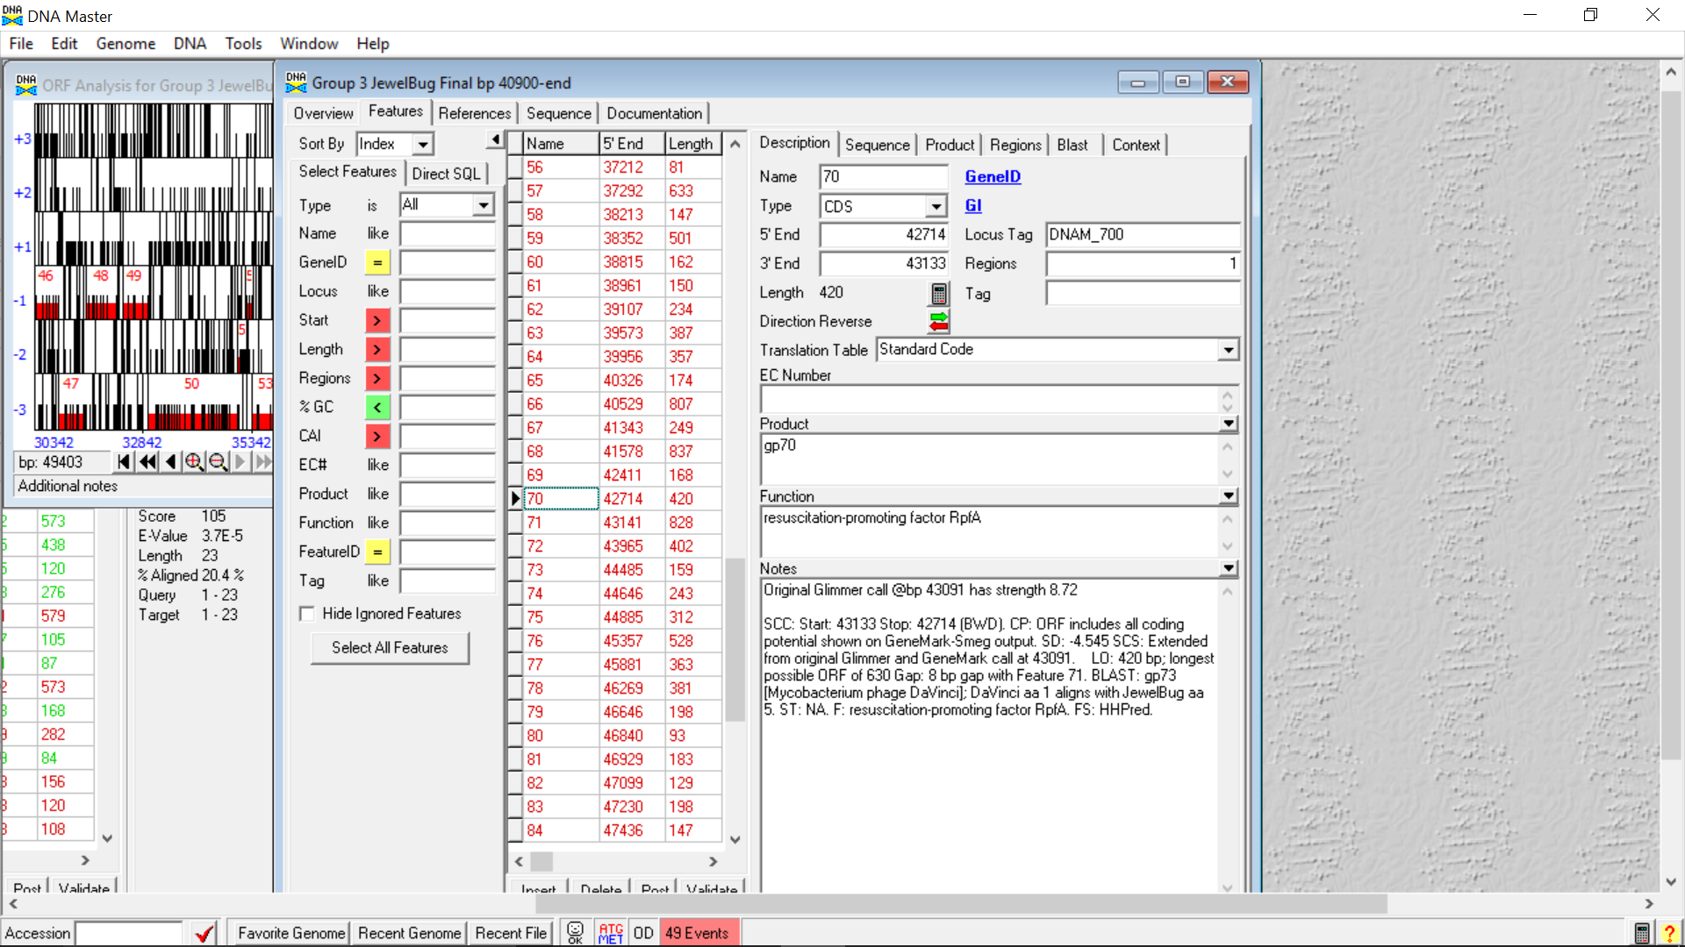

**Figure 47: Feature 70, Feature Window**

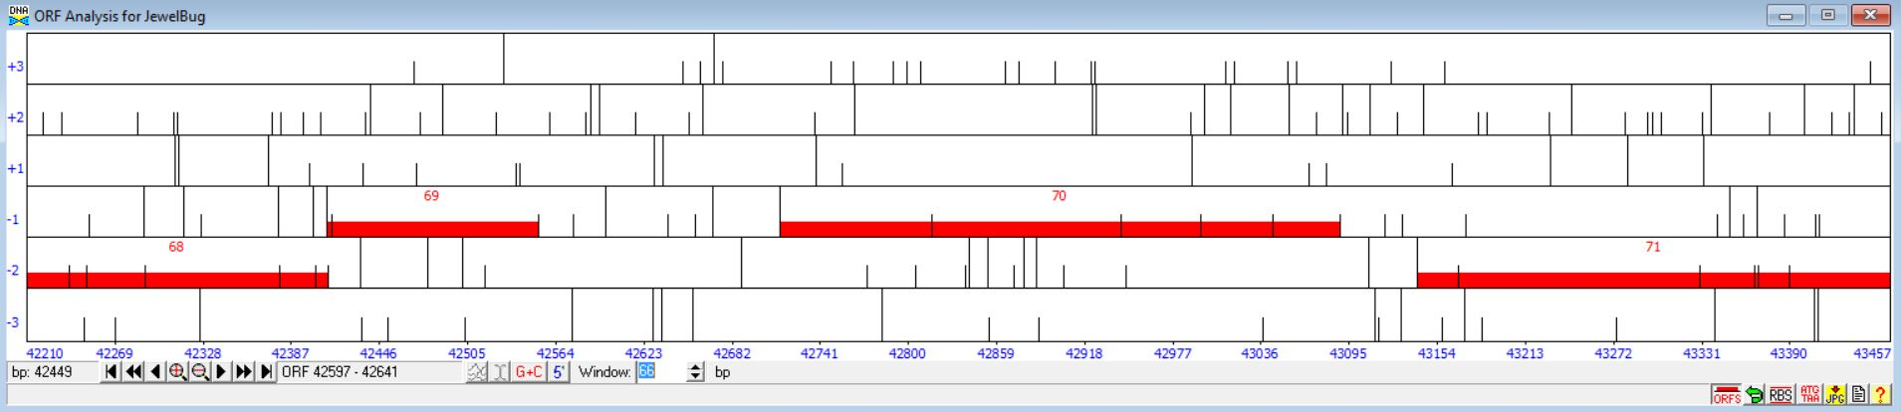

**Figure 48: Feature 70, Frame Window**

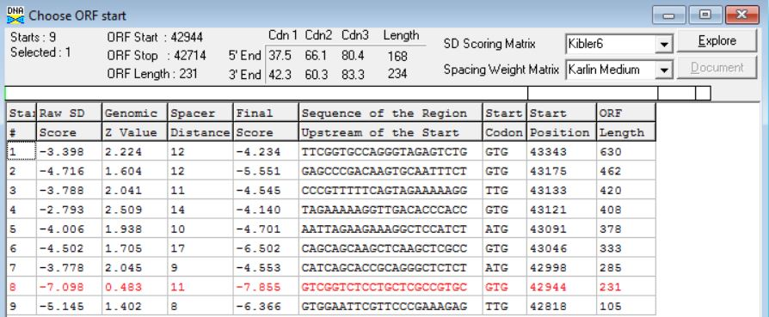

**Figure 49: Feature 70, Choose Start Window**

We chose to move the 3’ start site to 43121 (from DNA Master’s original prediction of 43091) since that GTG start site has the highest Final Score and a longer ORF. Additionally, the similarity and identity percentages are both 99.18%, which is slightly higher than the original blast results. Finally, making the gene longer helps to close the gap between genes 70 and 71.

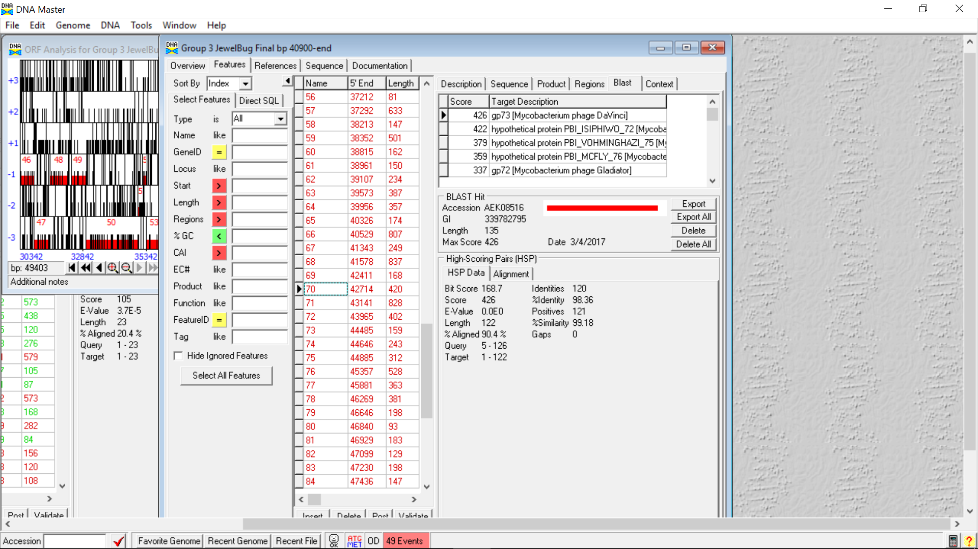

**Figure 50: Feature 70, HSP Data**

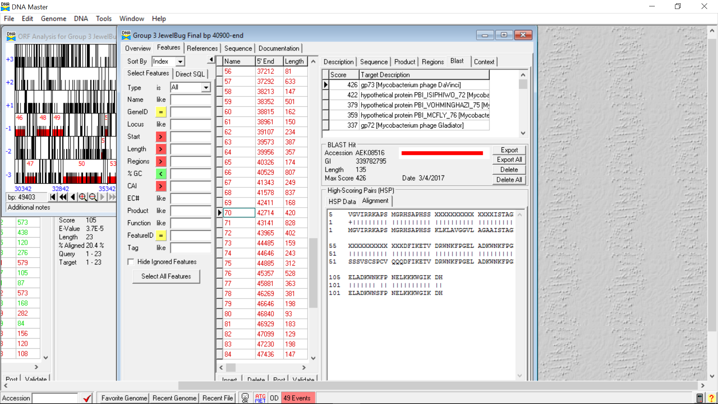

**Figure 51: Feature 70, Alignment**



**Figure 52: Feature 70, Conserved Domain**

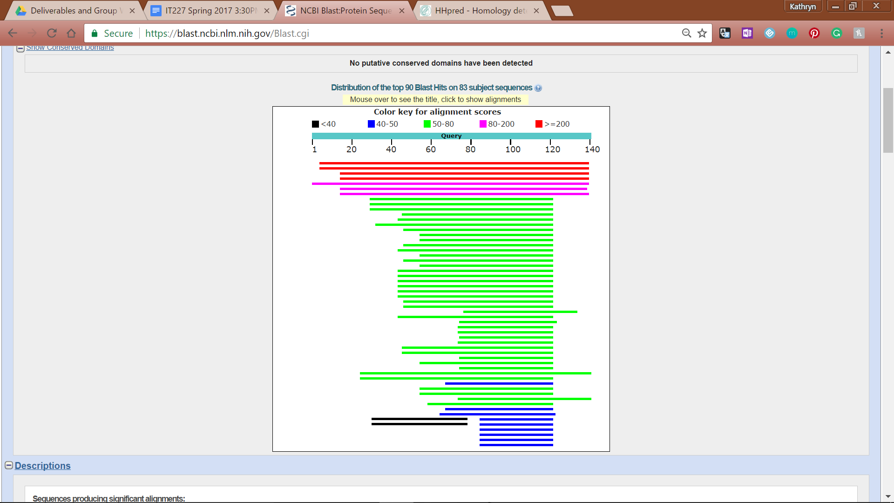

**Figure 53: Feature 70, BLASTp Hits Distribution Table**

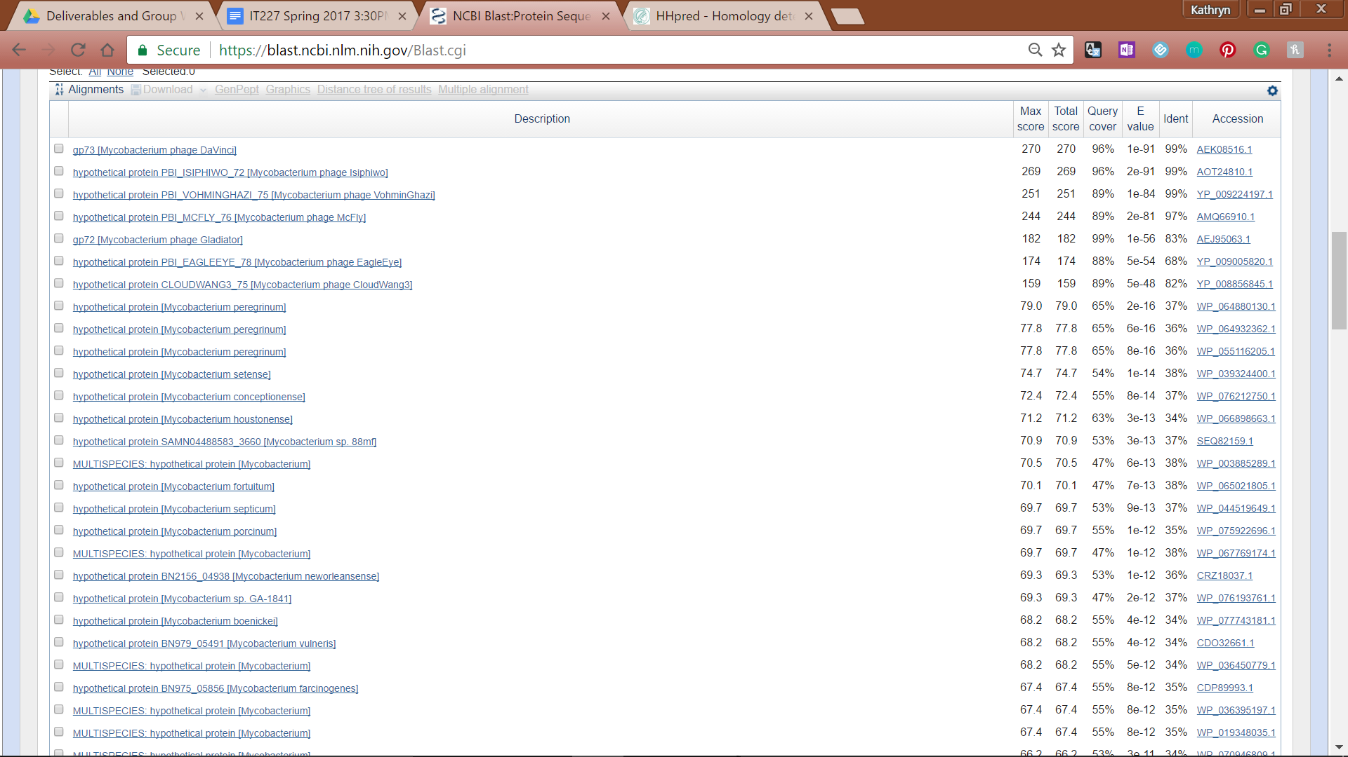

**Figure 54: Feature 70, BLASTp E-Values**

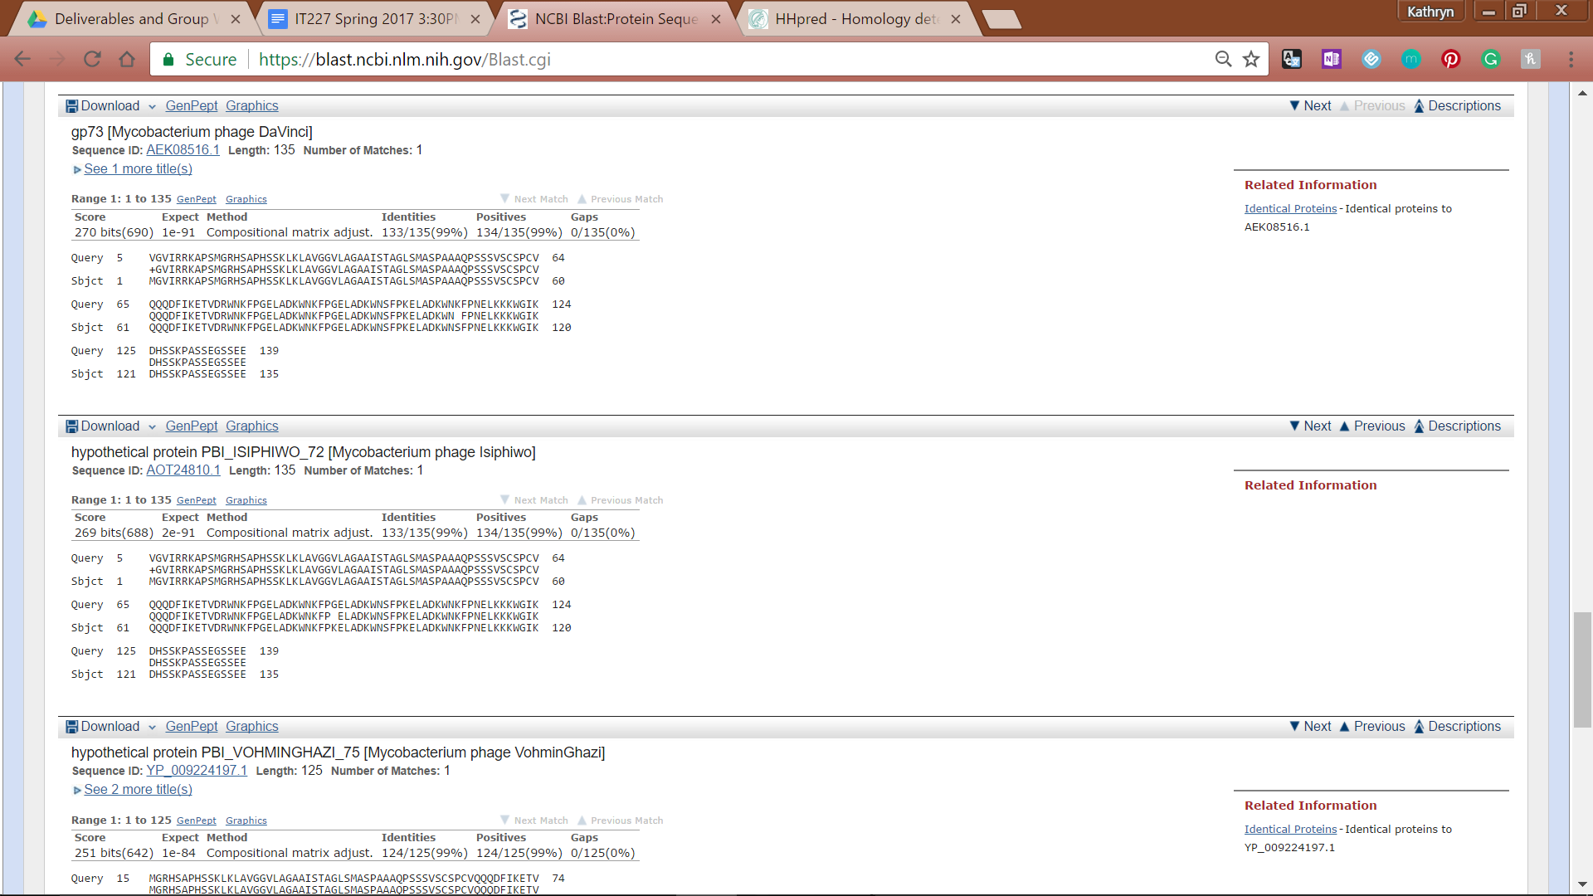

**Figure 55: Feature 70, BLASTp Alignments**

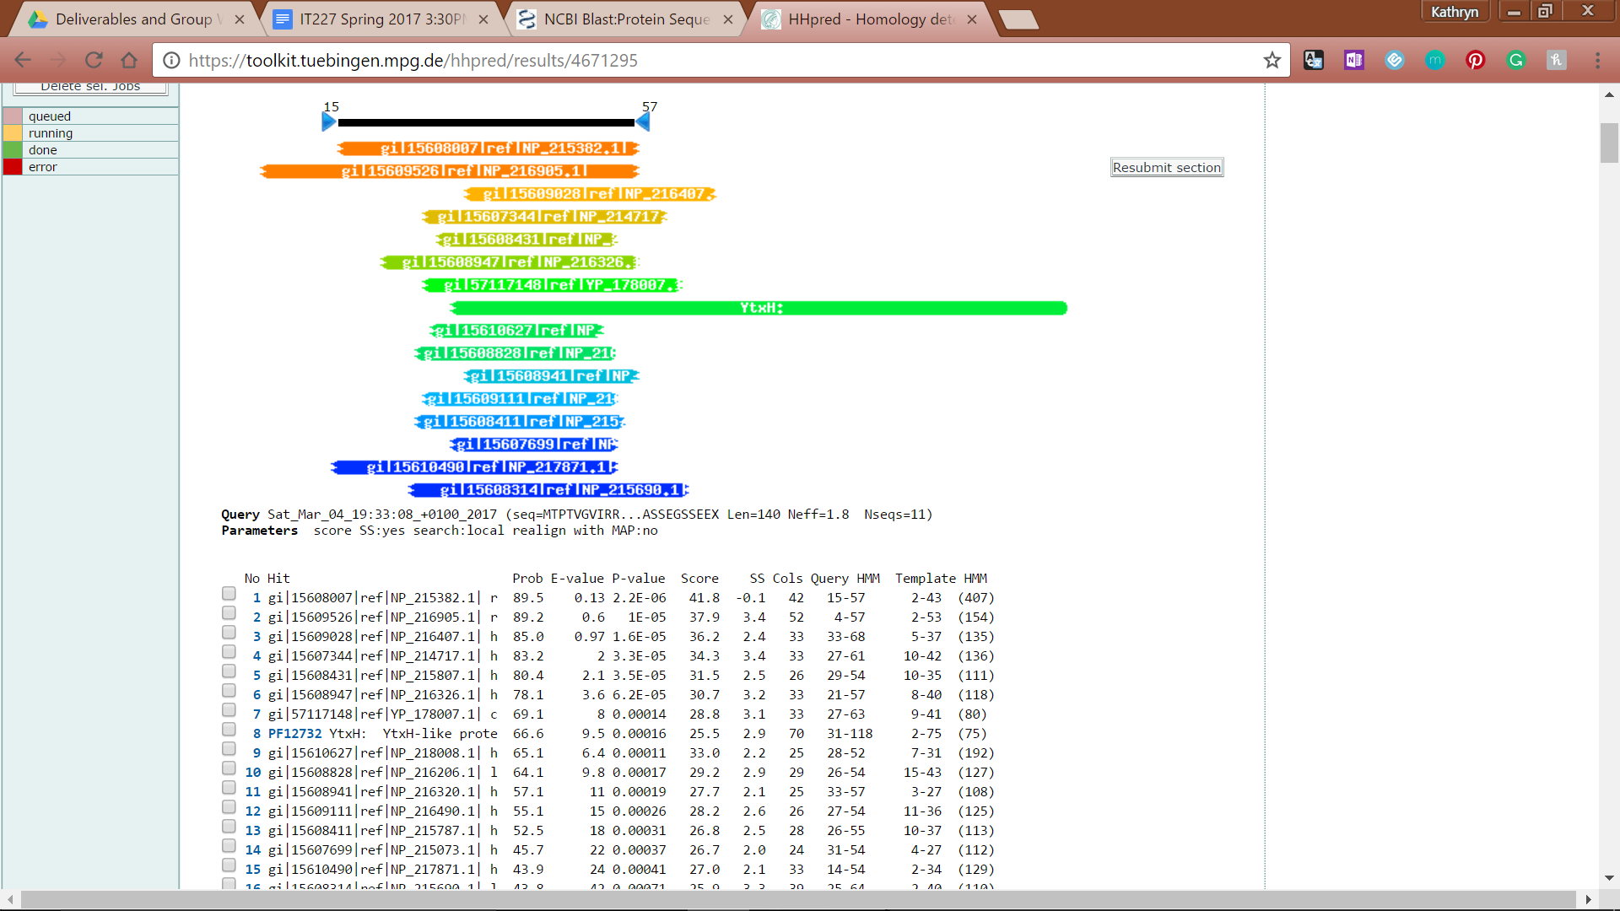

**Figure 56: Feature 70, HHPred Distribution List**

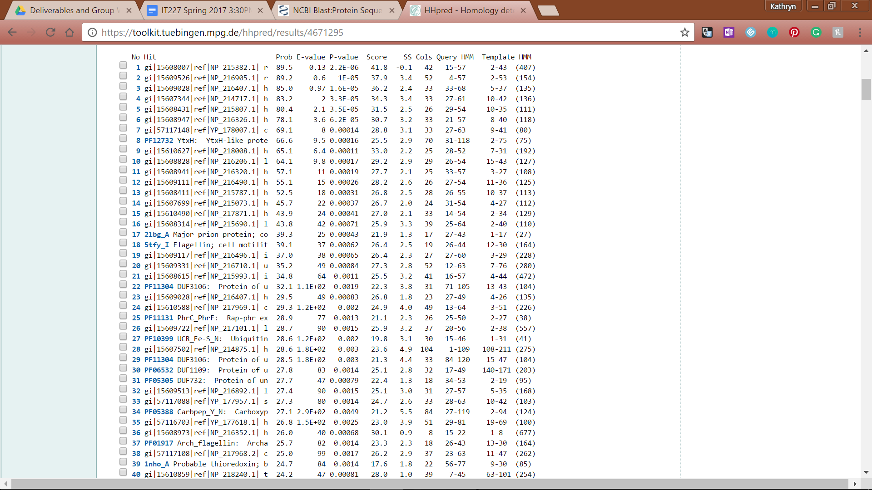

**Figure 57: Feature 70, HHPred Probabilities and Descriptions**

# Feature 71

**Table 5: Feature 71 Data**

|  |  |  |  |  |  |  |  |  |  |
| --- | --- | --- | --- | --- | --- | --- | --- | --- | --- |
| **Feature:** 71 | **3' End:** 43141 | **5' End:** 43968 | | | **Length:** 828 | | **Original Call:** | **Glimmer:** 43968 | |
| **GeneMark:** 43968 | |
| **Start / Stop Codon (SSC):** | | | | | | **Start:** GTG | | | |
| **Stop:** TAG; REV | | | |
| **Longest Open Reading Frame (LO):** 828 bp | | | | | | | | | Longest |
| **Shine Dalgarno (SD):** -2.736 / -3.493 | | | | | | | | | Highest |
| **Start Choice Source (SCS):** | | | | **Called by Glimmer:** Yes, 43968 | | | | | |
| **Called by GeneMark**: Yes, 43968 | | | | | |
| **Coding Potential (CP):** all covered | | | | | | | | | |
| **Gap / Overlap:** 3 bp overlap with feature 72 | | | | | | | | | |
| **BLASTp:** exonuclease/helicase [Mycobacterium phage Isiphiwo], bp 1 aligns with bp 1 | | | | | | | | | |
| **Function (F):** exonuclease/helicase | | | | | | | | | |
| **Function Source (FS):** | | | **Phamerator:** feature 74 of DaVinci (RecB) | | | | | | |
| **BLASTp:** Isiphiwo (RecB exonuclease/helicase) | | | | | | |
| **HHPred:** nuclease superfamily; 99.95% probability | | | | | | |
| **Comments:** Original call supported by GeneMark, Glimmer, Longest ORF, SD, best blast results (compared to start 2), acceptable bp overlap, capture of coding potential, and Phamerator similarity. | | | | | | | | | |

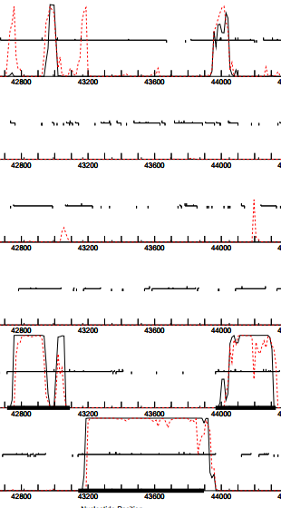

**Figure 58: Feature 71, GeneMark Map**

The original call fully captures all the coding potential between 43141 and 43968 with an acceptable overlap into the preceding coding potential at 43965.

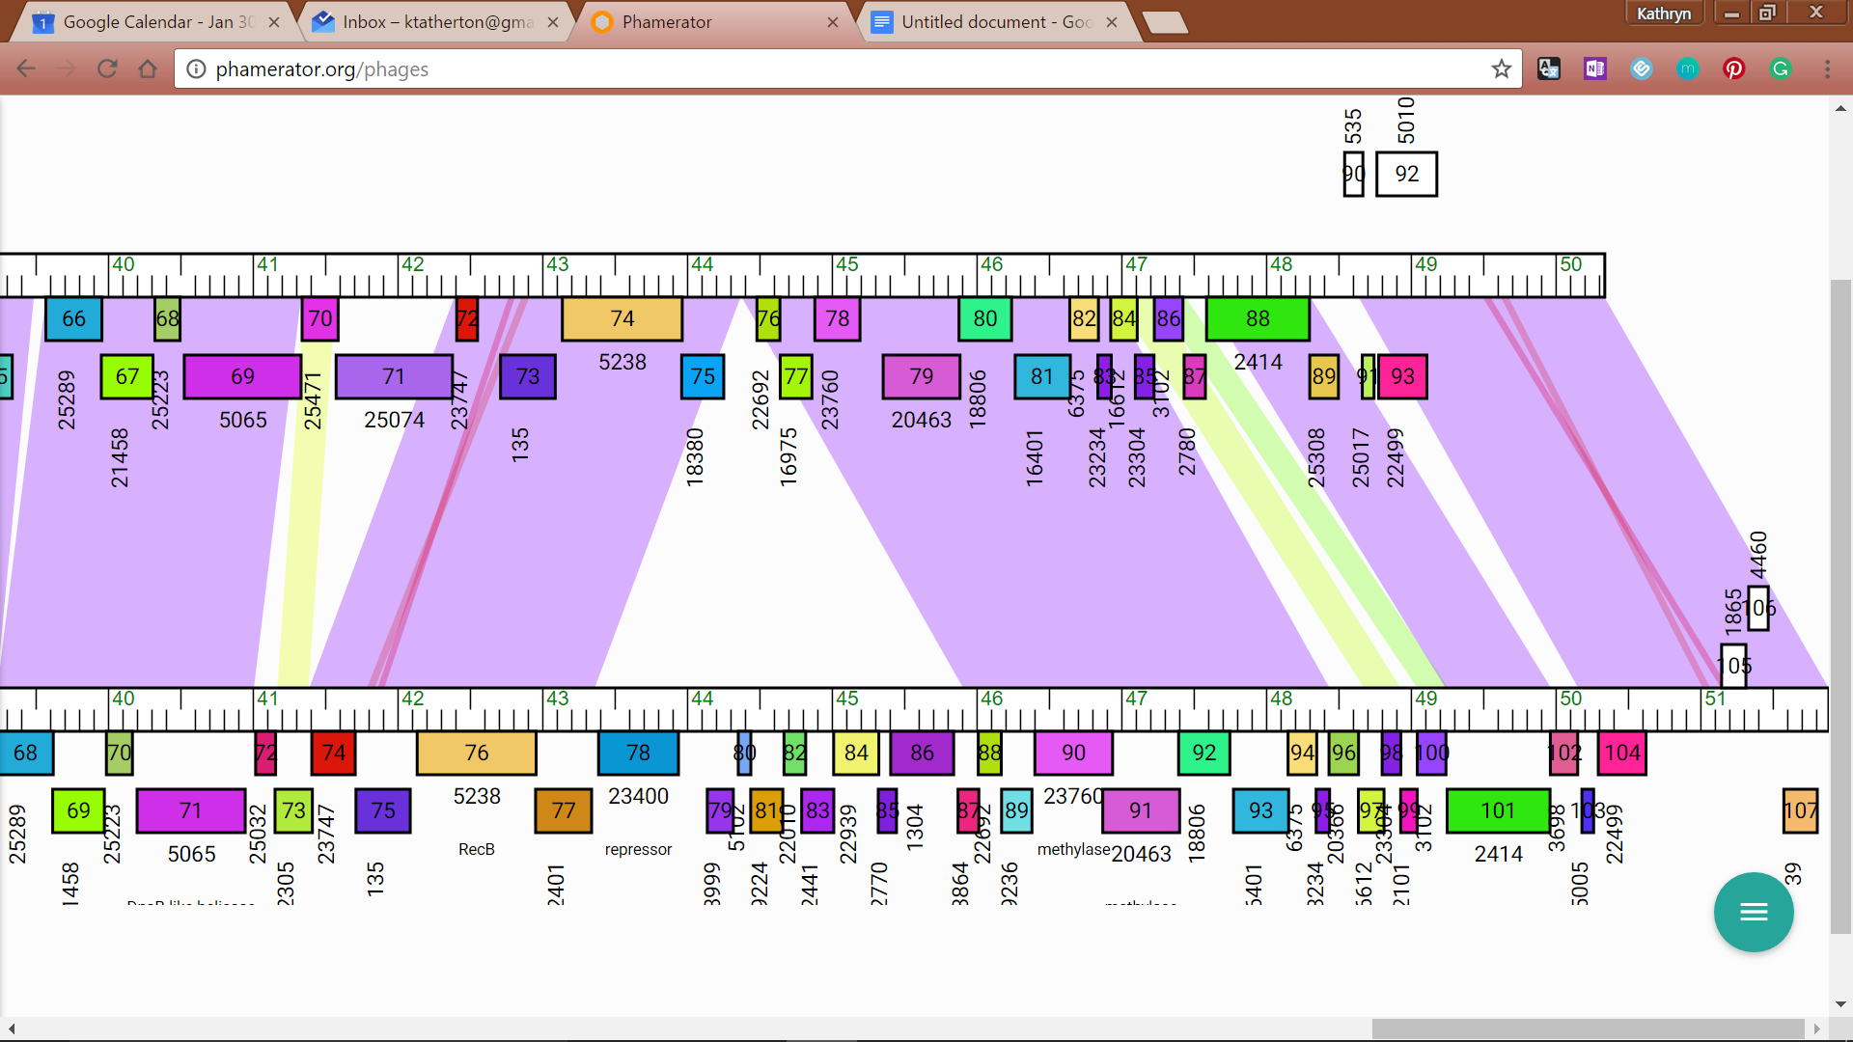

**Figure 59: Feature 71, JewelBug vs. Hammer Phamerator Map**

The gene labeled 74 in JewelBug_Draft’s Phamerator map (top line) is nearly identical to every single phamerator map of the A6 phage phamily (Hammer Phamerator map shown on bottom line)

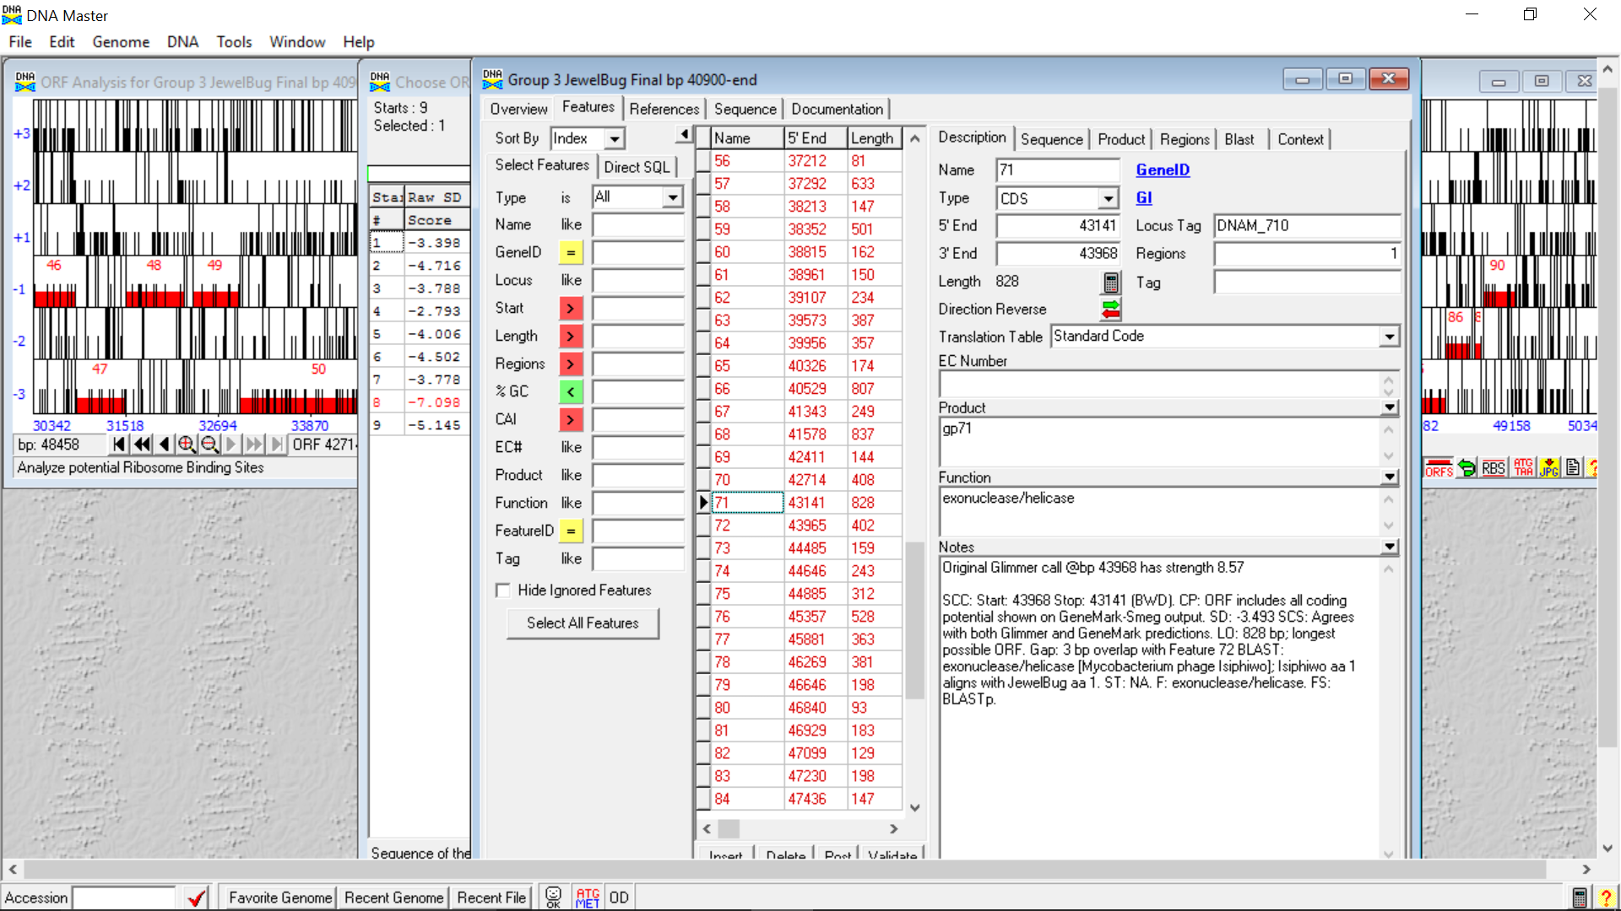

**Figure 60: Feature 71, Feature Window**

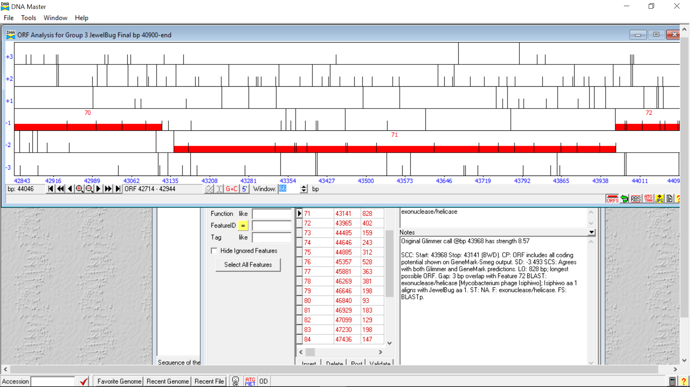

**Figure 61: Feature 71, Frame Window**

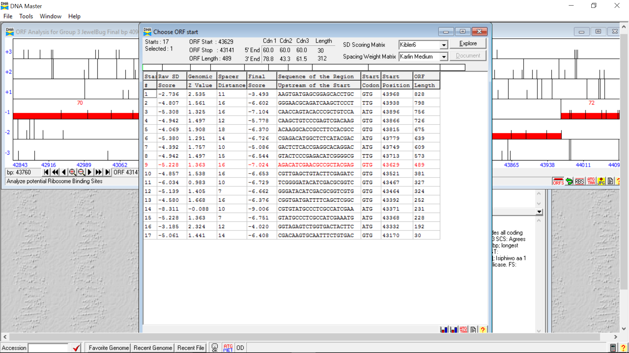

**Figure 62: Feature 71, Choose Start Window**

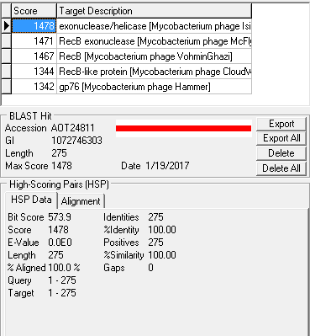

**Figure 63: Feature 71, HSP Data at Original Call**

100.0 % similarity and 100.0 % alignment with the original call at start 1, 43968

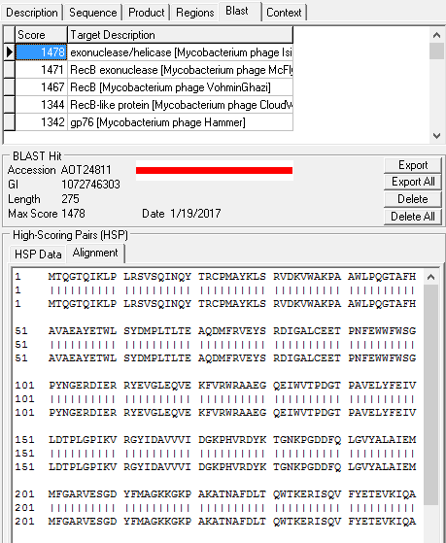

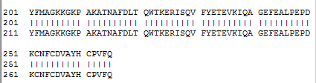

**Figure 64: Feature 71, Alignment at Original Call**

bp 1 of Feature 71 aligns with bp 1 of exonuclease/helicase [Mycobacterium phage Isiphiwo] at the original call

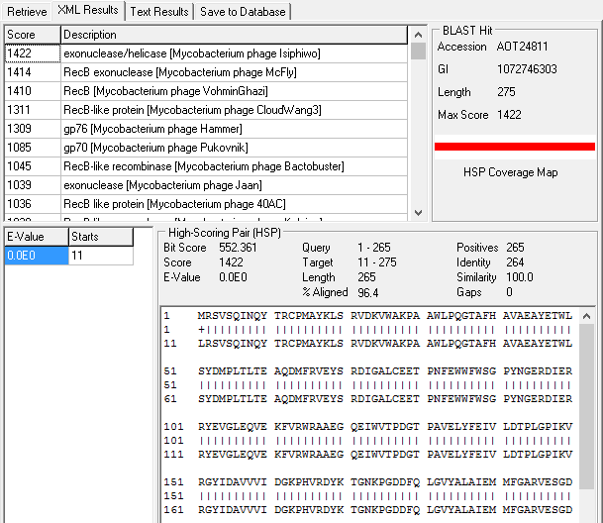



**Figure 65: Feature 71, HSP and Alignment for BLAST of Start Site 2**

Blast results from start site 2 at 43938, similarity remains 100%; however, alignment is reduced to 96.4%. This strongly supports keeping the start site at the original call.

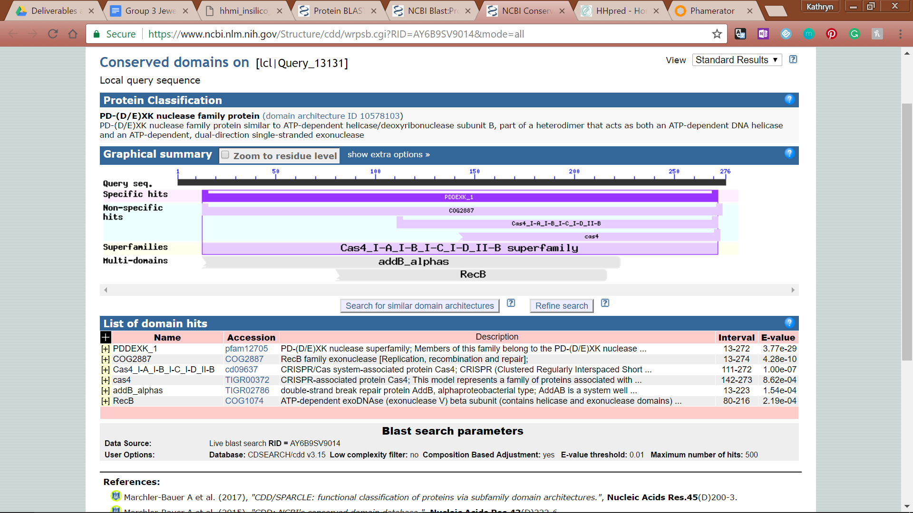

**Figure 66: Feature 71, Conserved Domain**

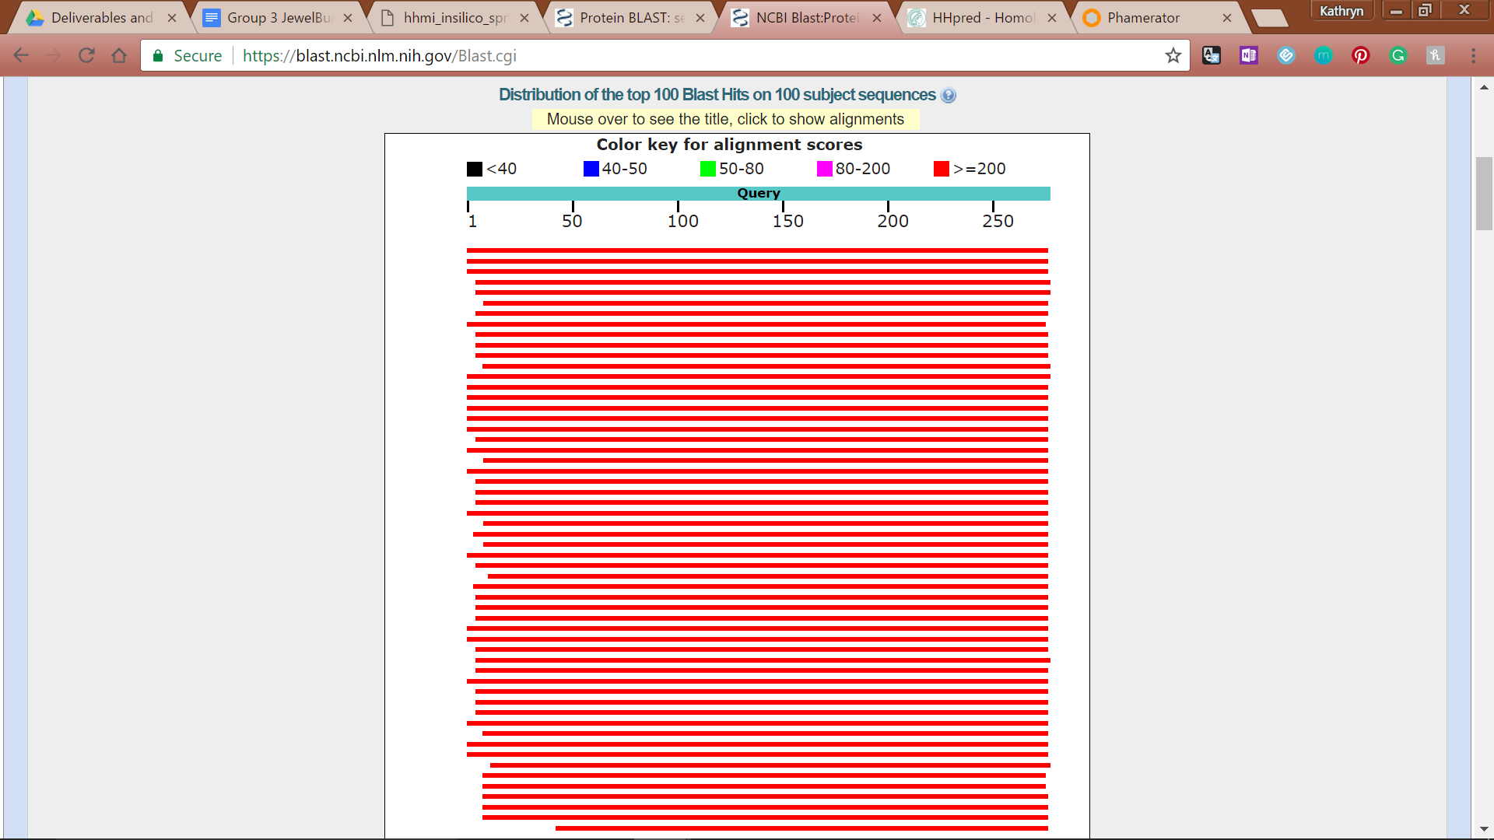

**Figure 67: Feature 71, BLASTp Hits Distribution Table**

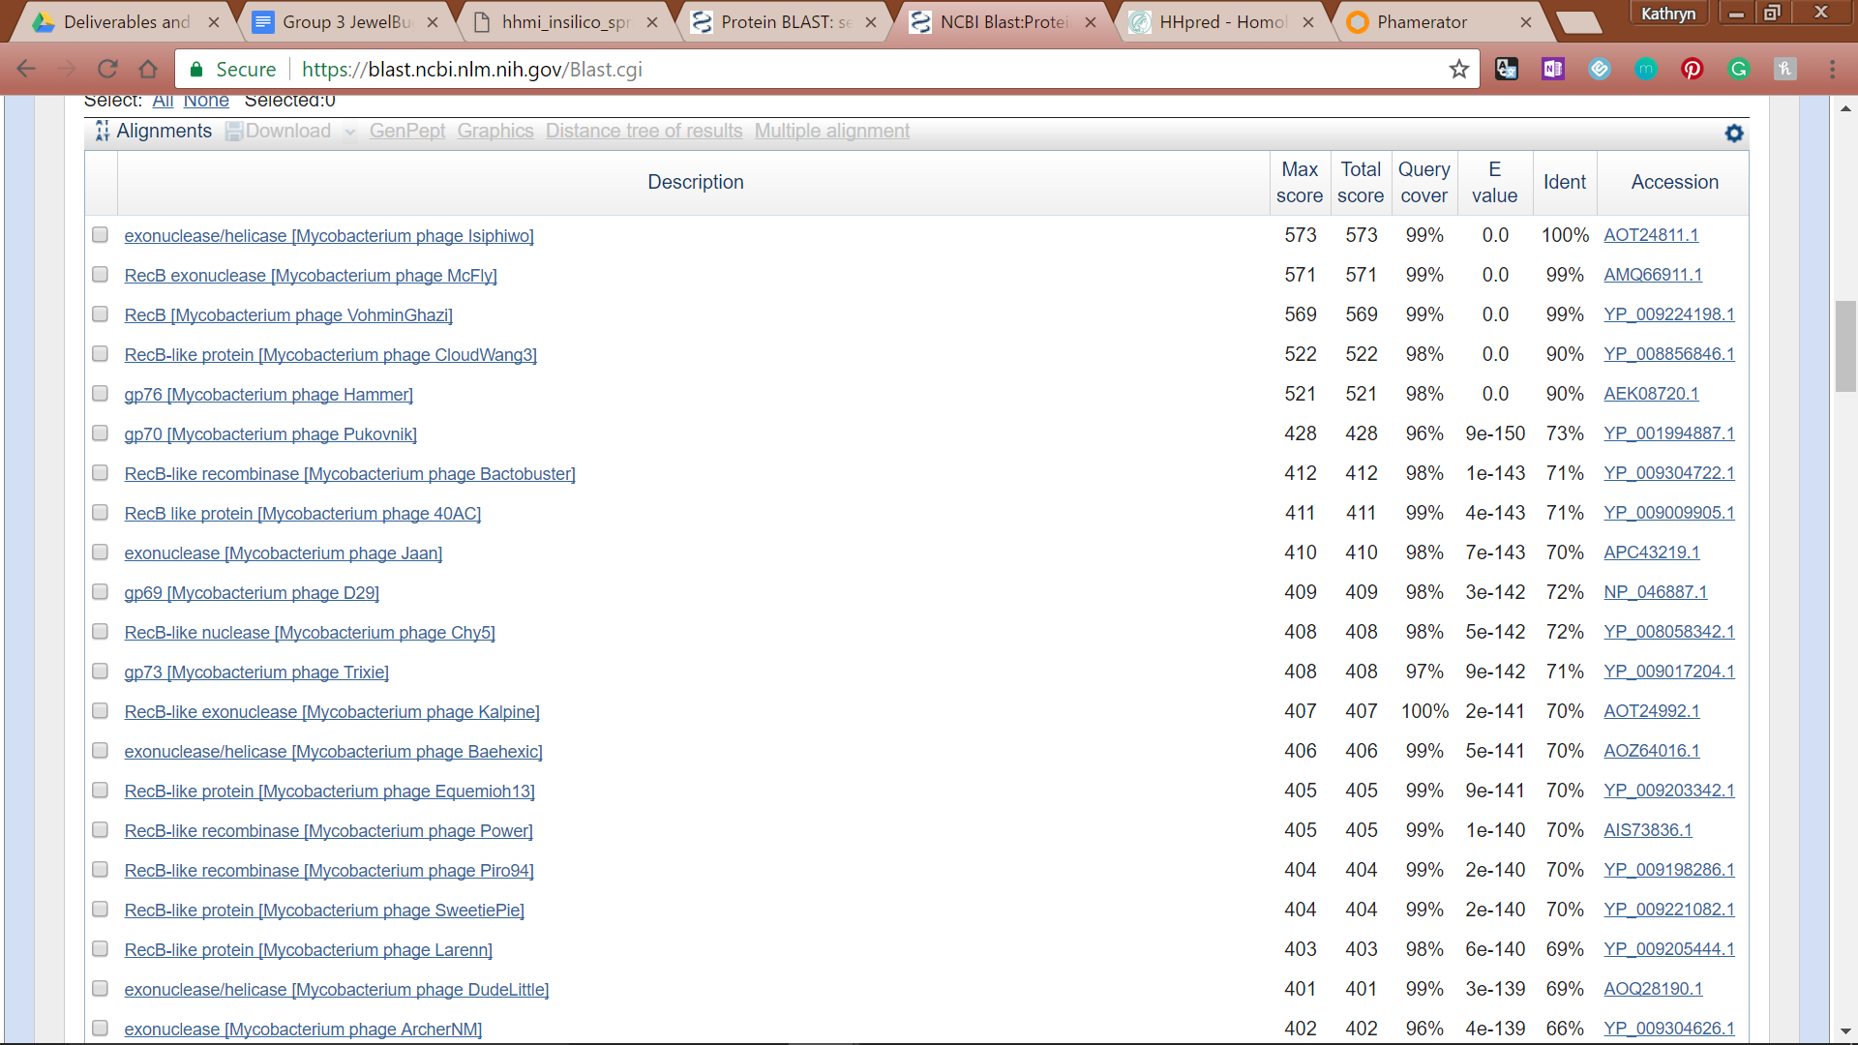

**Figure 68: Feature 71, BLASTp E-Values**

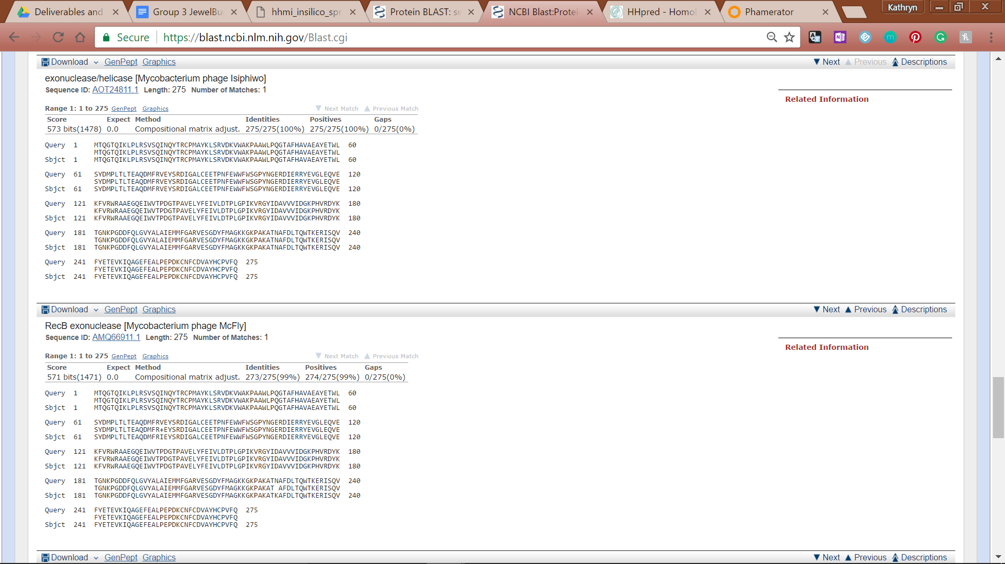

**Figure 69: Feature 71, BLASTp Alignments**

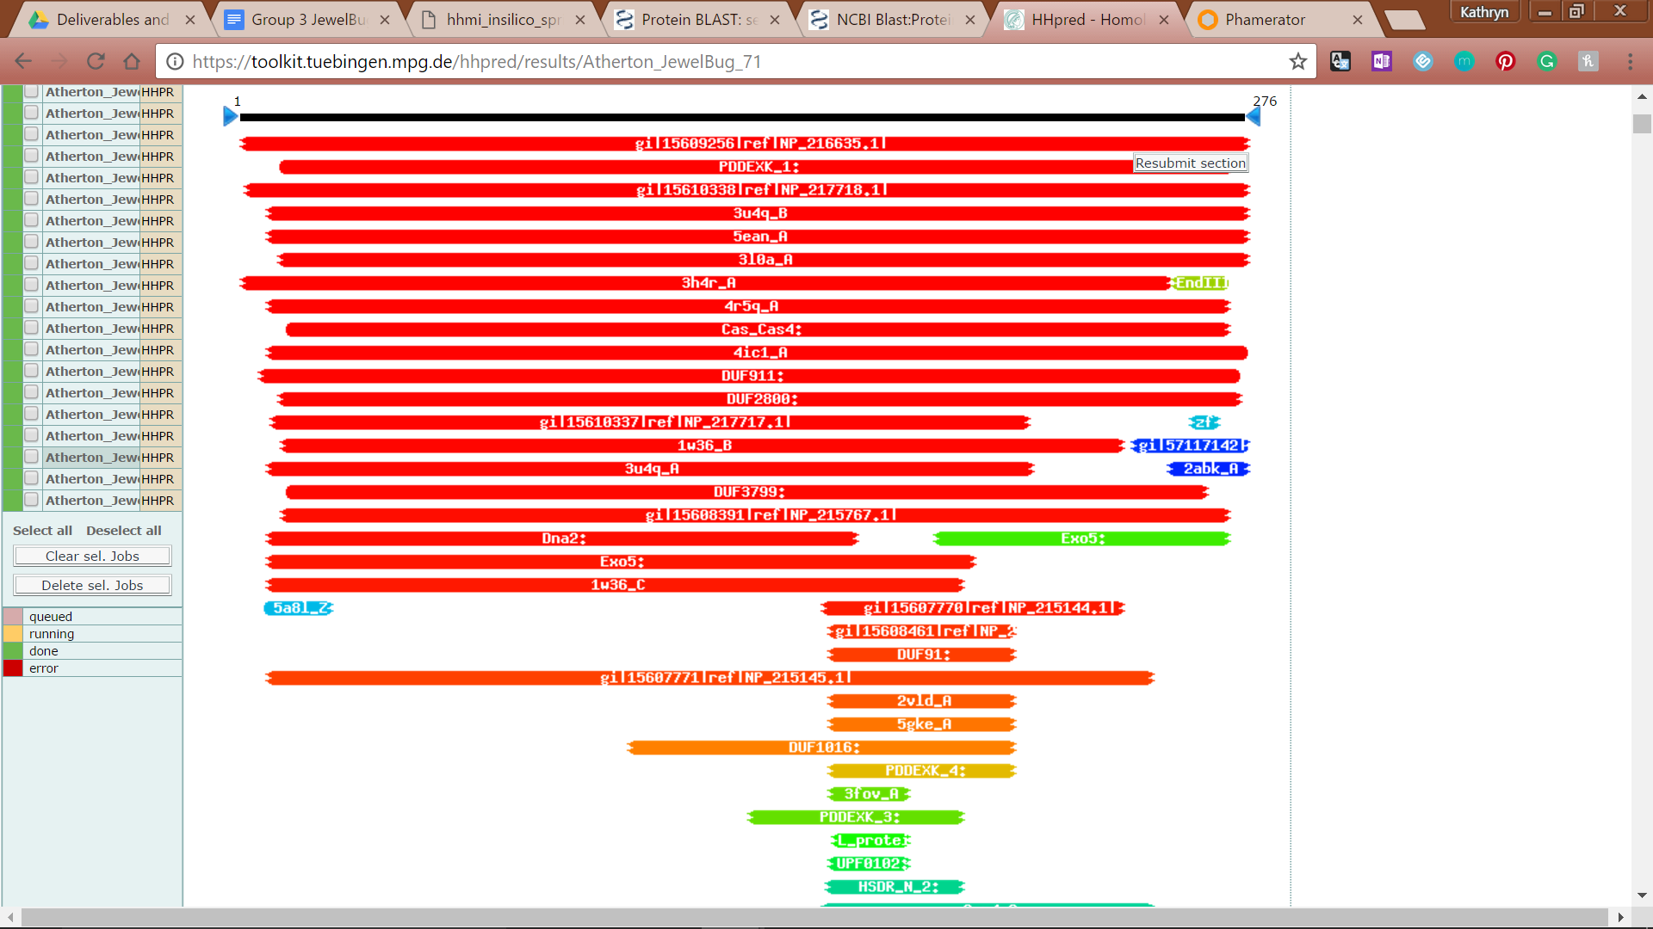

**Figure 70: Feature 71, HHPred Distribution List**

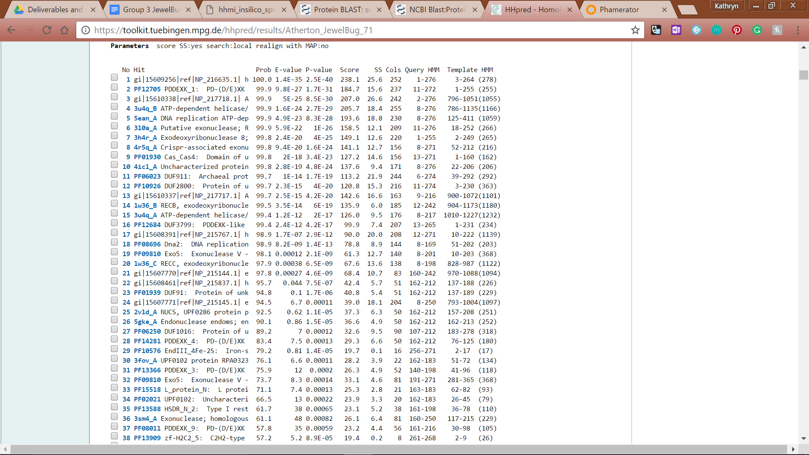

**Figure 71: HHPred Probabilities and Descriptions**

# 

# 

# Feature 72

**Table 6: Feature 72 Data**

|  |  |  |  |  |  |  |  |  |  |
| --- | --- | --- | --- | --- | --- | --- | --- | --- | --- |
| **Feature:** 72 | **3' End:** 43965 | **5' End:** 44366 | | | **Length:** 402 | | **Original Call:** | **Glimmer:** 44255 | |
| **GeneMark:** 44351 | |
| **Start / Stop Codon (SSC):** | | | | | | **Start:** TTG | | | |
| **Stop:** TGA; REV | | | |
| **Longest Open Reading Frame (LO):** 402 bp | | | | | | | | | Longest |
| **Shine Dalgarno (SD):** -2.100 / -3.702 | | | | | | | | | Highest |
| **Start Choice Source (SCS):** | | | | **Called by Glimmer:** Yes, 44255 | | | | | |
| **Called by GeneMark**: Yes, 44351 | | | | | |
| **Coding Potential (CP):** all covered and extending beyond | | | | | | | | | |
| **Gap / Overlap:** 33 bp overlap with feature 72.5 | | | | | | | | | |
| **BLASTp:** hypothetical protein PBI_MCFLY_78, BP1 aligns with BP1 | | | | | | | | | |
| **Function (F):** No Known Function | | | | | | | | | |
| **Function Source (FS):** | | | **Phamerator:** No noted functions from similar phages | | | | | | |
| **BLASTp:** gp75 from DaVinci (unknown function) | | | | | | |
| **HHPred:** No significant results found | | | | | | |
| **Comments:** The original start site (3’ end) was 44255, which had a final score of only -5.5 but a reasonable length of 291. The identity and similarity matches of the first two BLAST results were both 100%. To at3' End:t to lengthen the ORF and reduce the Final Score, a start site at 44288 with the codon GTG was explored. The identity of the top two matches were 99.07%, and the similarity was 100%. Since Glimmer called at 44351, that possibility was explored. The start codon at 44351 is GTG and the ORF is 387 bp. The BLAST data showed 99.22% similarity and identity for the top result. The second result, another hypothetical protein, had 100% similarity and 99.22% identity. Finally, we explored the start site at 44366, which has a start codon of TTG, which comprises only 7% of start codons in mycobacteriophage. The identity, similarity, and alignment of the top BLAST result is 100% and had a very high score of 699. | | | | | | | | | |

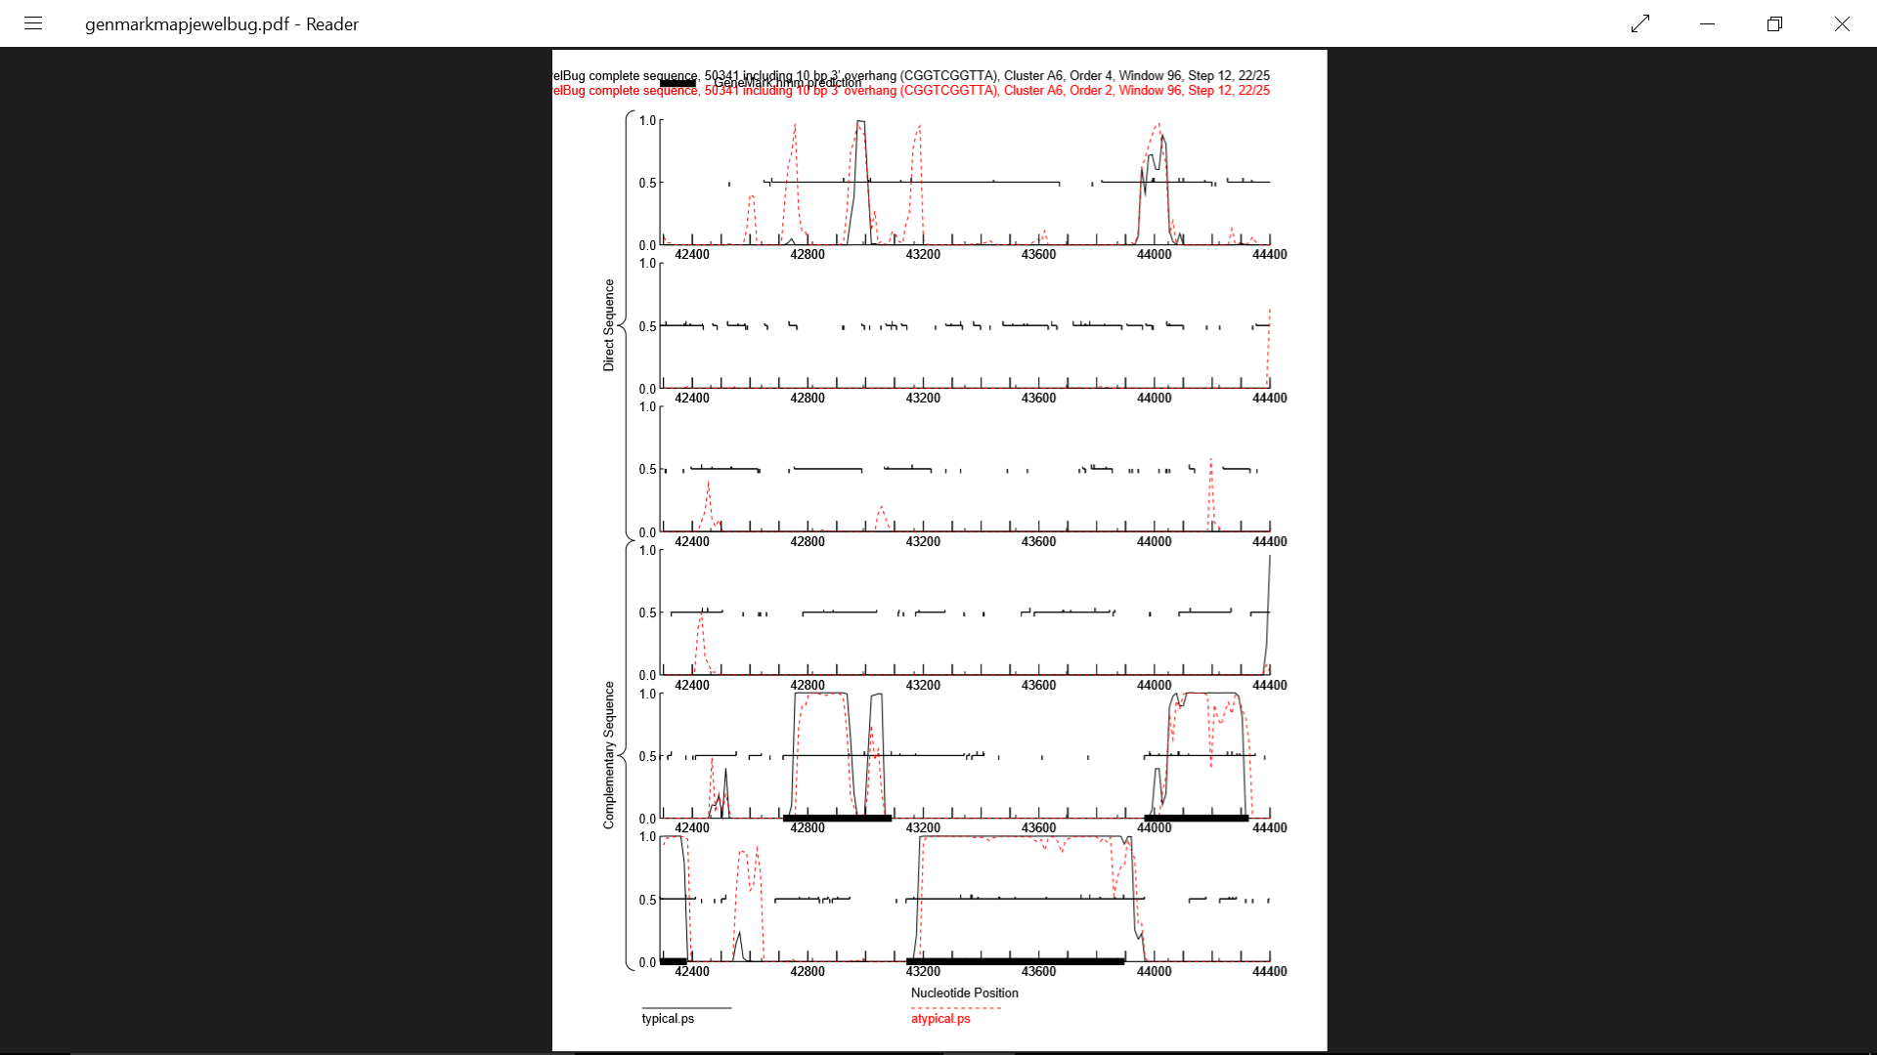

**Figure 72: Feature 72, GeneMark Map**

In the second line of complementary sequence, there is a high amount of coding potential. By calling the gene from 43965 to 44366, all of the coding potential is captured.

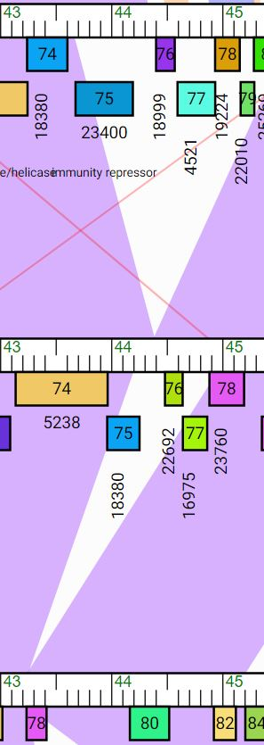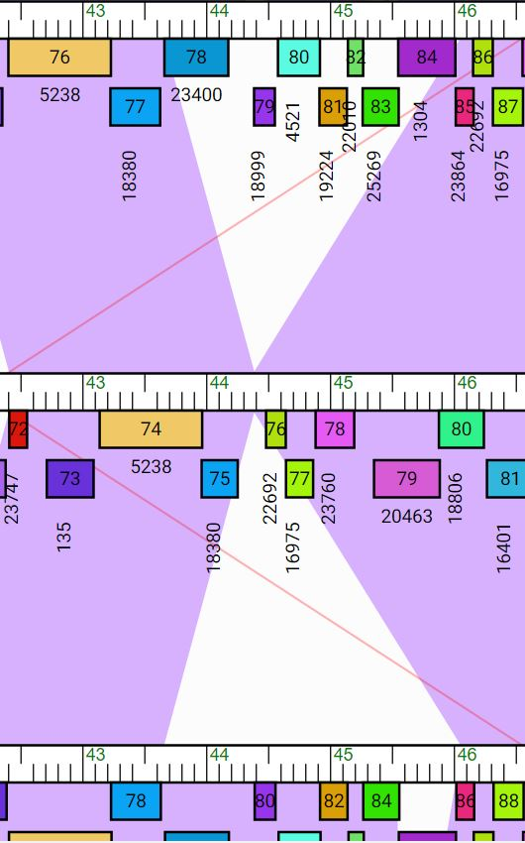

**Figure 73: Feature 72, JewelBug Phamerator Maps**

In the above images where JewelBug is being compared to 6 total phage, JewelBug is always in the middle. Gene 75 on JewelBug’s phamerator (cerulean-colored box) corresponds to Feature 72. With the white triangles in between the purple regions, five of these A6 phage demonstrate the possibility that part of JewelBug’s genome was lost although the part that remains is all at least 95% similar to these phage. The phage comparison in the center image on the bottom actually shows that Jeffabunny must have lost some of its genome in the region of JewelBug’s 75-77 genes on phamerator.

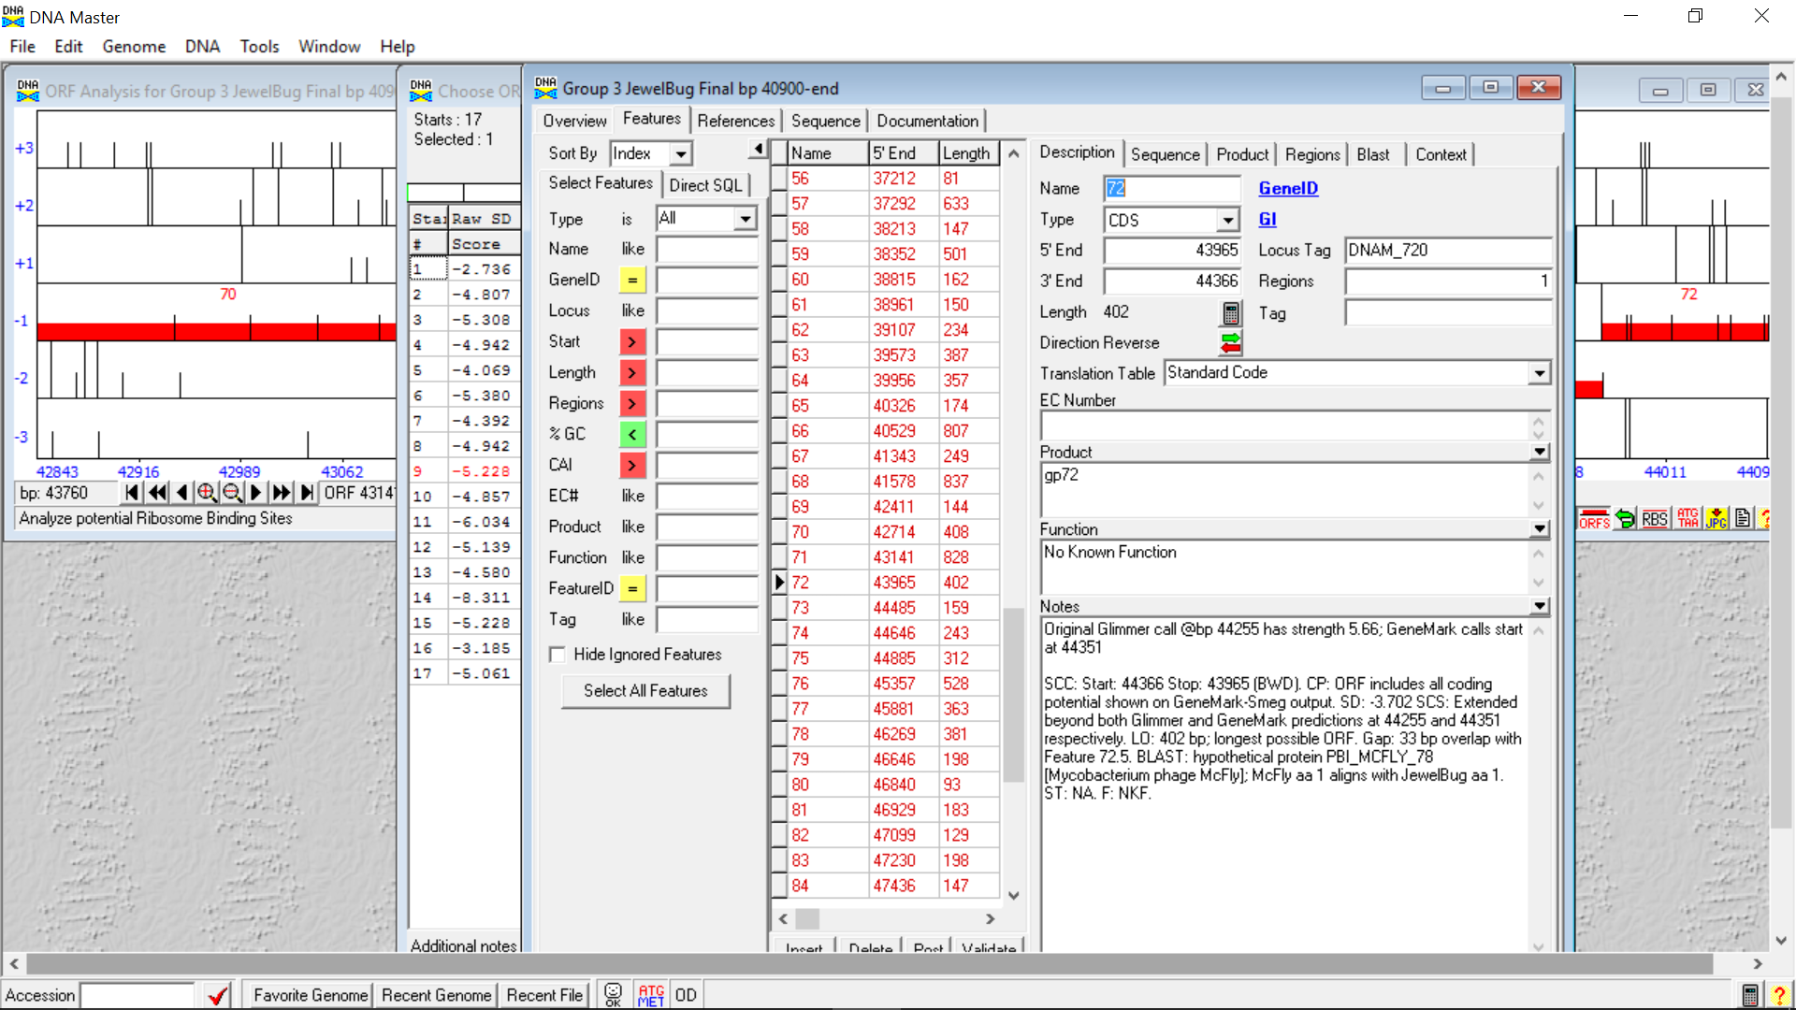

**Figure 74: Feature 72, Feature Window**

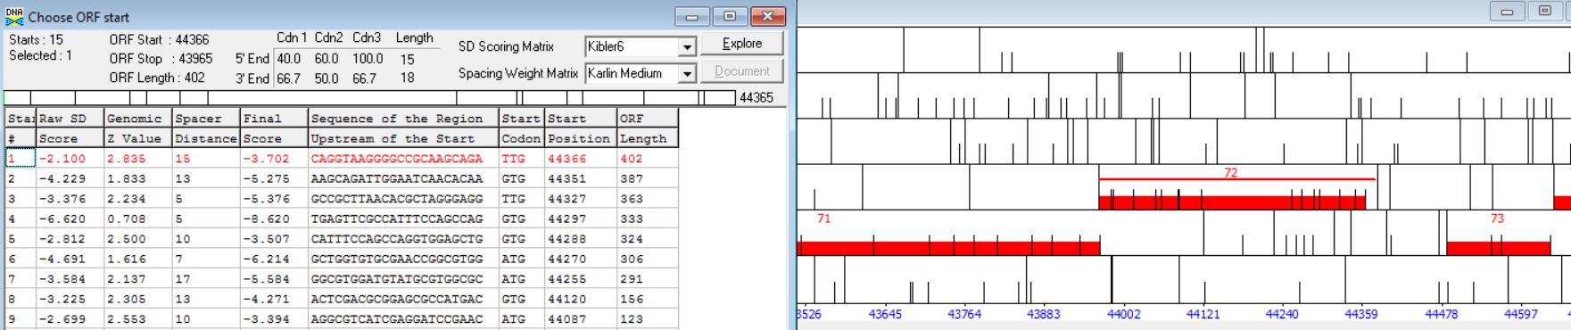

**Figure 75: Feature 72, Frame Window**



**Figure 76: Feature 72, Choose Start Window**

This open reading frame depicts a 3bp overlap with gene 71, and no overlap with gene 73 but rather a 119 bp gap. The red highlighted start site is the one we chose.

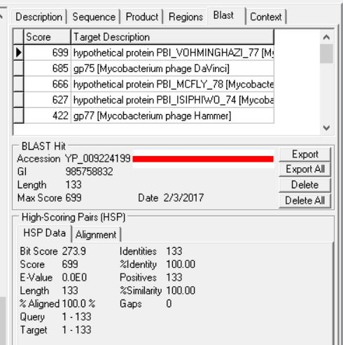

**Figure 77: Feature 72, HSP Data**

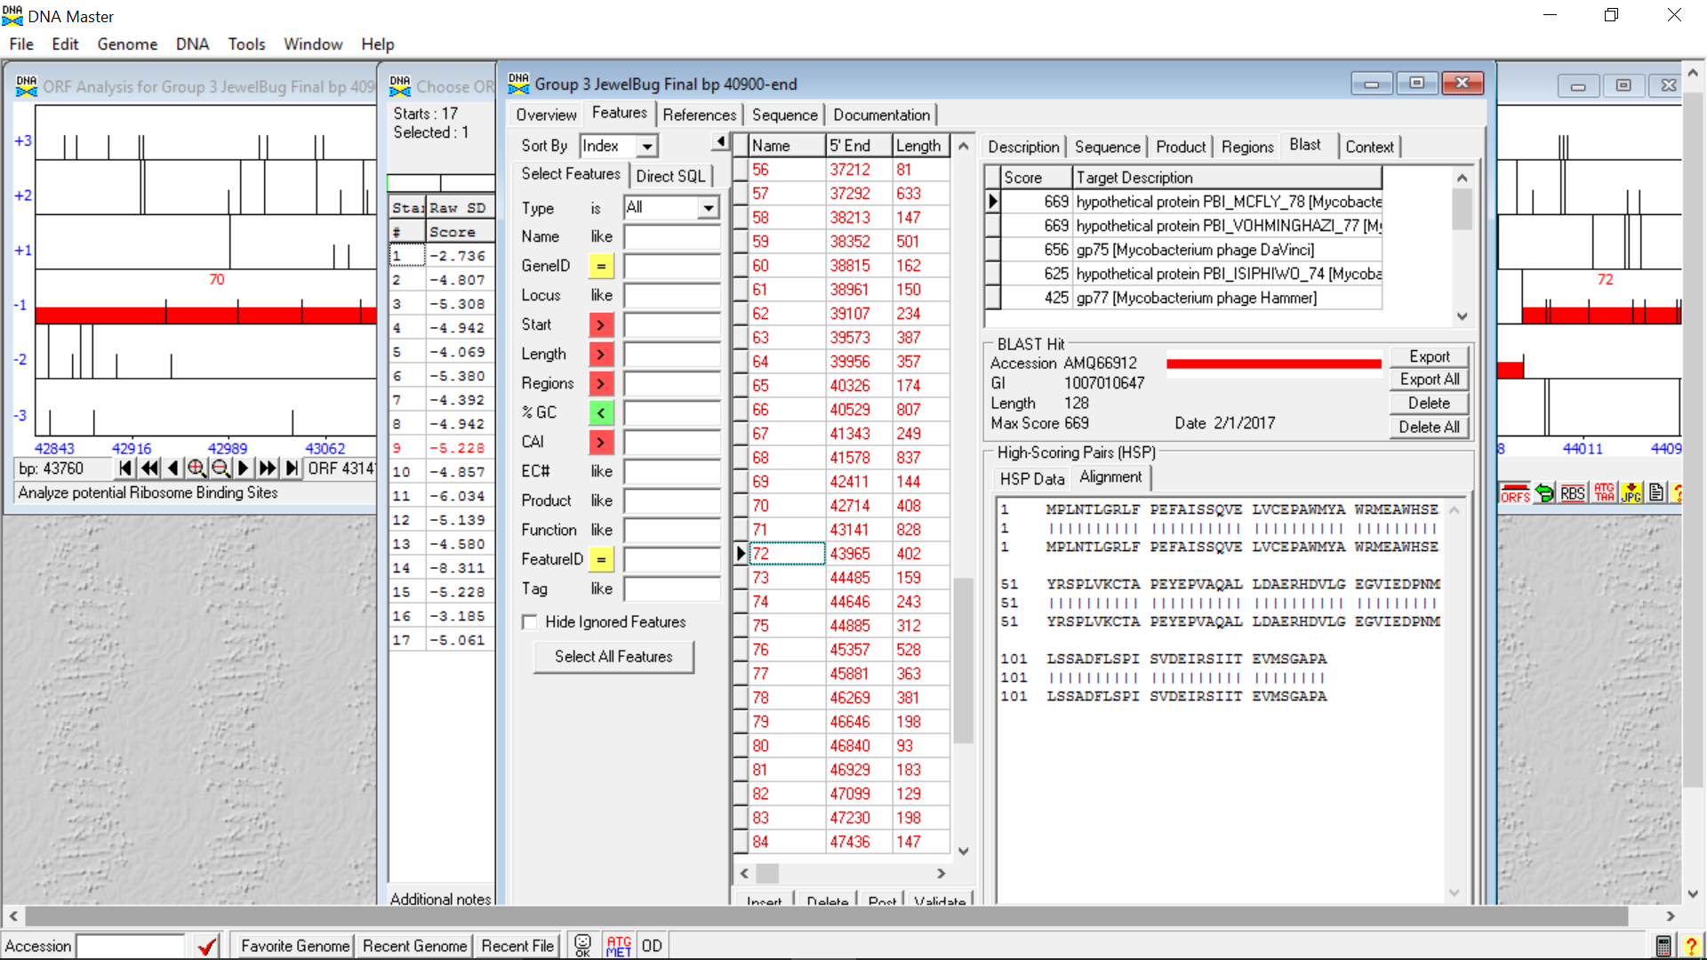

**Figure 78: Feature 72, Alignment**

Moving the start to 44366 allowed the top BLAST result, a hypothetical protein, to be 100% aligned, similar, and identical.



**Figure 79: Feature 72, Conserved Domain**

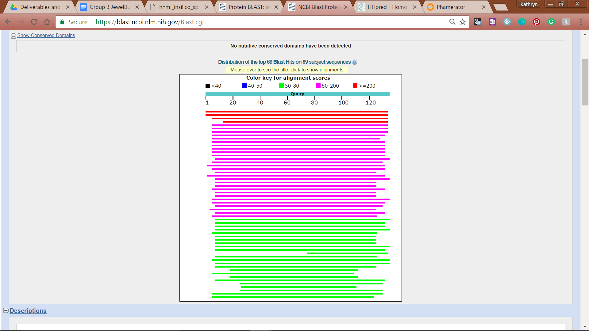

**Figure 80: Feature 72, BLASTp Hits Distribution Data**

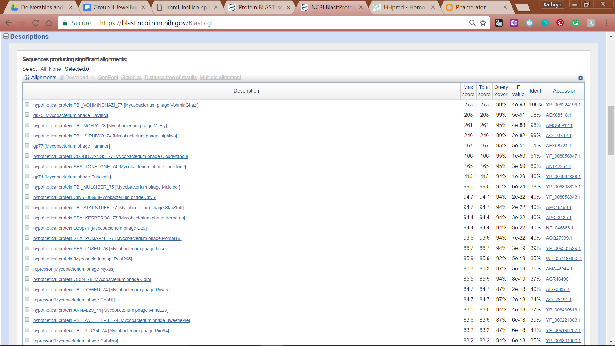

**Figure 81: Feature 72, BLASTp E-Values**

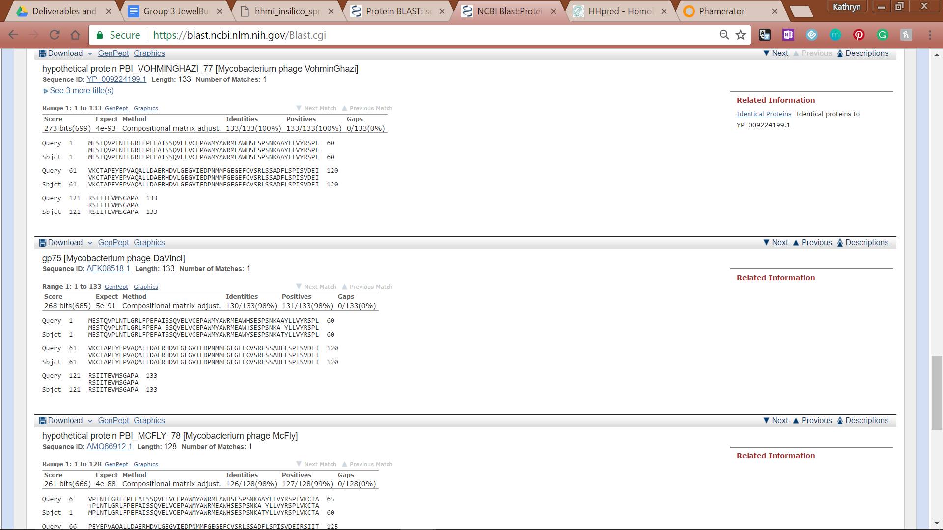

**Figure 82: Feature 72, BLASTp Alignments**

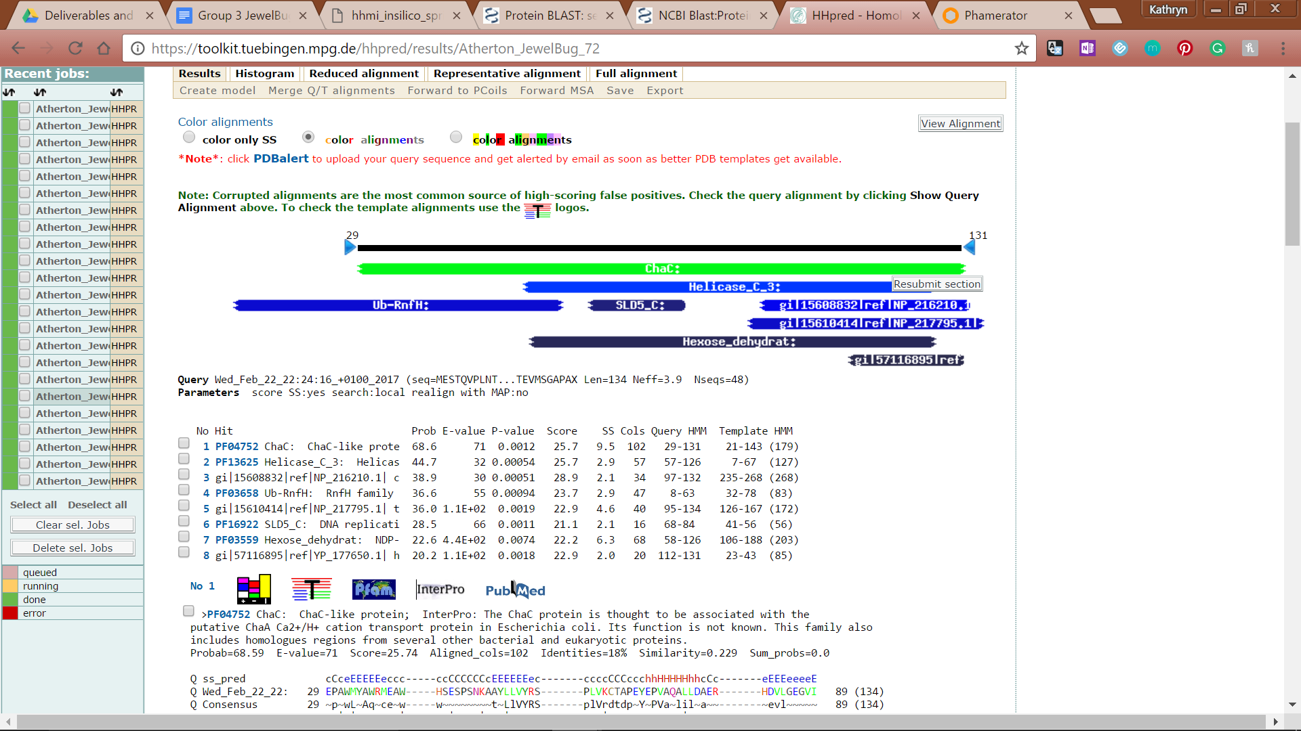

**Figure 83: Feature 72, HHPred Distribution List**



**Figure 84: Feature 72, HHPred Problems and Descriptions**

# 

# 

# Feature 72.5

**Table 7: Feature 72.5 Data**

|  |  |  |  |  |  |  |  |  |  |
| --- | --- | --- | --- | --- | --- | --- | --- | --- | --- |
| **Feature:** 72.5 | **3' End:** 44333 | **5' End:** 44488 | | | **Length:** 156 | | **Original Call:** | **Glimmer:** NA | |
| **GeneMark:** NA | |
| **Start / Stop Codon (SSC):** | | | | | | **Start:** GTG | | | |
| **Stop:** TAG; REV | | | |
| **Longest Open Reading Frame (LO):** 195 bp | | | | | | | | | Not Longest |
| **Shine Dalgarno (SD):** -4.543 / -5.318 | | | | | | | | | Not Highest |
| **Start Choice Source (SCS):** | | | | **Called by Glimmer:** No | | | | | |
| **Called by GeneMark**: No | | | | | |
| **Coding Potential (CP):** all covered | | | | | | | | | |
| **Gap / Overlap:** 3 bp overlap with feature 73 | | | | | | | | | |
| **BLASTp:** hypothetical protein PBI_VOHMINGHAZI_85, bp 1 aligns with bp 1 | | | | | | | | | |
| **Function (F):** No known function | | | | | | | | | |
| **Function Source (FS):** | | | **Phamerator:** Not predicted call in Phamerator | | | | | | |
| **BLASTp:** gp87 from Hammer (unknown function) | | | | | | |
| **HHPred:** no significant results found | | | | | | |
| **Comments:** This feature was inserted because there was coding potential in the open reading frame and there was over 100 bp gap between called features 72 and 73. | | | | | | | | | |

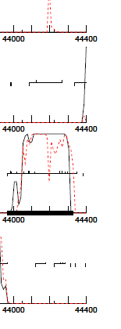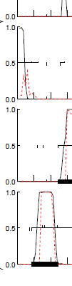

**Figure 85: Feature 72.5, GeneMark Map**

There is coding potential between features 72 and 73 which in inserting feature 72.5, the coding potential is all captured and the large gap between these features eliminated.

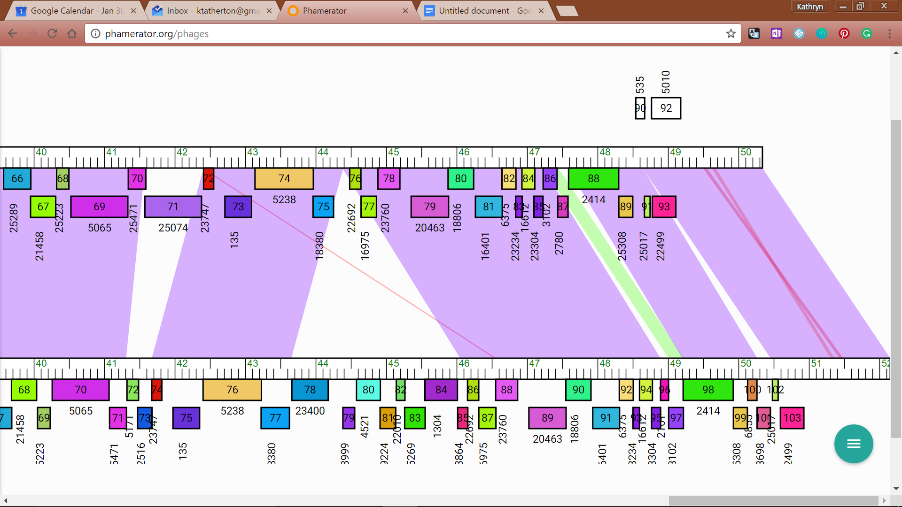

**Figure 86: Feature 72.5, JewelBug vs. VohminGhazi Phamerator Map**

Phamerator Map shows feature 72 of JewelBug matches with feature 85 of VohminGhazi.

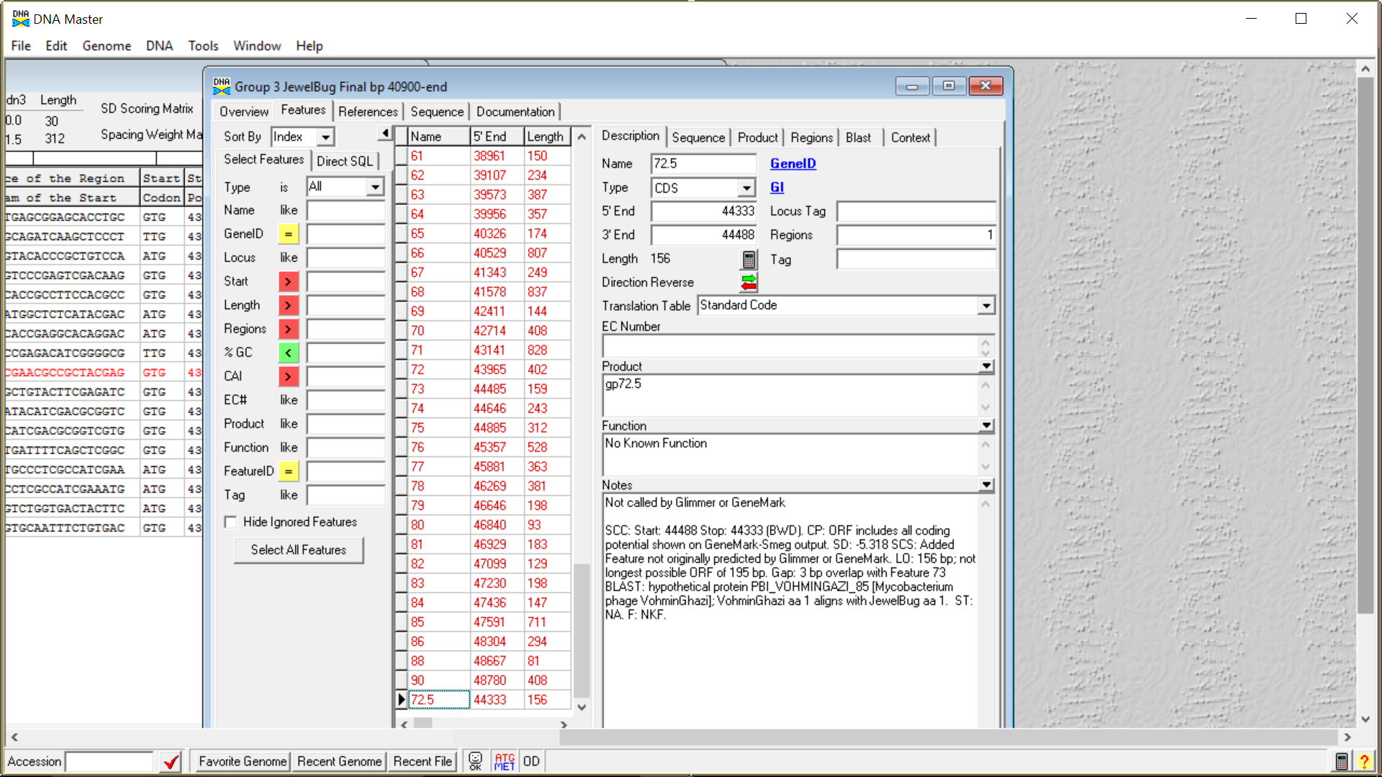

**Figure 87: Feature 72.5, Feature Window**

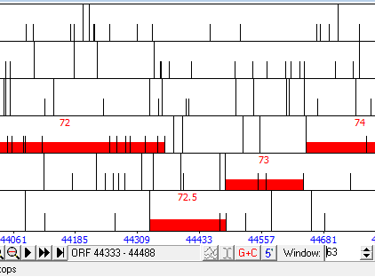

**Figure 88: Feature 72.5, Frame Window**

Adding feature 72.5 eliminates the large gap between features 72 and 73, instead there is a 33 bp overlap with feature 72 and a 3 bp overlap with feature 73.

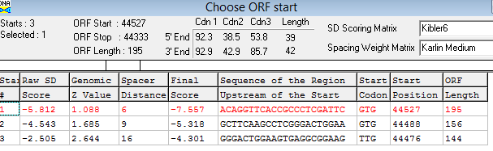

**Figure 89: Feature 72.5, Choose Start Window**

Start site 2 was chosen because it was the longest ORF that would not cause a significant overlap with surrounding features.

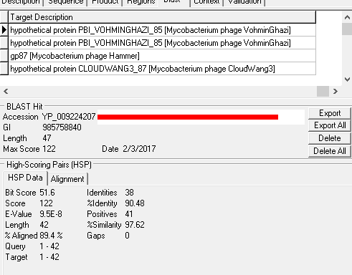

**Figure 90: Feature 72.5, HSP Data**

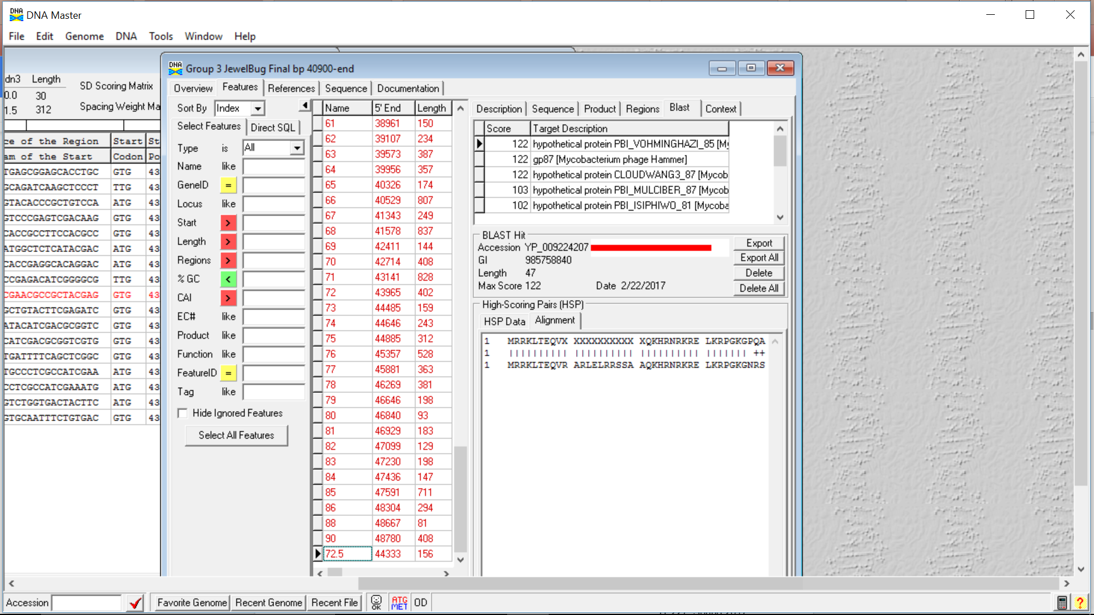

**Figure 91: Feature 72.5, Alignment**

BLAST results show over 90% identity and similarity to hypothetical protein VohminGhazi.



**Figure 92: Feature 72.5, Conserved Domain**

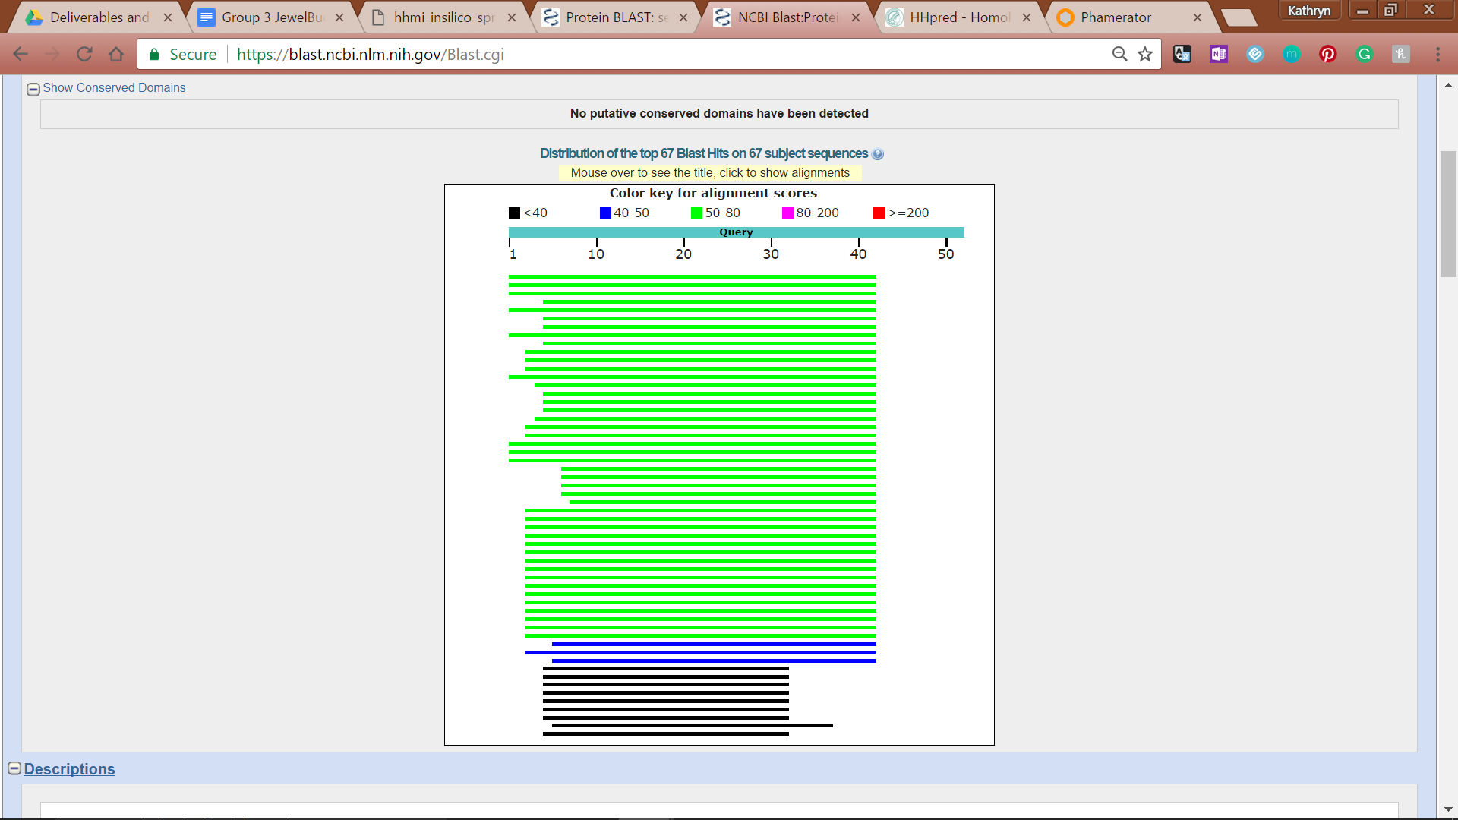

**Figure 93: Feature 72.5, BLASTp Hits Distribution Table**

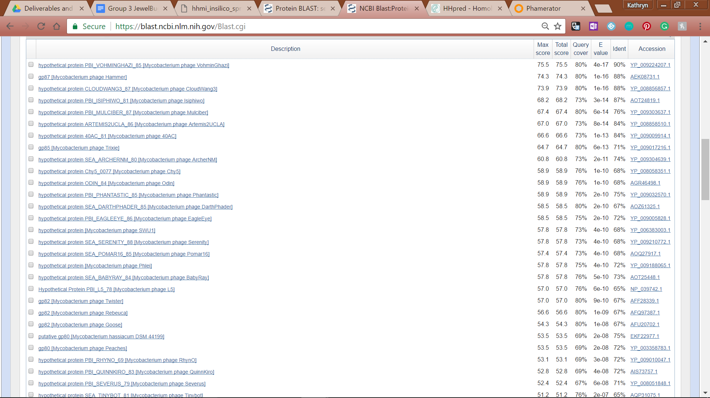

**Figure 94: Feature 72.5, BLASTp E-Values**

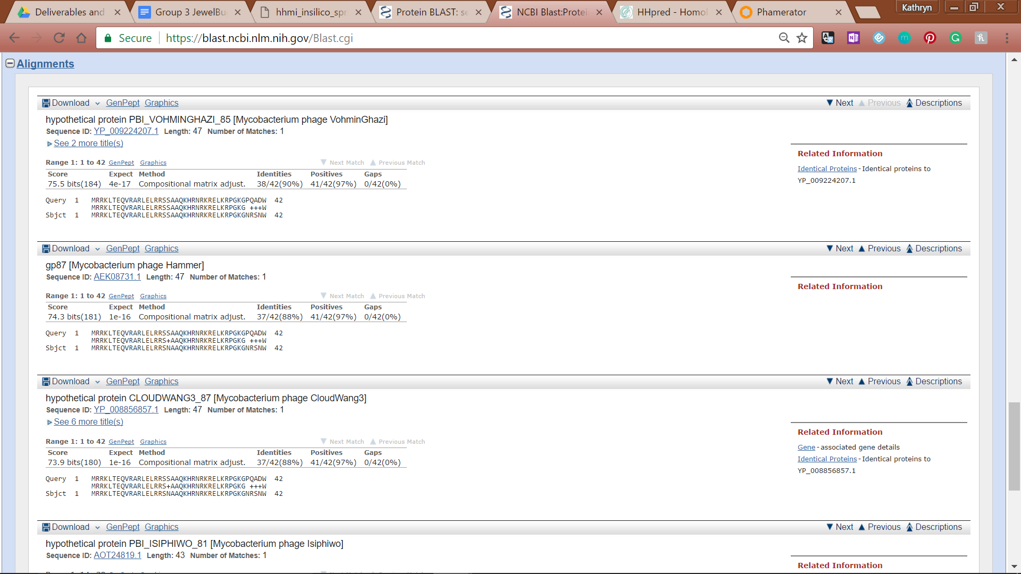

**Figure 95: Feature 72.5, BLASTp Alignments**

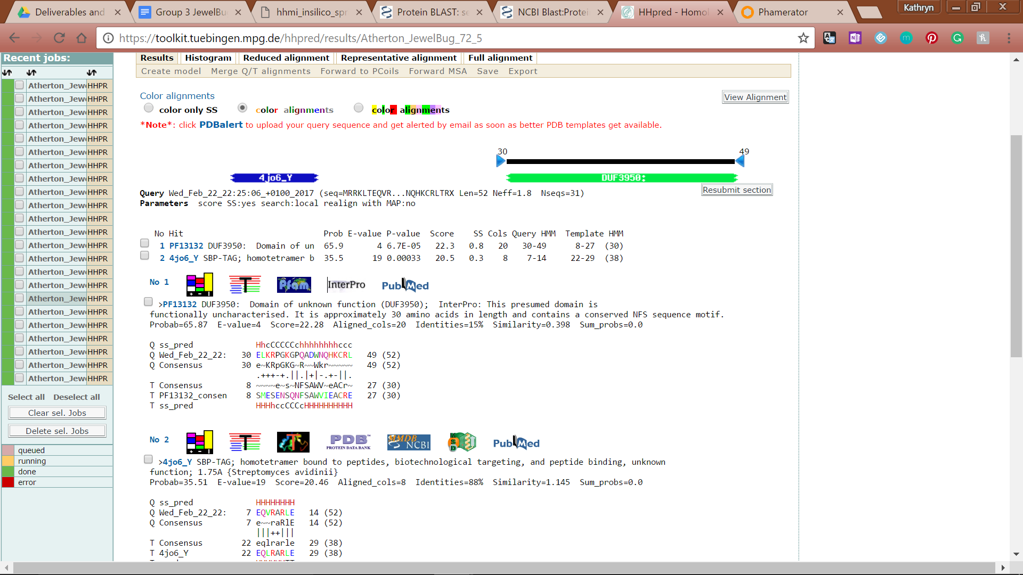

**Figure 96: Feature 72.5, HHPred Distribution List**



**Figure 97: Feature 72.5, HHPred Probabilities and Descriptions**

# Feature 73

**Table 8: Feature 73 Data**

|  |  |  |  |  |  |  |  |  |  |
| --- | --- | --- | --- | --- | --- | --- | --- | --- | --- |
| **Feature:** 73 | **3' End:** 44485 | **5' End:** 44643 | | | **Length:** 159 | | **Original Call:** | **Glimmer:** 44643 | |
| **GeneMark:** 44643 | |
| **Start / Stop Codon (SSC):** | | | | | | **Start:** ATG | | | |
| **Stop:** TGA; REV | | | |
| **Longest Open Reading Frame (LO):** 360 bp | | | | | | | | | Not Longest |
| **Shine Dalgarno (SD):** -3.178 / -4/701 | | | | | | | | | Highest |
| **Start Choice Source (SCS):** | | | | **Called by Glimmer:** Yes, 44643 | | | | | |
| **Called by GeneMark**: Yes, 44643 | | | | | |
| **Coding Potential (CP):** all covered | | | | | | | | | |
| **Gap / Overlap:** 3 bp gap following gene | | | | | | | | | |
| **BLASTp:** hypothetical protein CLOUDWANG3_88, bp 1 aligns with bp 1 | | | | | | | | | |
| **Function (F):** No Known Function | | | | | | | | | |
| **Function Source (FS):** | | | **Phamerator:** No function found in similar genomes | | | | | | |
| **BLASTp:** gp84 from DaVinci (unknown function) | | | | | | |
| **HHPred:** No significant results found | | | | | | |
| **Comments:** | | | | | | | | | |

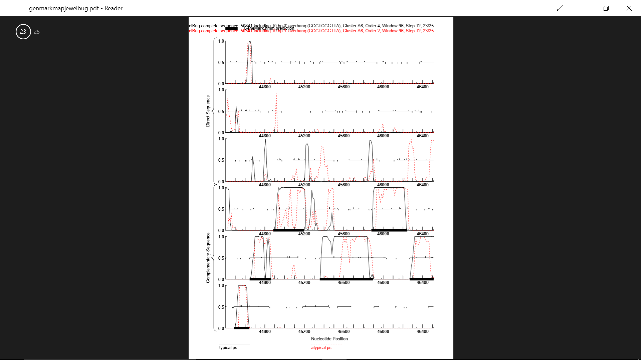

**Figure 98: Feature 73, GeneMark Map**

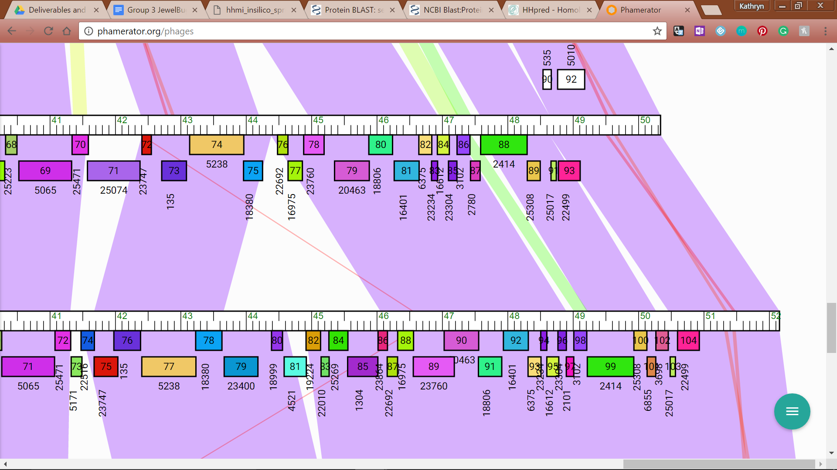

**Figure 99: Feature 73, JewelBug vs. Kazan Phamerator Map**

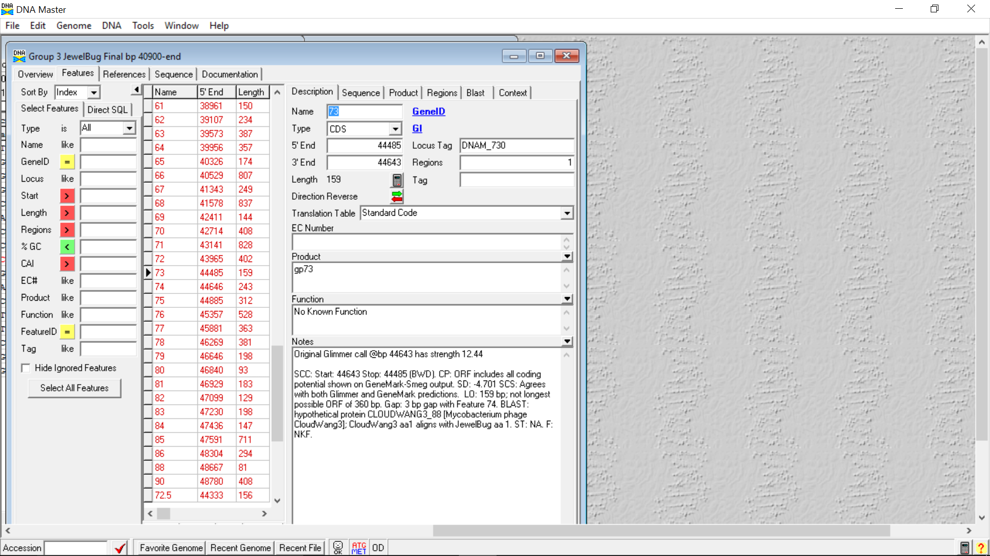

**Figure 100: Feature 73, Feature Window**

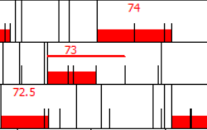

**Figure 101: Feature 73, Frame Window**

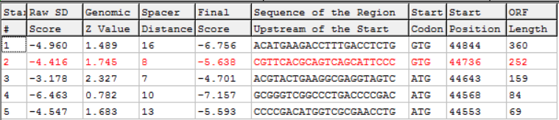

**Figure 102: Feature 73, Choose Start Window**

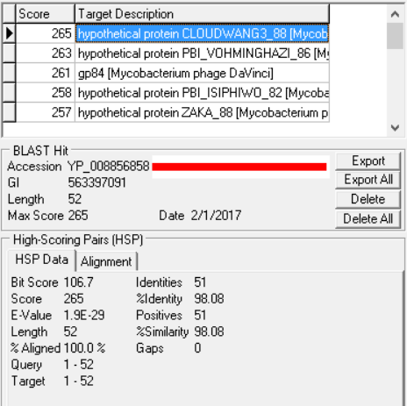

**Figure 103: Feature 73, HSP Data**

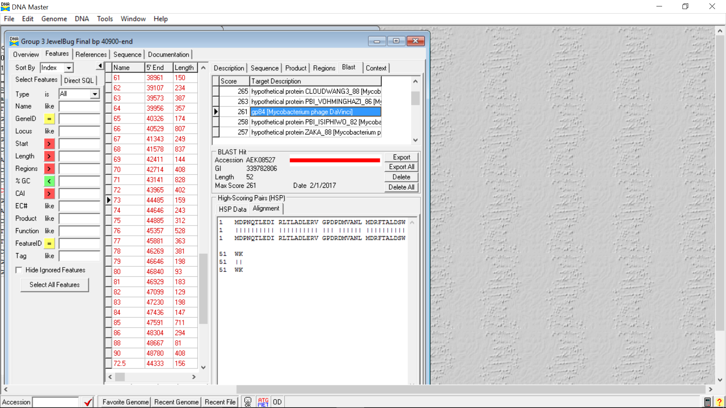

**Figure 104: Feature 73, Alignment**



**Figure 105: Feature 73, Conserved Domain**

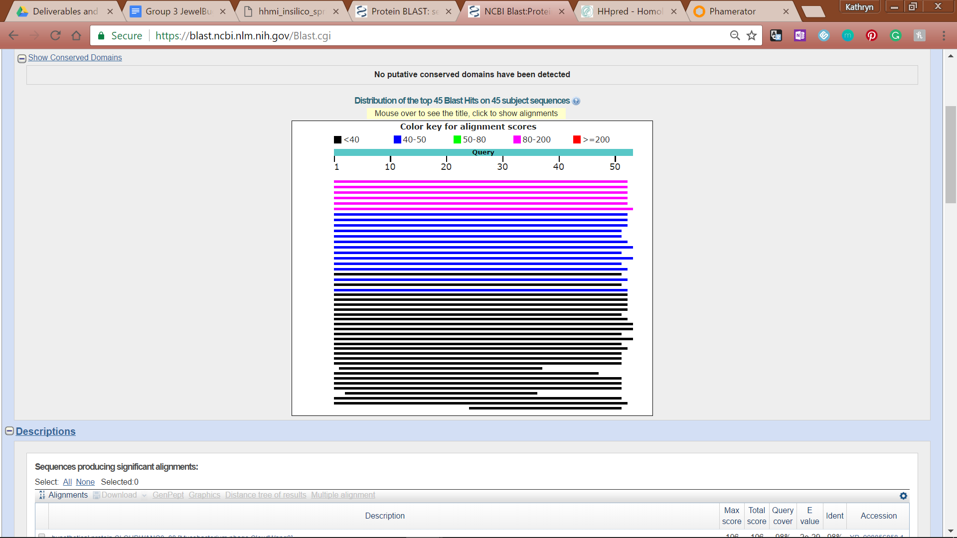

**Figure 106, Feature 73, BLASTp Hits Distribution Table**

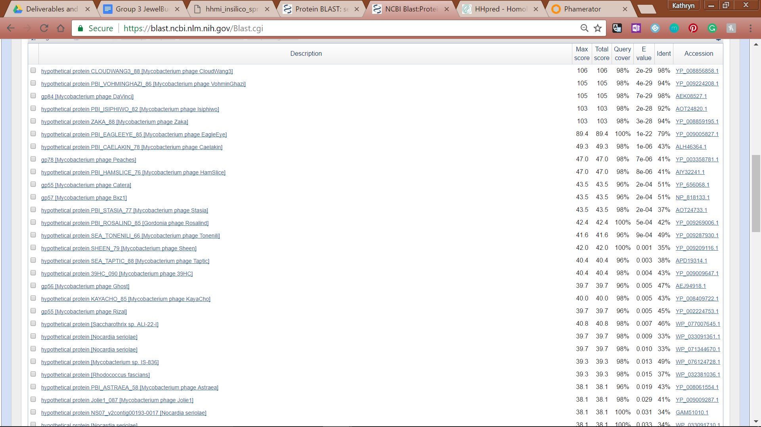

**Figure 107: Feature 73, BLASTp E-Values**

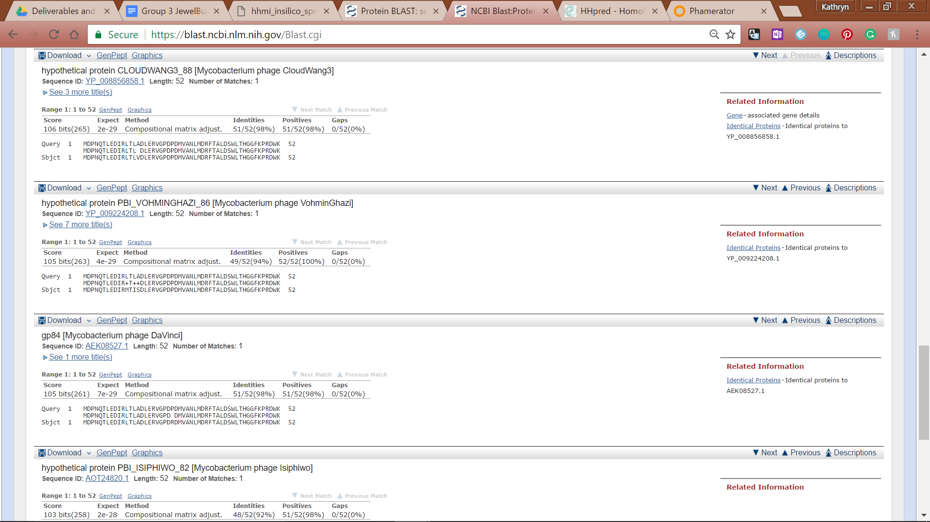

**Figure 108: Feature 73, BLASTp Alignments**

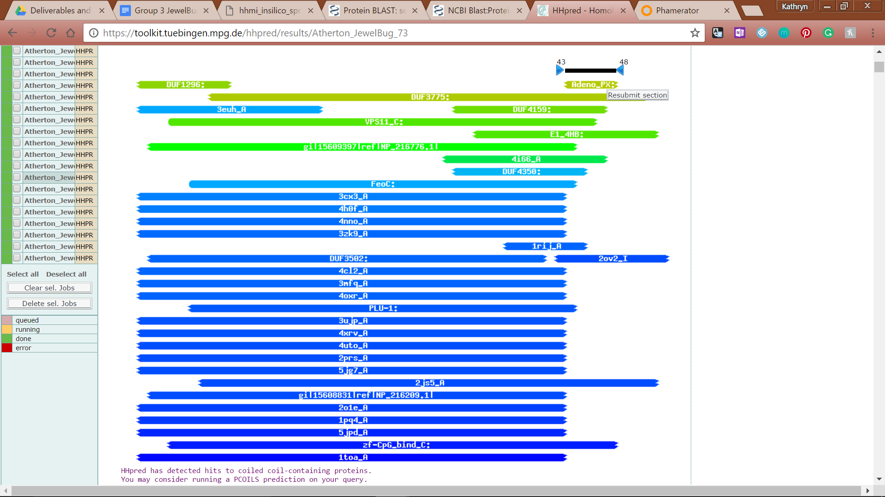

**Feature 109: Feature 73, HHPred Distribution List**

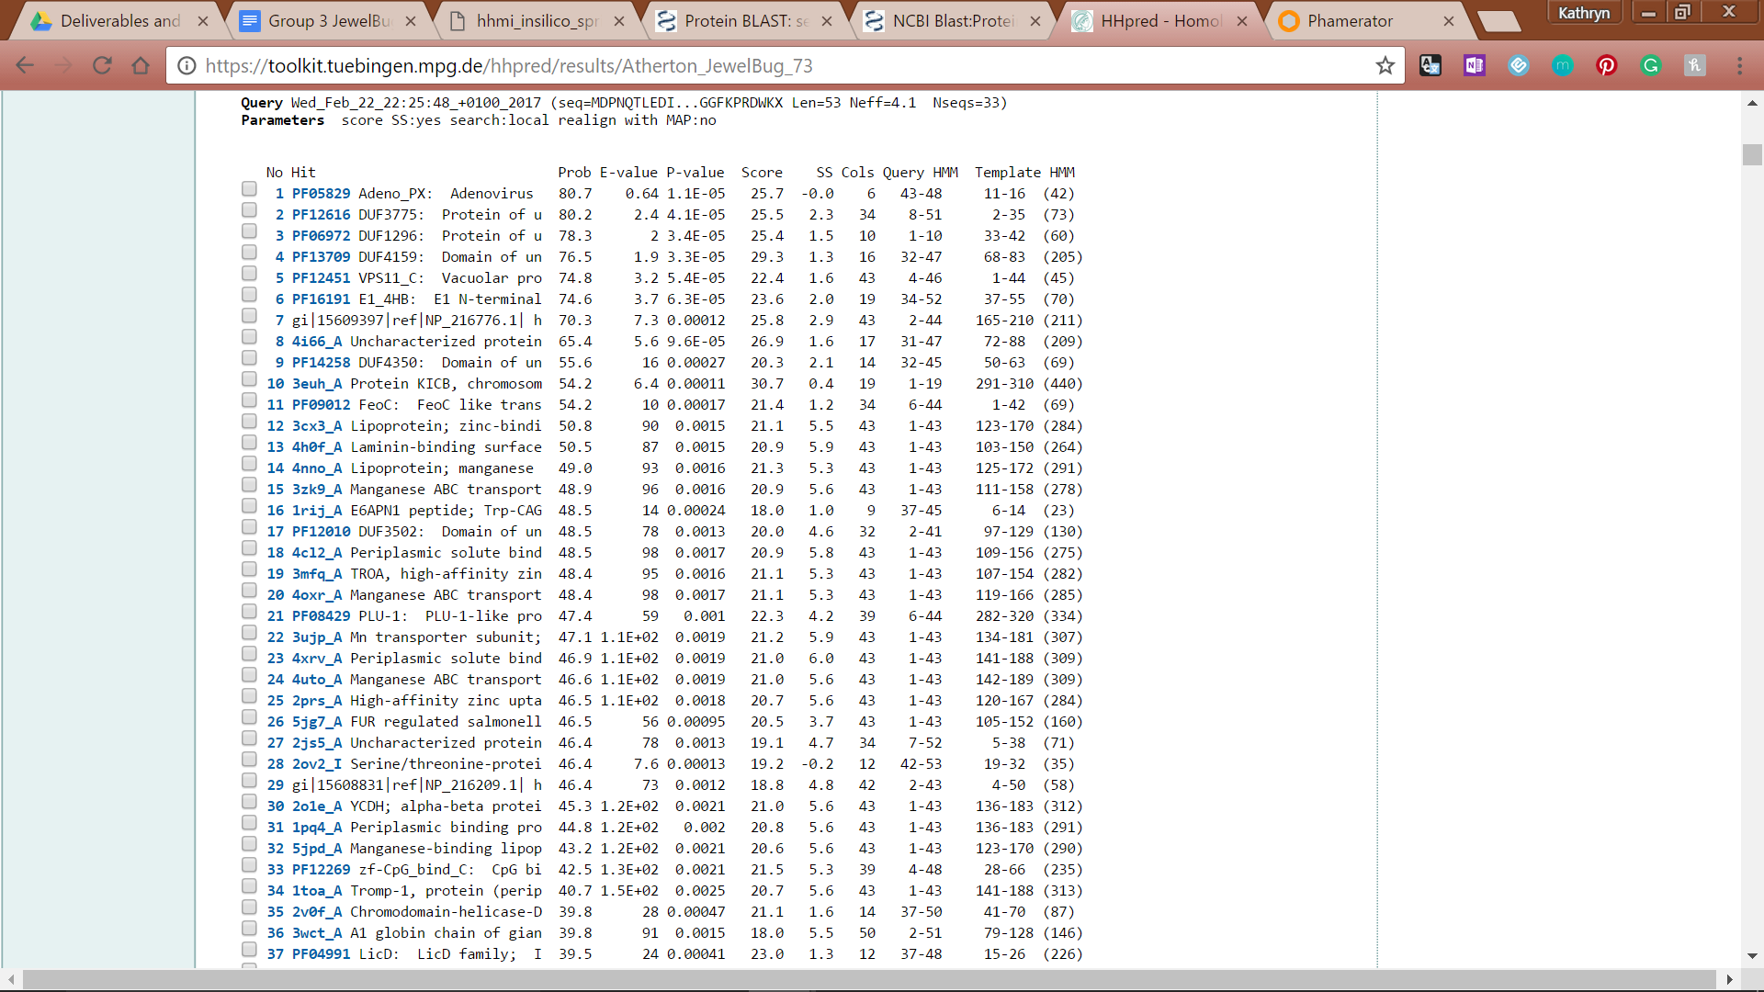

**Figure 110: Feature 73, HHPred Probabilities and Descriptions**

# Feature 74

**Table 9: Feature 74 Data**

|  |  |  |  |  |  |  |  |  |  |
| --- | --- | --- | --- | --- | --- | --- | --- | --- | --- |
| **Feature:** 74 | **3' End:** 44646 | **5' End:** 44888 | | | **Length:** 243 | | **Original Call:** | **Glimmer:** 44864 | |
| **GeneMark:** 44864 | |
| **Start / Stop Codon (SSC):** | | | | | | **Start:** TTG | | | |
| **Stop:** TAG; REV | | | |
| **Longest Open Reading Frame (LO):** 492 bp | | | | | | | | | Not Longest |
| **Shine Dalgarno (SD):** -2.994 / -4.739 | | | | | | | | | Not Highest |
| **Start Choice Source (SCS):** | | | | **Called by Glimmer:** Yes, 44864 | | | | | |
| **Called by GeneMark**: Yes, 44864 | | | | | |
| **Coding Potential (CP):** all covered | | | | | | | | | |
| **Gap / Overlap:** 3 bp overlap with feature 75 | | | | | | | | | |
| **BLASTp:** gp90 [Mycobacterium phage Blue7], bp 1 aligns with bp 27 | | | | | | | | | |
| **Function (F):** No Function Found | | | | | | | | | |
| **Function Source (FS):** | | | **Phamerator:** no noted functions in similar phages | | | | | | |
| **BLASTp:** gp90 from Blue7 (unknown function) | | | | | | |
| **HHPred:** No significant results found | | | | | | |
| **Comments:** Start moved from the original call at 44864 (start 5) to 44888 (start 4). This lowers the SD score and utilizes a TTG start codon. However, start 4 lengthens the gene, increases alignment while maintaining similarity, and also fully captures coding potential. | | | | | | | | | |

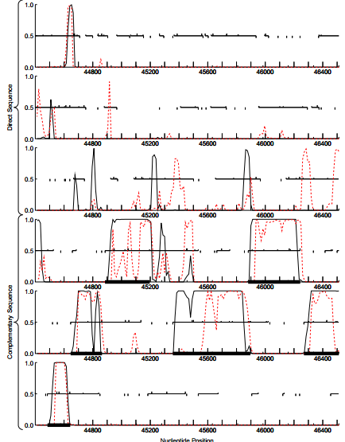

**Figure 111: Feature 74, GeneMark Map**

All the coding potential is captured by start 5 as well as start 4. Start 6 would significantly cut off coding potential by about 100 bp, and start 3 would encroach into feature 75 and extend beyond the coding potential by over 100 bp. As such start 3 and 6 are not considered.

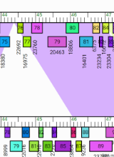

**Figure 112: Feature 74, JewelBug vs. Artemis2UCLA Phamerator Map**

Gene 77 on the Phamerator draft of JewelBug (equivalent to Feature 74), when compared to the rest of the non-draft genomes in A6, scored well (colored purple) for similarity with all of genomes except that of phage Jeffabunny (section colored white), making 14 / 15 significant matches.

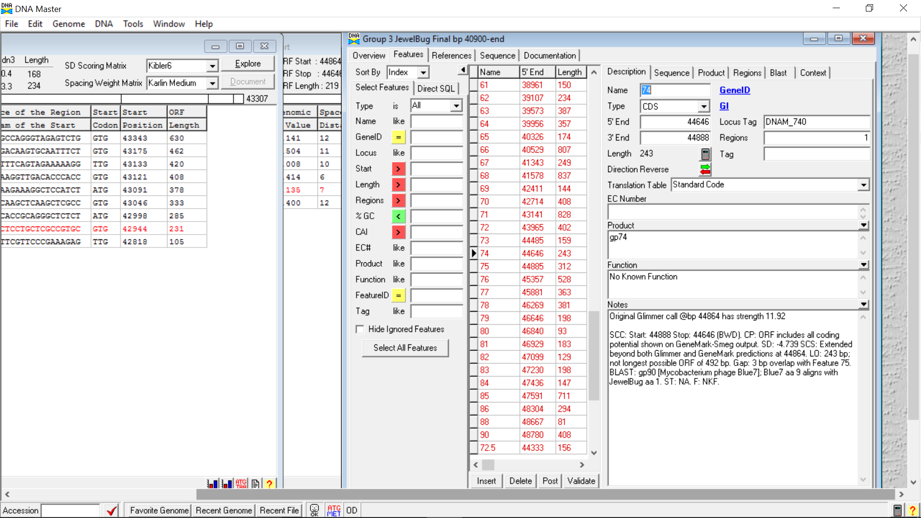

**Figure 113: Feature 74, Feature Window**

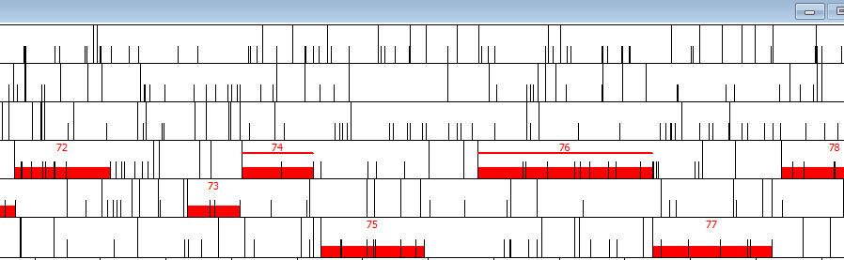

**Figure 114: Feature 74, Frame Window**

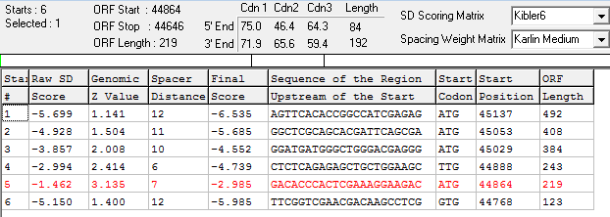

**Figure 115: Feature 74, Choose Start Window**

Start 5 is originally called by GeneMark and Glimmer. However, expanding to start 4 does not over encroach on feature 75 (overlap of 3 bp). Even though the start is TTG and the SD score is lower for start 4 then start 5, the increased alignment as well as increased similarity combined with the principle of increasing gene density supports moving the start site to start 4 at 44888.

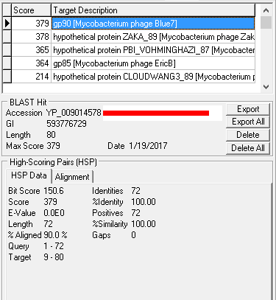

**Figure 116: Feature 74, HSP Data at Original Call**

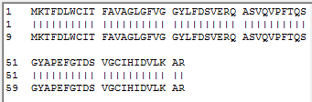

**Figure 117: Feature 74, Alignment at Original Call**

Blast of original call at start five 44864. The most similar protein is gp90[Mycobacterium phage Blue7]. Alignment is only 90.0% but similarity is 100.0% suggesting that lengthening the gene would be worth investigating.

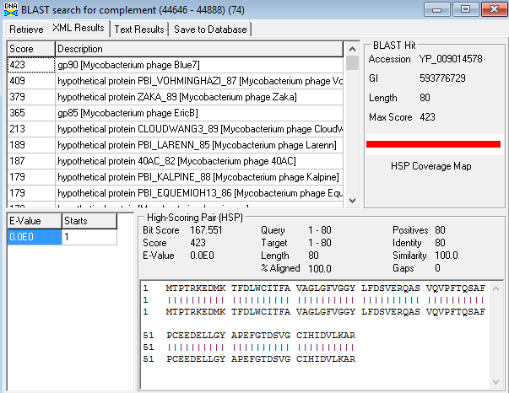

**Figure 118: Feature 74, HSP Data and Alignment at Fourth Call**

Comparing to gp90 [Mycobacterium phage Blue7] as well. Alignment is improved to 100.0% while maintaining 100.0% similarity. The score is also improved from 379 to 423. This suggests that start site 4 is more accurate than start site 5.



**Figure 119: Feature 74, Conserved Domain**

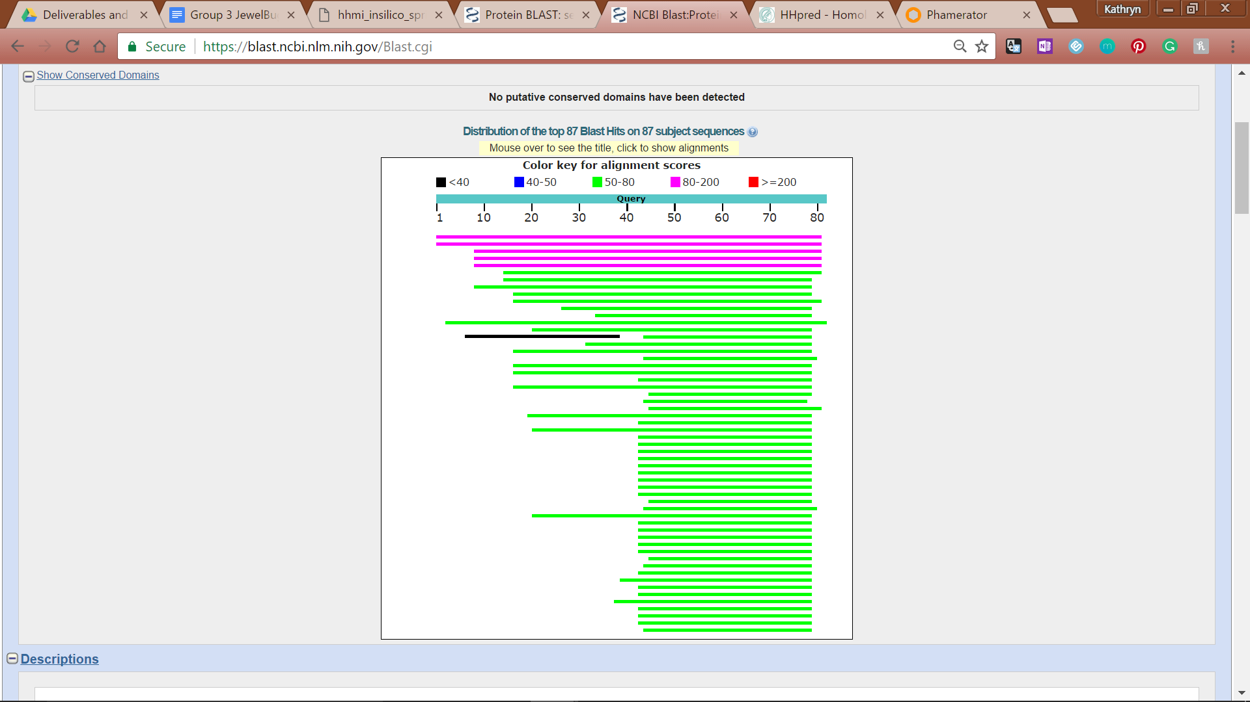

**Figure 120: Feature 74, BLASTp Distribution Table**

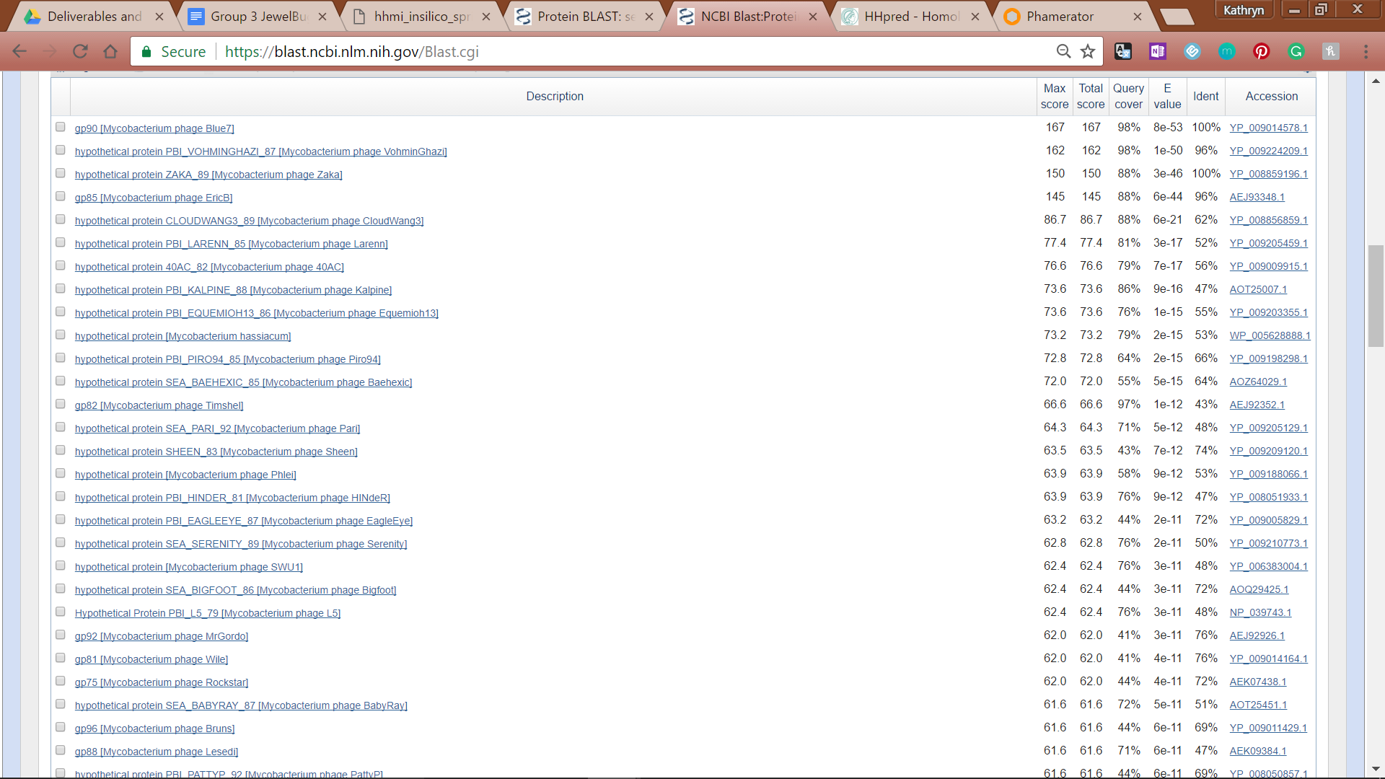

**Figure 121: Feature 74, BLASTp E-Values**

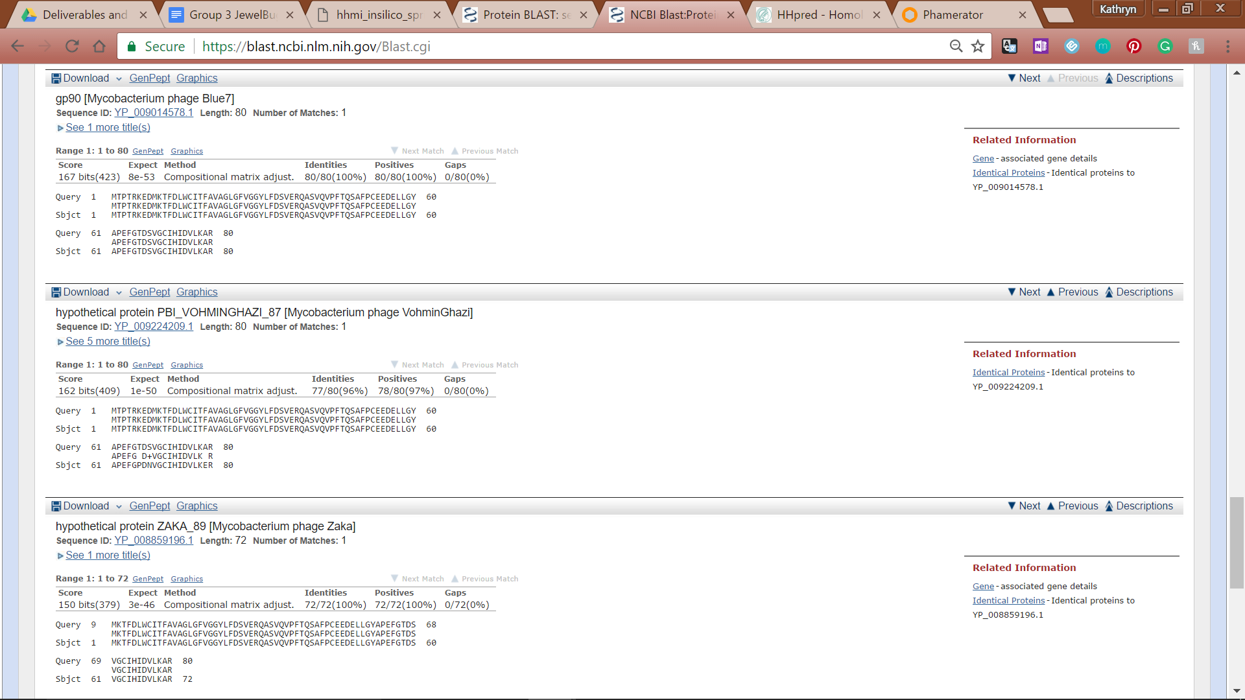

**Figure 122: Feature 74, BLASTp Alignments**

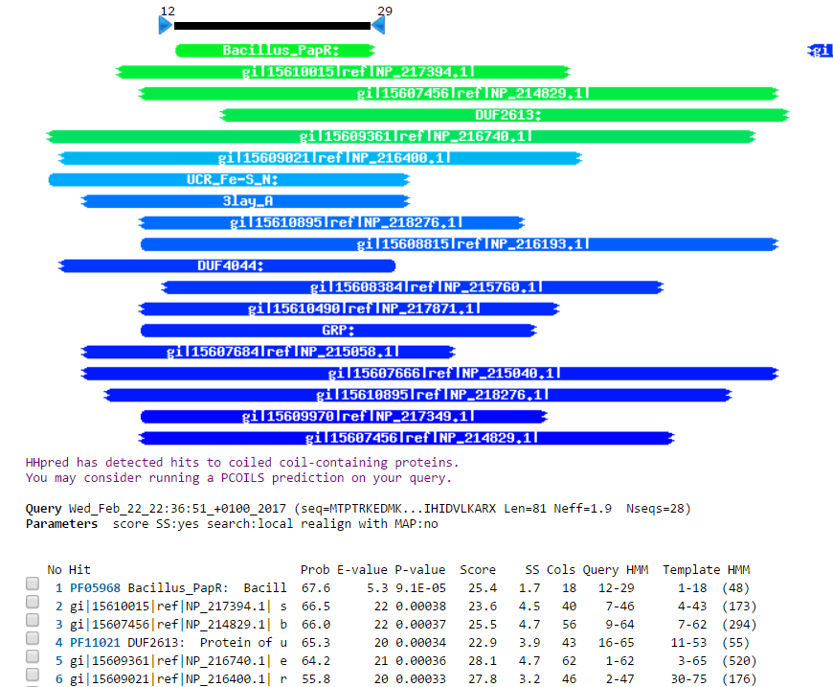

**Figure 123: Feature 74, HHPred Distribution List**



**Figure 124: Feature 74, HHPred Probabilities and Descriptions**

# Feature 75

**Table 10: Feature 75 Data**

|  |  |  |  |  |  |  |  |  |  |
| --- | --- | --- | --- | --- | --- | --- | --- | --- | --- |
| **Feature:** 75 | **3' End:** 44885 | **5' End:** 45535 | | | **Length:** 651 | | **Original Call:** | **Glimmer:** 45196 | |
| **GeneMark:** 45196 | |
| **Start / Stop Codon (SSC):** | | | | | | **Start:** GTG | | | |
| **Stop:** TGA; REV | | | |
| **Longest Open Reading Frame (LO):** 651 bp | | | | | | | | | Longest |
| **Shine Dalgarno (SD):** -2.590 / -3.121 | | | | | | | | | 2nd Highest |
| **Start Choice Source (SCS):** | | | | **Called by Glimmer:** Yes, 45196 | | | | | |
| **Called by GeneMark**: Yes, 45196 | | | | | |
| **Coding Potential (CP):** all covered | | | | | | | | | |
| **Gap / Overlap:** 178 bp overlap with feature 76 | | | | | | | | | |
| **BLASTp:** DNA methylase | | | | | | | | | |
| **Function (F):** DNA Methylase | | | | | | | | | |
| **Function Source (FS):** | | | **Phamerator:** DNA Methylase | | | | | | |
| **BLASTp:** DNA Methylase | | | | | | |
| **HHPred:** no significant functions found | | | | | | |
| **Comments:** The original start site at 45196 is where Glimmer and GeneMark both called. The top BLAST result had 99.03% identity and similarity with 100% alignment. The ORF was only 312bp. Start sites of 45511 (the lowest final score and second longest ORF) and 45535 (the second lowest ORF and longest ORF) were explored to lengthen the ORF and therefore close the gap between features 75 and 76. Start site 45535 with a start codon of GTG showed 100% alignment, identity, and similarity to DNA methylase, so 45535 was chosen as the start site until we looked at its overlap with gene 76. The guiding principles state that the maximum overlap allowed is around 30bp, and the start site at 45535 had a 178bp overlap with feature 76. The start site for feature 75 was returned to the programs’ original guess at 45196.  ***After another revision, we decided to make 45535 the start site since many other phage in Phamerator had been confirmed as having a gene with a long overlap. | | | | | | | | | |

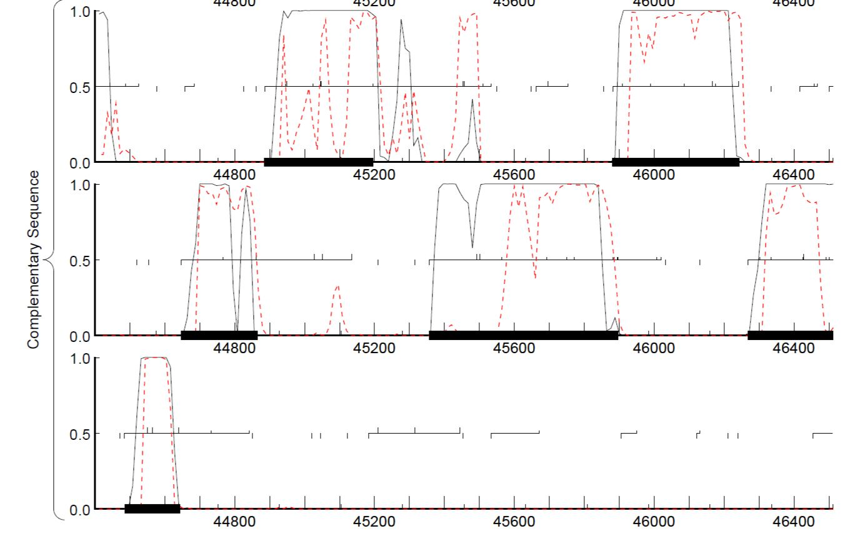

## **Figure 125: Feature 75, GeneMark Map**

The top complementary strand frame shows gene 75.

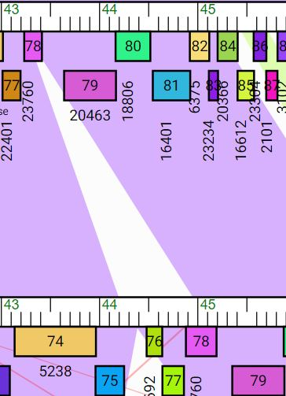

**Figure 126: Feature 75, Jeffabunny vs. JewelBug**

Jeffabunny is shown on top being compared to JewelBug, where the 78 gene is equivalent to Feature 75. Jeffabunny has a feature equivalent to 79, but the 78 gene is much shorter (hence the white space breaking up the purple similarity).

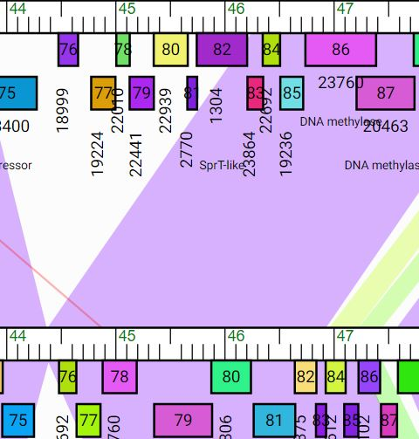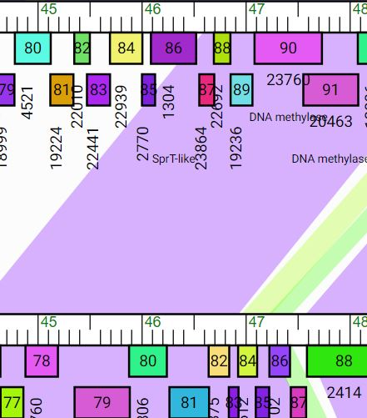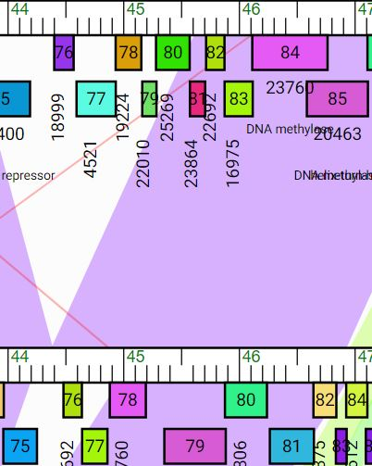

**Feature 127: Feature 75, Isiphiwo, CloudWang, Gladiator Phamerator Map**

From left to right, the phamerator maps show Isiphiwo, CouldWang, and Gladiator all on top while JewelBug is on the bottom. Isiphiwo, shown on top, is 95% similar to JewelBug in this region, including gene 78 on the map which is Feature 75, although gene 84 of Isiphiwo is much longer even overlapping Isiphiwo’s 89.All three of these genes show a similar long, overlapping gene in addition to 95% similarity with JewelBug. Gruunaga and Kazan, also A6 phage, demonstrate the same theme.

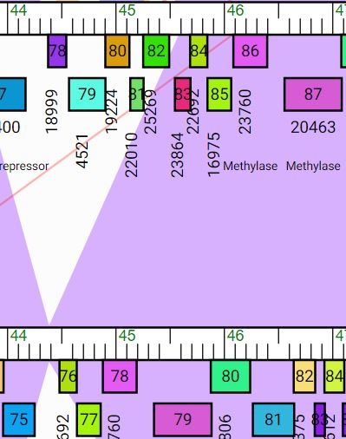

**Figure 128: Feature 75, EricB vs. JewelBug Phamerator Map**

EricB, the phage on top, shows 95% similarity to JewelBug in the entire region captured. The genes corresponding to JewelBug’s 78 and 79 are 86 and 87, which are of equivalent length to JewelBug’s.

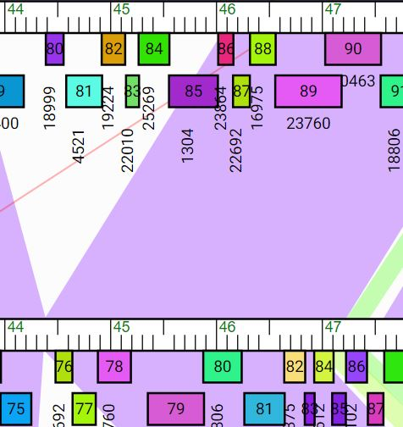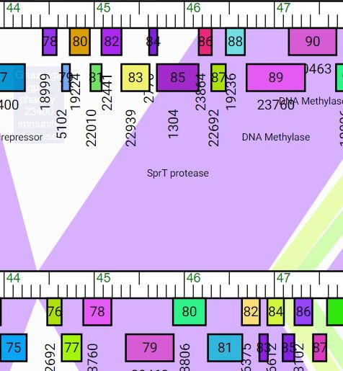

**Figure 129: Feature 75, Gruunga and Kazan Phamerator Map**

Like Figure 127, these two phamerator maps demonstrate a 95% similarity to two A6 phage in this region. These two phage have a long, overlapping feature that corresponds to JewelBug’s 75 (which is 78 on the phamerator map).

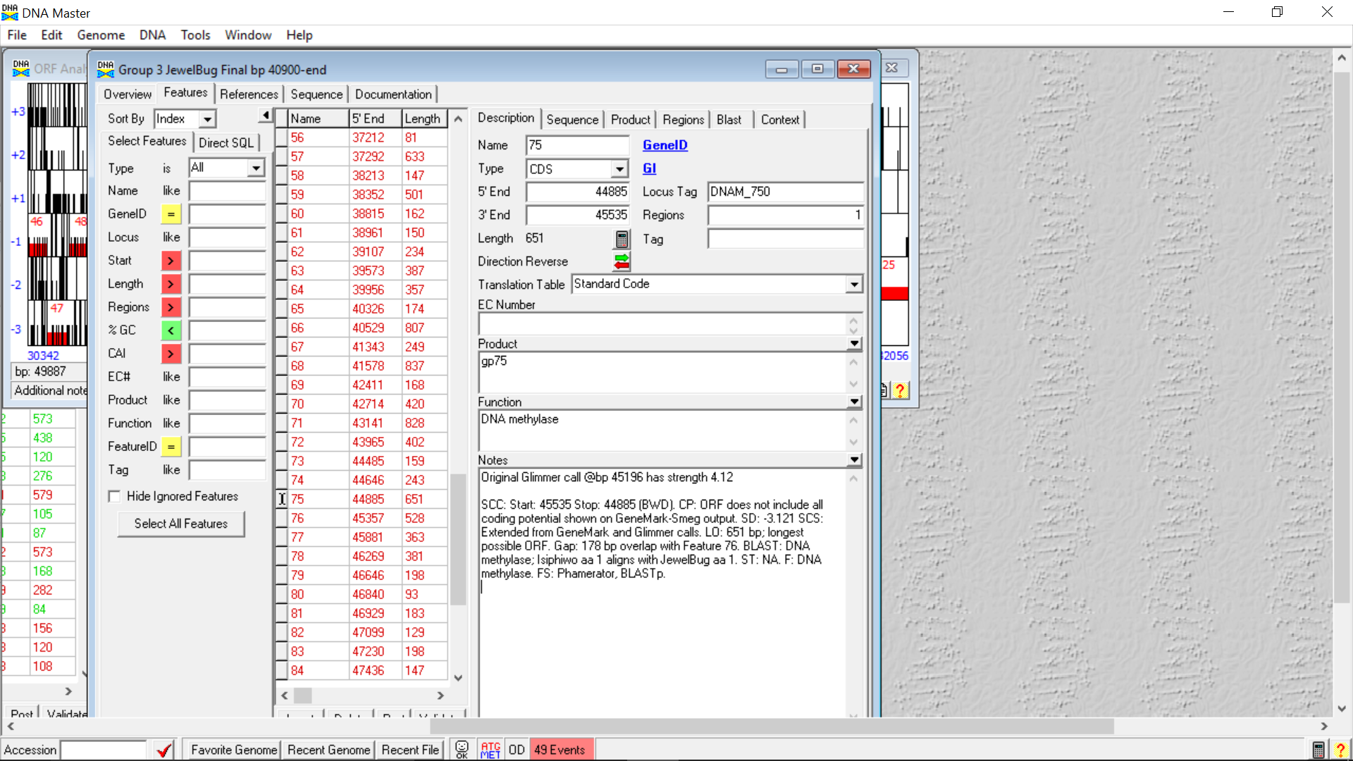

**Figure 130: Feature 75, Feature Window**

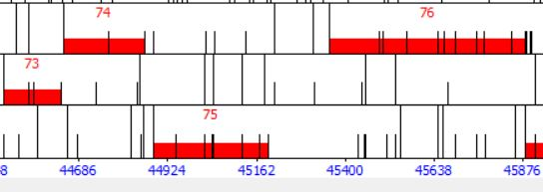

**Feature 131: Feature 75, Frame Window**

The above image shows DNA Master’s view of the open reading frame where Feature 75 starts at 45196.

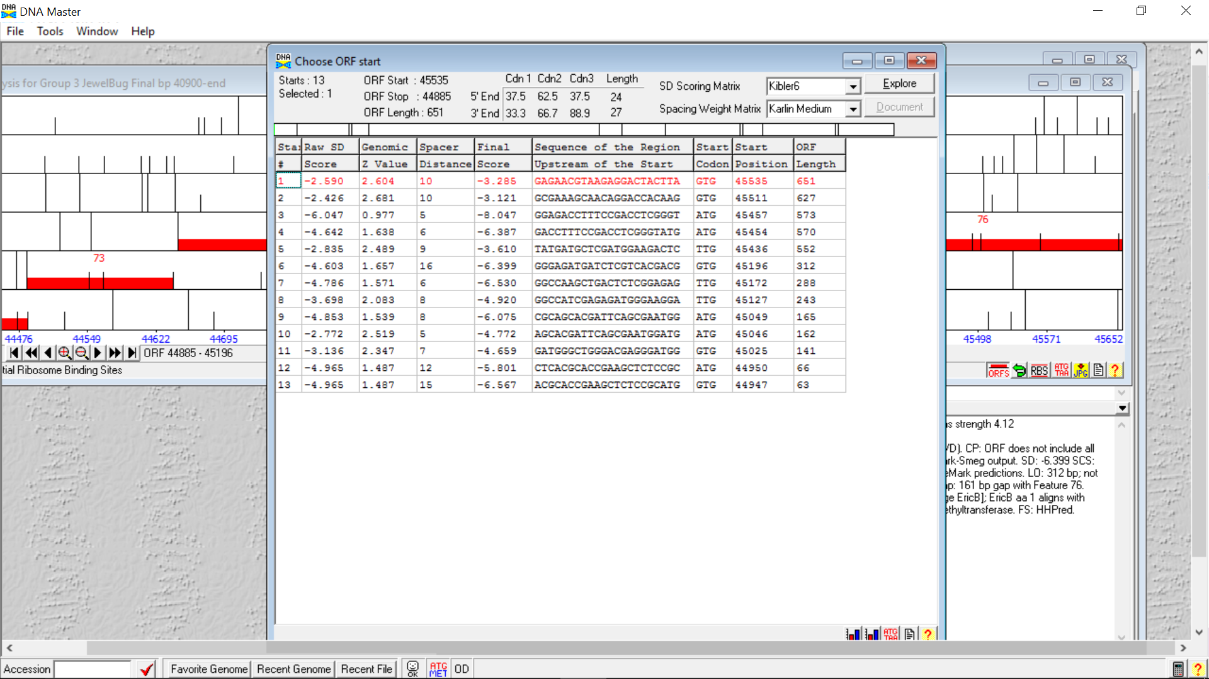

**Figure 132: Feature 75, Choose Start Window**

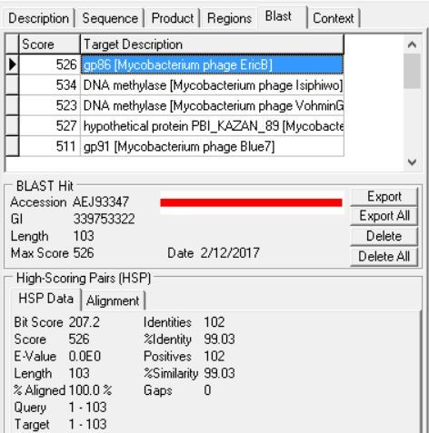

**Figure 133: Feature 75, HSP Data from Original Call**

The top match is shown above. The second match, DNA methylase from Isiphiwo, has 100% similarity but 47% alignment.

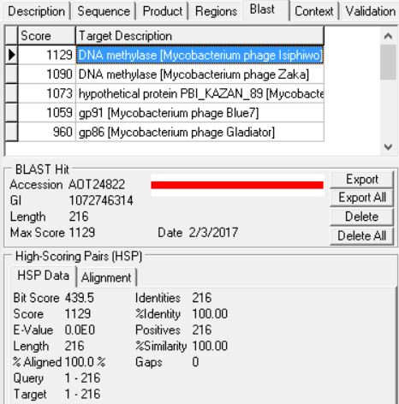

**Figure 134: Feature 75, HSP Data from Call at 45535**

The top BLAST match at start site 45535 was DNA methylase with 100% aligned, identity, and similarity.

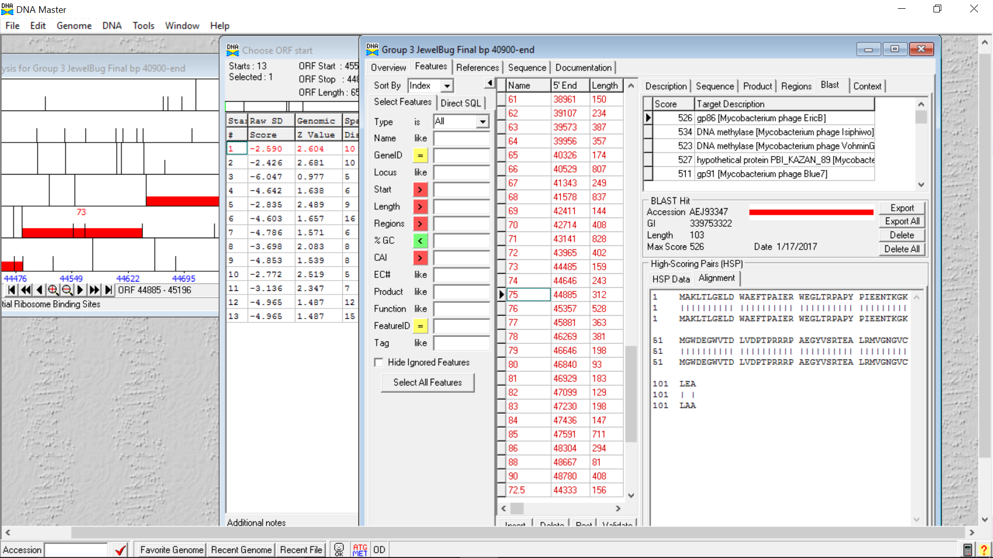

**Figure 135: Feature 75, Alignment Data from Call at 45535**

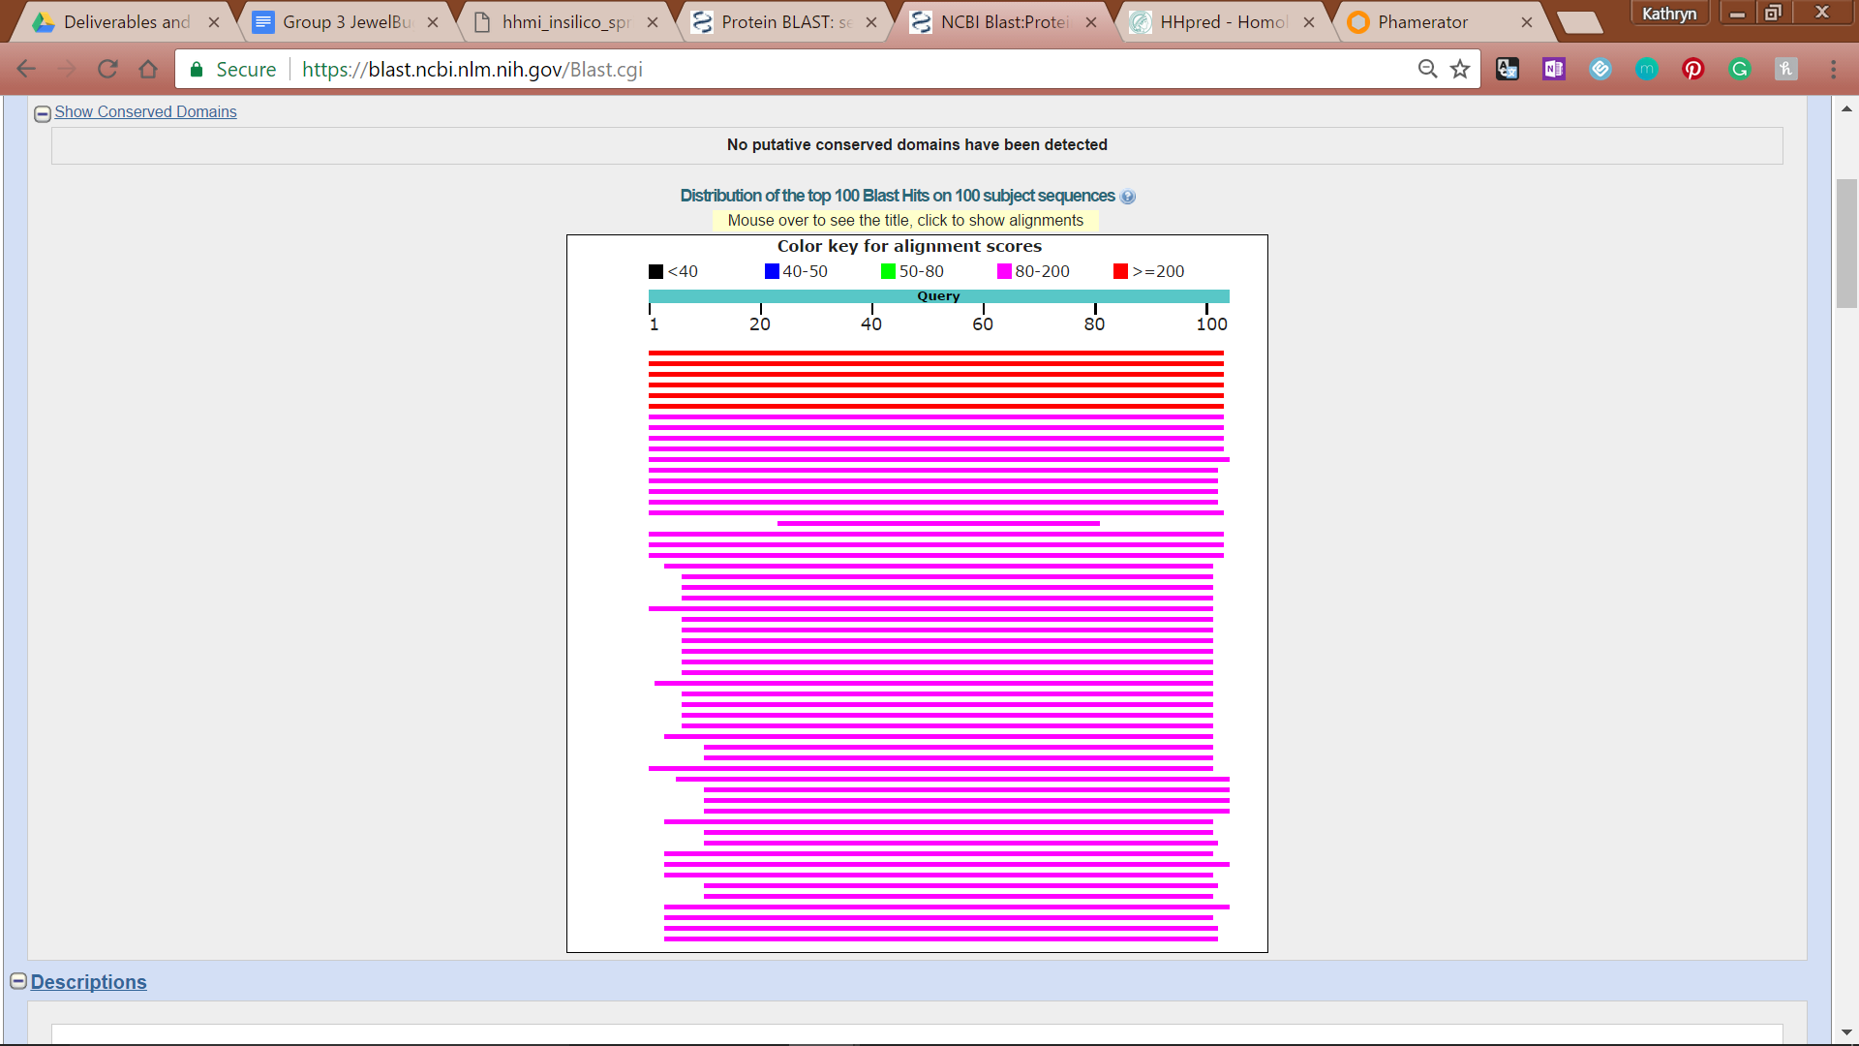

**Figure 136: Feature 75, Conserved Domain**

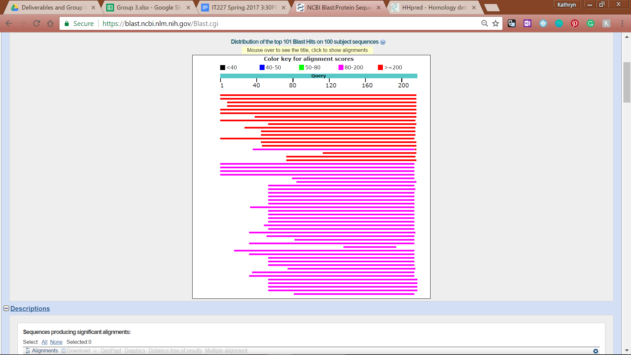

**Figure 137: Feature 75, BLASTp Hits Distribution Table**

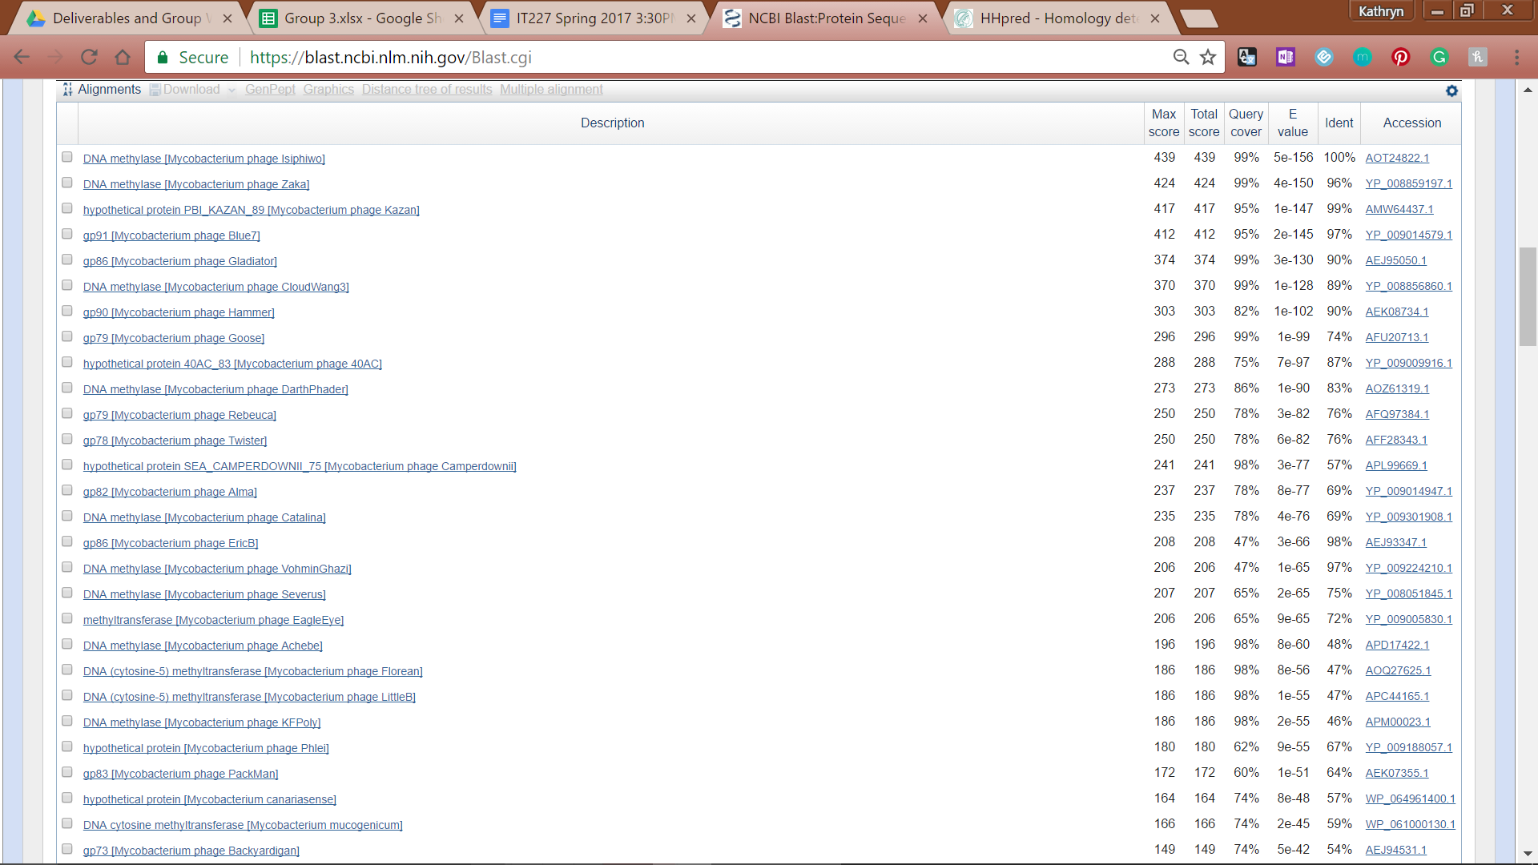

**Figure 138: Feature 75, BLASTp E-Values**

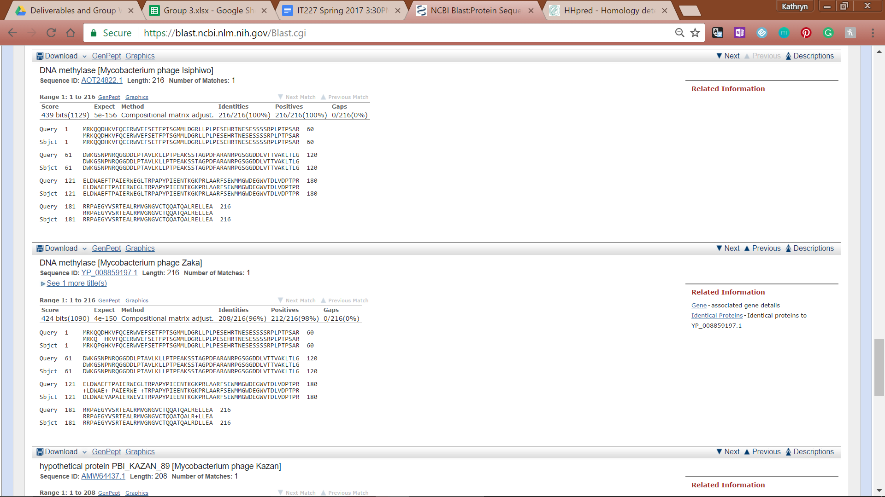

**Figure 139: Feature 75, BLASTp Alignments**

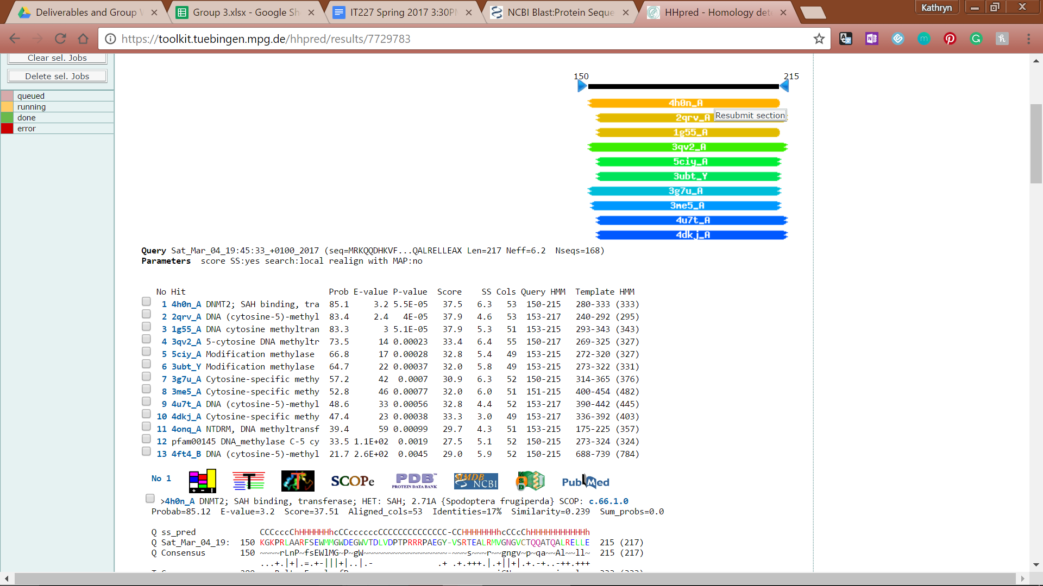

**Figure 140: Feature 75, HHPred Distribution List**



**Figure 141: Feature 75, HHPred Probabilities and Descriptions**

# 

# 

# Feature 76

**Table 11: Feature 76 Data**

|  |  |  |  |  |  |  |  |  |  |
| --- | --- | --- | --- | --- | --- | --- | --- | --- | --- |
| **Feature:** 76 | **3' End:** 45357 | **5' End:** 45884 | | | **Length:** 528 | | **Original Call:** | **Glimmer:** 45887 | |
| **GeneMark:** 45887 | |
| **Start / Stop Codon (SSC):** | | | | | | **Start:** GTG | | | |
| **Stop:** TAG; REV | | | |
| **Longest Open Reading Frame (LO):** 666 bp | | | | | | | | | Not Longest |
| **Shine Dalgarno (SD):** -3.372 / -4.417 | | | | | | | | | Not Highest |
| **Start Choice Source (SCS):** | | | | **Called by Glimmer:** Yes, 45887 | | | | | |
| **Called by GeneMark**: Yes, 45887 | | | | | |
| **Coding Potential (CP):** all covered | | | | | | | | | |
| **Gap / Overlap:** 3 bp overlap with feature 77 | | | | | | | | | |
| **BLASTp:** DNA Methylase [Mycobacterium phage VohminGhazi], bp 1 aligns with bp 18 | | | | | | | | | |
| **Function (F):** DNA Methylase | | | | | | | | | |
| **Function Source (FS):** | | | **Phamerator:** Isiphiwo feature 85 function (DNA Methylase) | | | | | | |
| **BLASTp:** VohminGhazi (DNA Methylase) | | | | | | |
| **HHPred:** DNA Methylase; 100% probability | | | | | | |
| **Comments:** bp 1 to bp 1 alignment is achieved through the shortening of the gene from the original call at 45887 to 45884 without sacrificing coding potential or gene density. | | | | | | | | | |



**Figure 142: Feature 76, GeneMark Map**

The original call of start 6 at 45887 fully captures the coding potential present in the middle complementary reading frame. Any starts shorter than 45887 will be disregarded unless future investigations warrants consideration. Starts that do not significantly encroach on Feature 77 will be investigated.

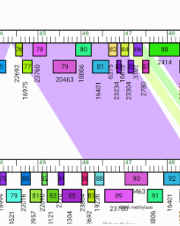

**Figure 143: Feature 76, JewelBug vs Artemis2UCLA Phamerator Map**

Feature 76 corresponds to Gene 79 on the Phamerator map. All of the 15 sequenced phage genomes in the A6 cluster contain a gene that shows significant similarities (the region is colored purple) to Gene 79. For a look at other phage, see the phamerator maps in Feature 75, too.

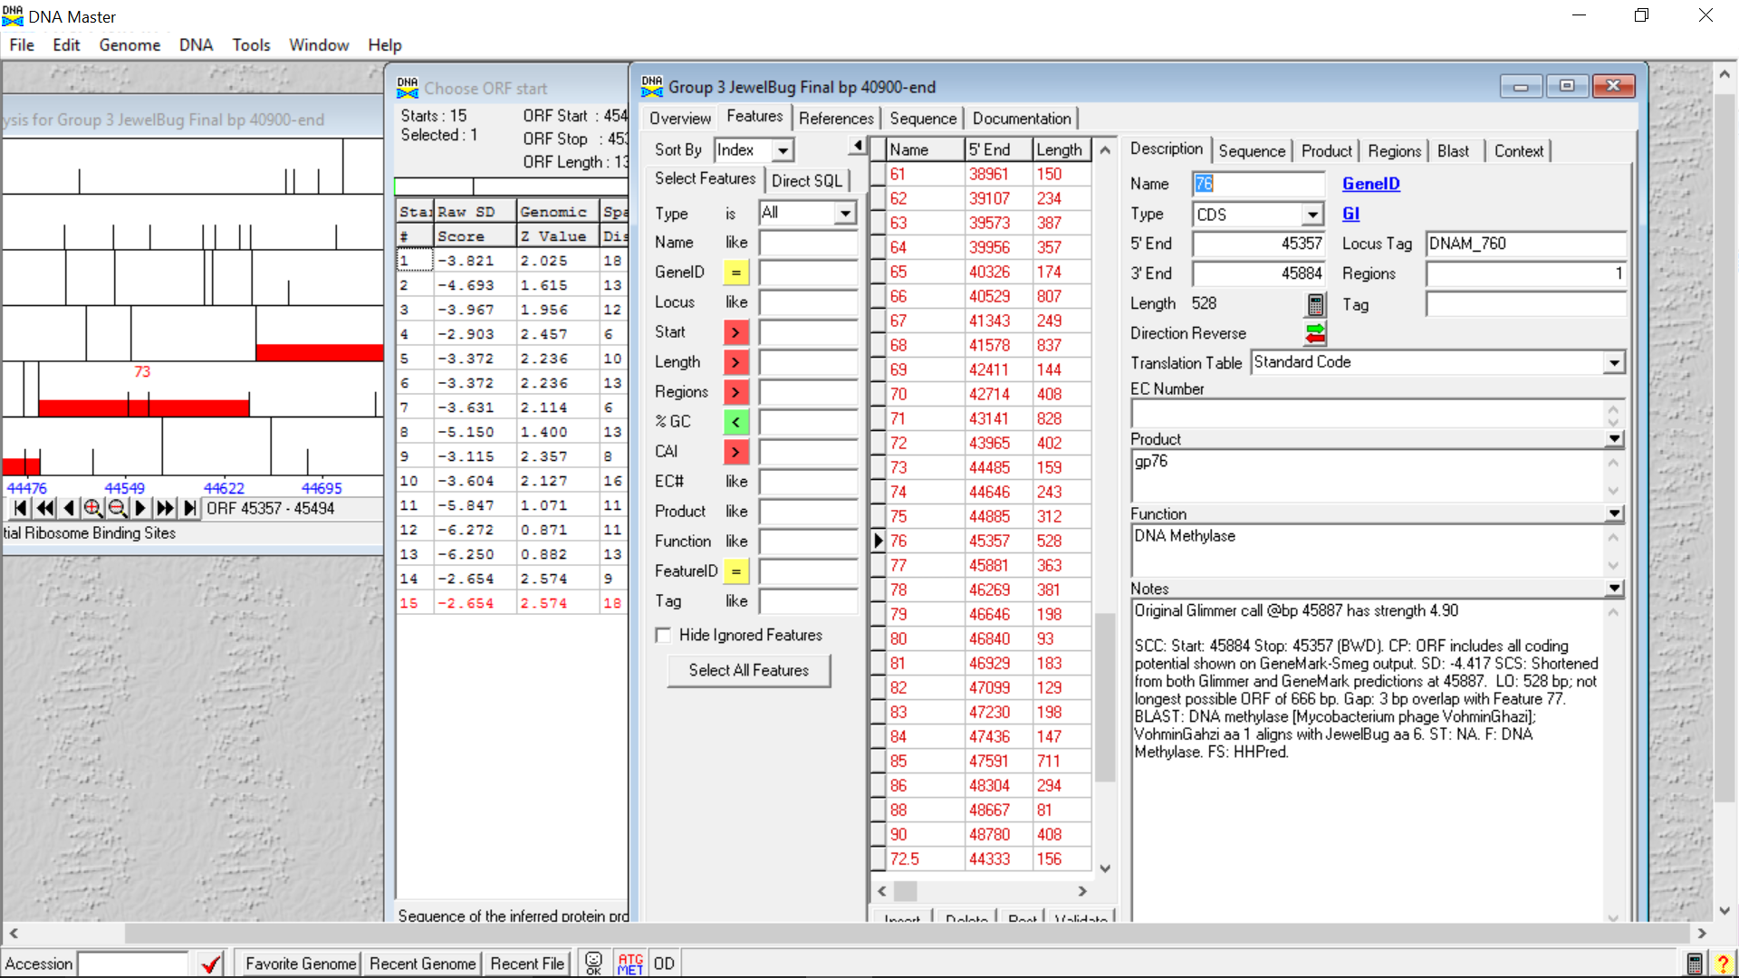

**Figure 144: Feature 76, Feature Window**

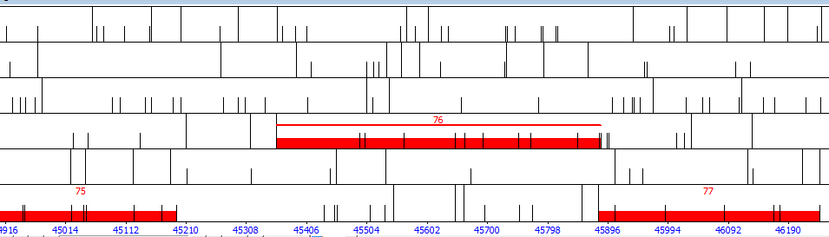

**Figure 145: Feature 76, Frame Window**

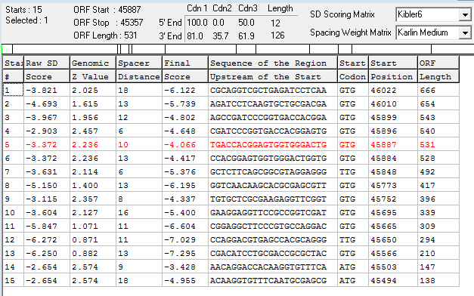

**Figure 146: Feature 76, Choose Start Window**

The original call is at start 5. Start 5 has the second lowest final score and a decently low raw score. Start 5 incurs a 6 bp overlap with Feature 77; therefore starts 1 - 3 are unlikely to be valid. Starts 7 - 15 will not be considered since they do not fully capture the coding potential see above. Starts 4 and 6 will be blasted to determine validity based on similarity to existing proteins.

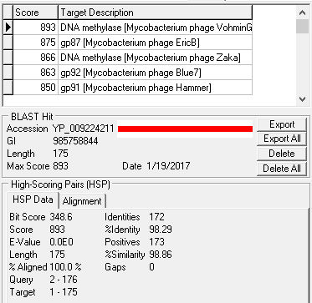

**Figure 147: Feature 76, HSP Data at Original Call**

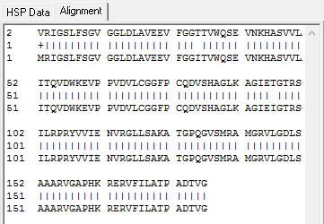

**Figure 148: Feature 76, Alignment at Original Call**

Data corresponding to the original call: start 5 at 45887. This sequence most closely resembles DNA methylase [Mycobacterium phage VohminGhazi], with base pair 4 aligning with base pair one of JewelBug and VohminGhazi respectively. The rest of the protein is highly conserved with a similarity of 98.86%. Several other DNA methylases also report strong similarities to Feature 76 at this start site.

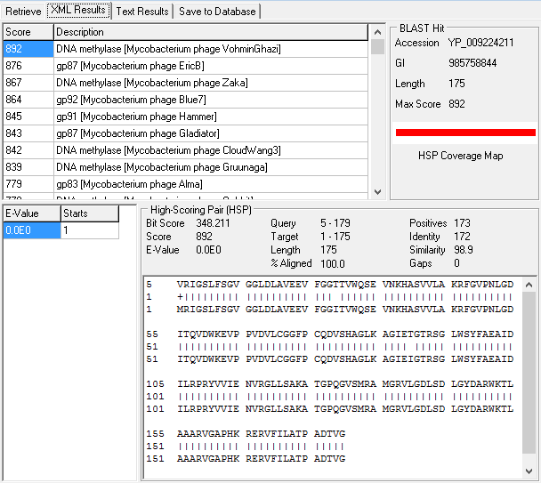

**Figure 149: Feature 76, HSP and Alignment Data for Fourth Start Call**

HSP and alignment data for a blast of start 4 at 45896. Lengthening the gene slightly improved similarity, but moved the start of the alignment from base pairs 1 and 4 to base pairs 1 and 16, which does not indicate that the call has been made at a better location.

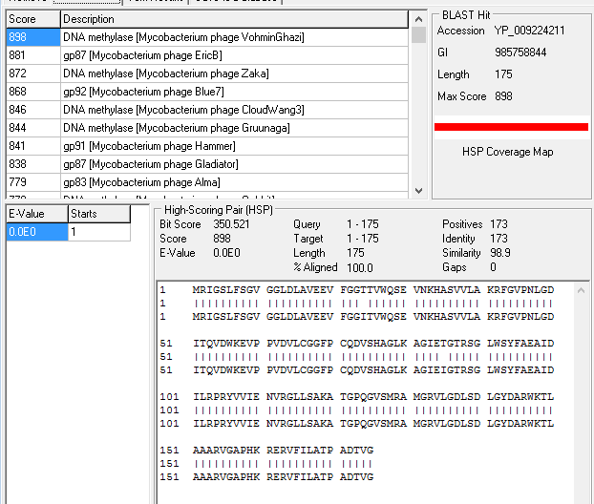

**Figure 150: Feature 76, HSP and Alignment Data for Sixth Start Call**

Start 6 at 45884 has the same similarity of Start 4, while maintaining the 100.0% identity and moving the alignment to base pair 1 of both genes. It also improves the overall score between Feature 76 and DNA methylase [Mycobacterium phage VohminGhazi] at 5 points about Start 5 and 6 points above Start 4. Based on this evidence, the gene call will be moved to Start 6. Even though it is shorter than Start 5, the difference is a mere 3 bp and acceptable overlap of 3 bp is retained as well as full capture of coding potential.

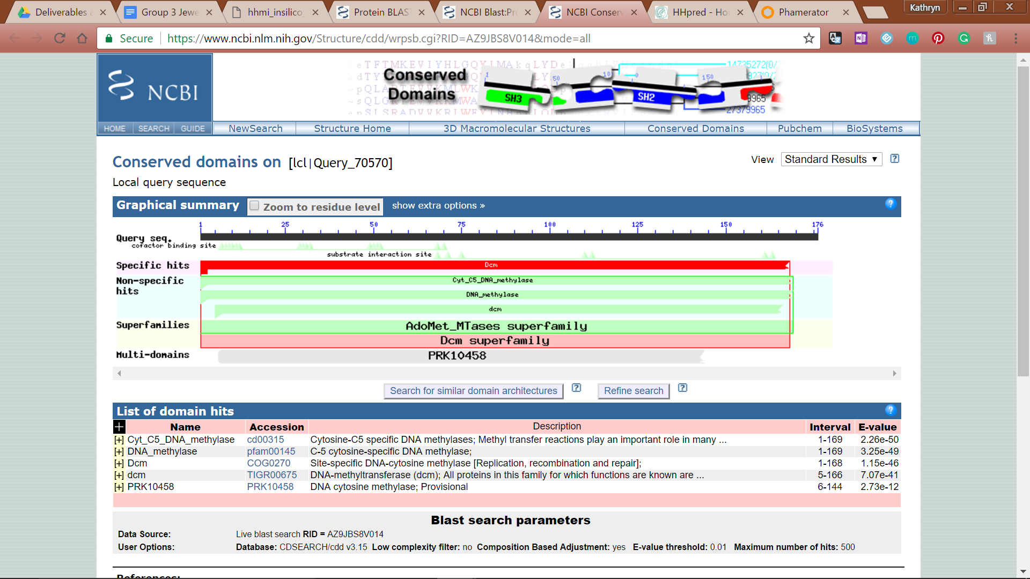

**Figure 151: Feature 76, Conserved Domain**

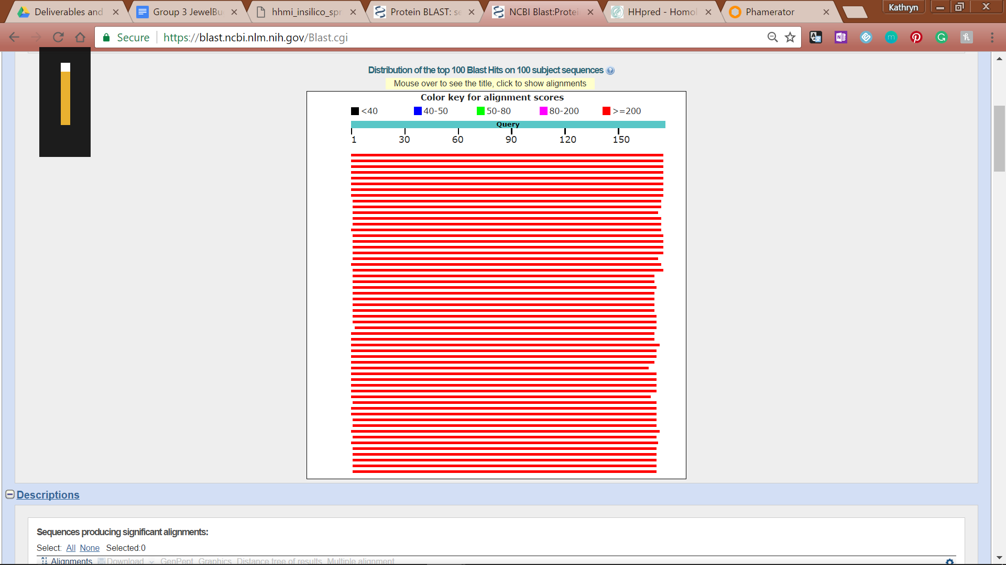

**Figure 152: Feature 76, BLASTp Hits Distribution Table**

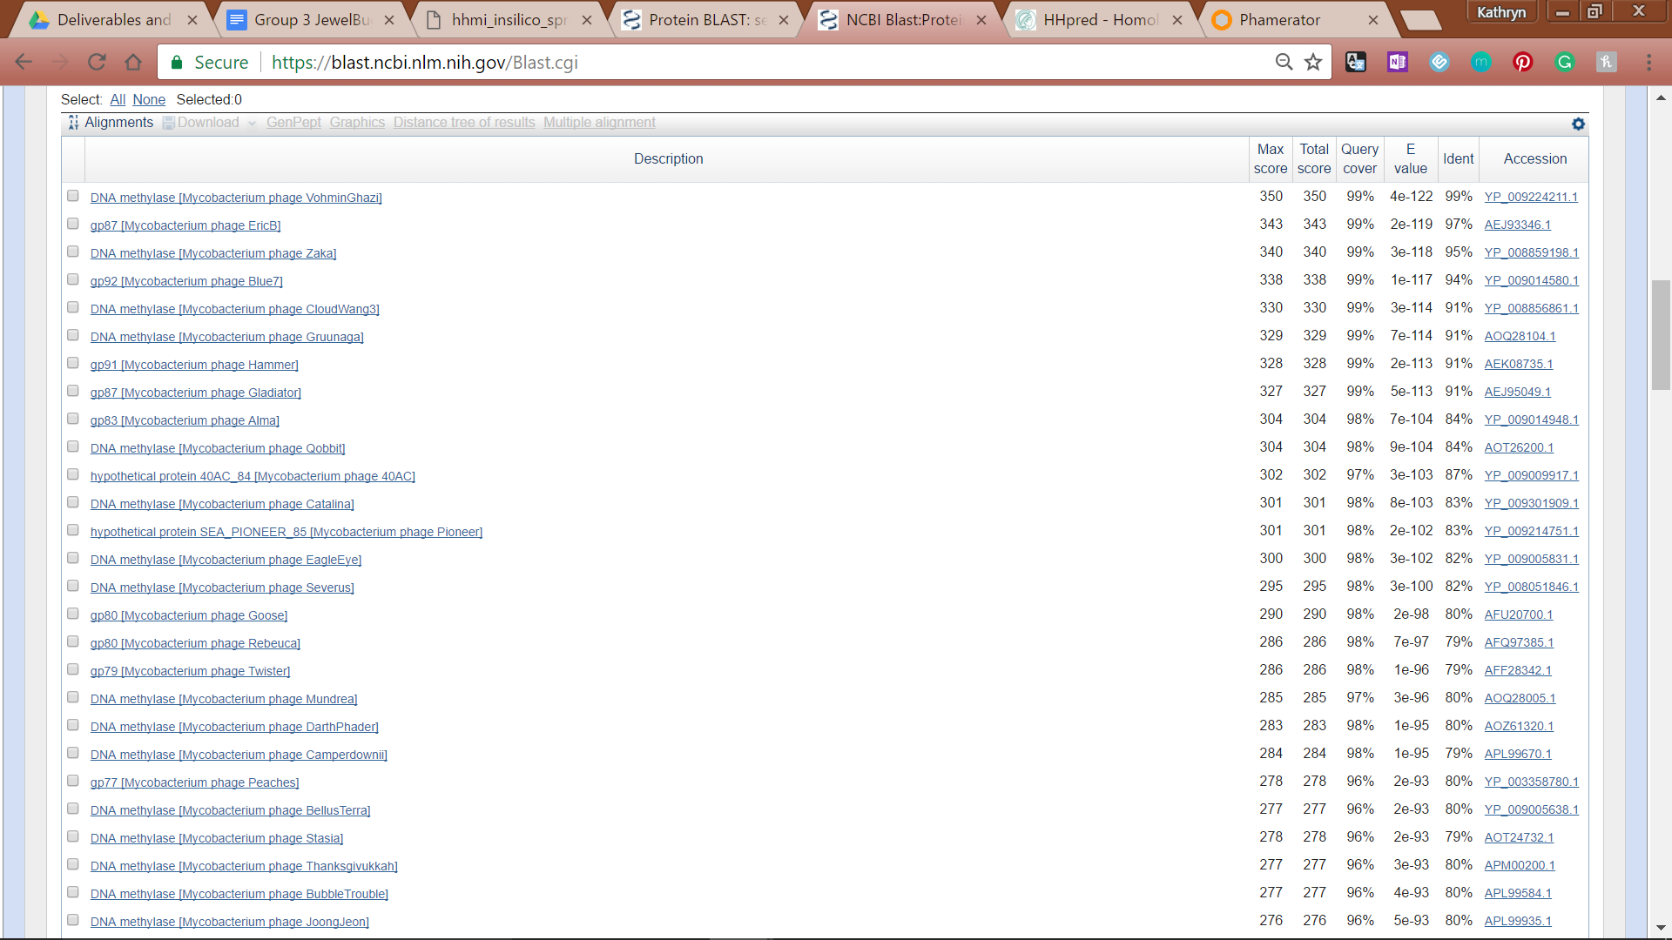

**Figure 153: Feature 76, BLASTp E-Values**

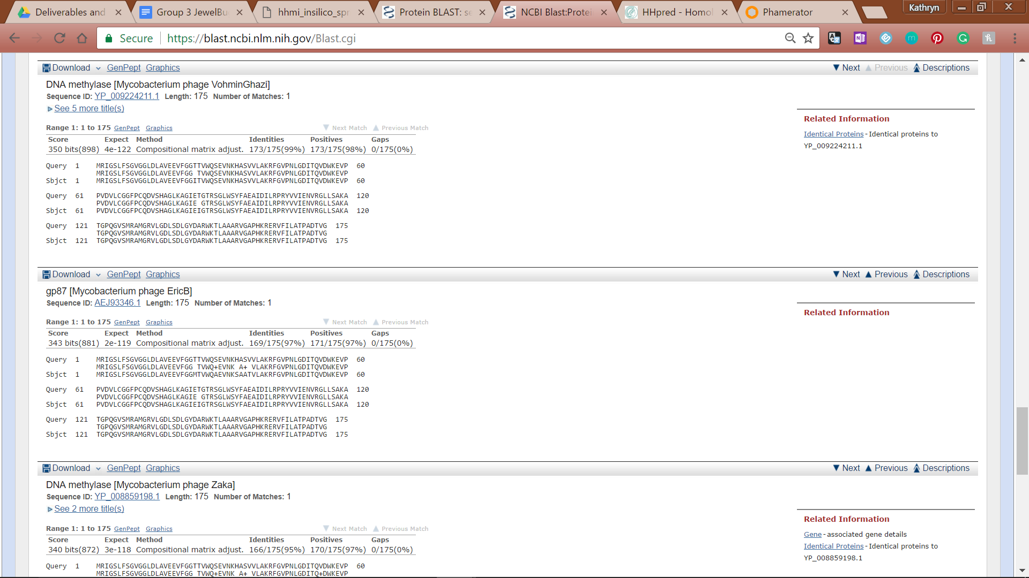

**Figure 154: Feature 76, BLASTp Alignments**

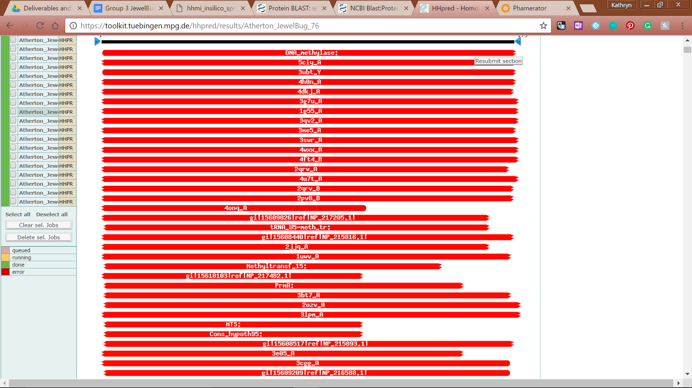

**Figure 155: Feature 76, HHPred Distribution List**

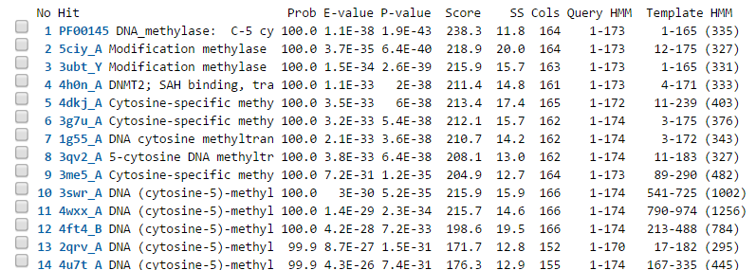

**Figure 156: Feature 76, HHPred Probabilities and Descriptions**

# Feature 77

**Table 12: Feature 77 Data**

|  |  |  |  |  |  |  |  |  |  |
| --- | --- | --- | --- | --- | --- | --- | --- | --- | --- |
| **Feature:** 77 | **3' End:** 45881 | **5' End:** 46243 | | | **Length:** 363 | | **Original Call:** | **Glimmer:** 46243 | |
| **GeneMark:** 46243 | |
| **Start / Stop Codon (SSC):** | | | | | | **Start:** ATG | | | |
| **Stop:** TGA; REV | | | |
| **Longest Open Reading Frame (LO):** 363 bp | | | | | | | | | Longest |
| **Shine Dalgarno (SD):** -2.367 / -3.062 | | | | | | | | | Highest |
| **Start Choice Source (SCS):** | | | | **Called by Glimmer:** Yes, 46243 | | | | | |
| **Called by GeneMark**: Yes, 46243 | | | | | |
| **Coding Potential (CP):** all covered | | | | | | | | | |
| **Gap / Overlap:** 26 bp gap following gene | | | | | | | | | |
| **BLASTp:** gp88 [Mycobacterium phage EricB], bp 1 aligns with bp 1 | | | | | | | | | |
| **Function (F):** Helix-turn-helix DNA binding protein | | | | | | | | | |
| **Function Source (FS):** | | | **Phamerator:** Isiphiwo feature 86 function (Helix-turn-helix DNA binding) | | | | | | |
| **BLASTp:** gp88 from EricB (Helix-turn-helix DNA binding protein) | | | | | | |
| **HHPred:** Helix-turn-helix, 99% probability | | | | | | |
| **Comments:** The site where Glimmer and Genemark called has the longest ORF and lowest SD score, so this gene requires no modifications. | | | | | | | | | |

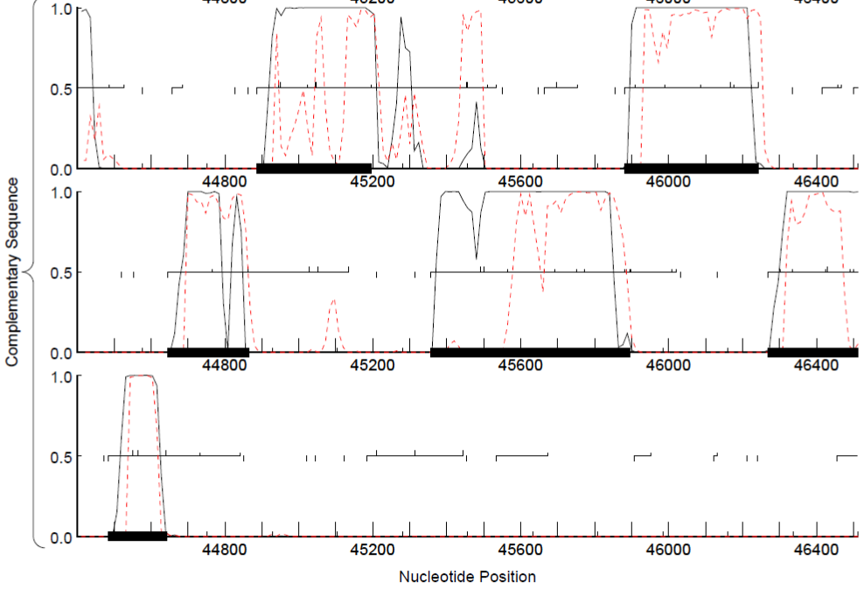

**Figure 157: Feature 77, GeneMark Map**

Coding potential in the top section of the complementary sequence align well with start at 46243 and end at 45881.

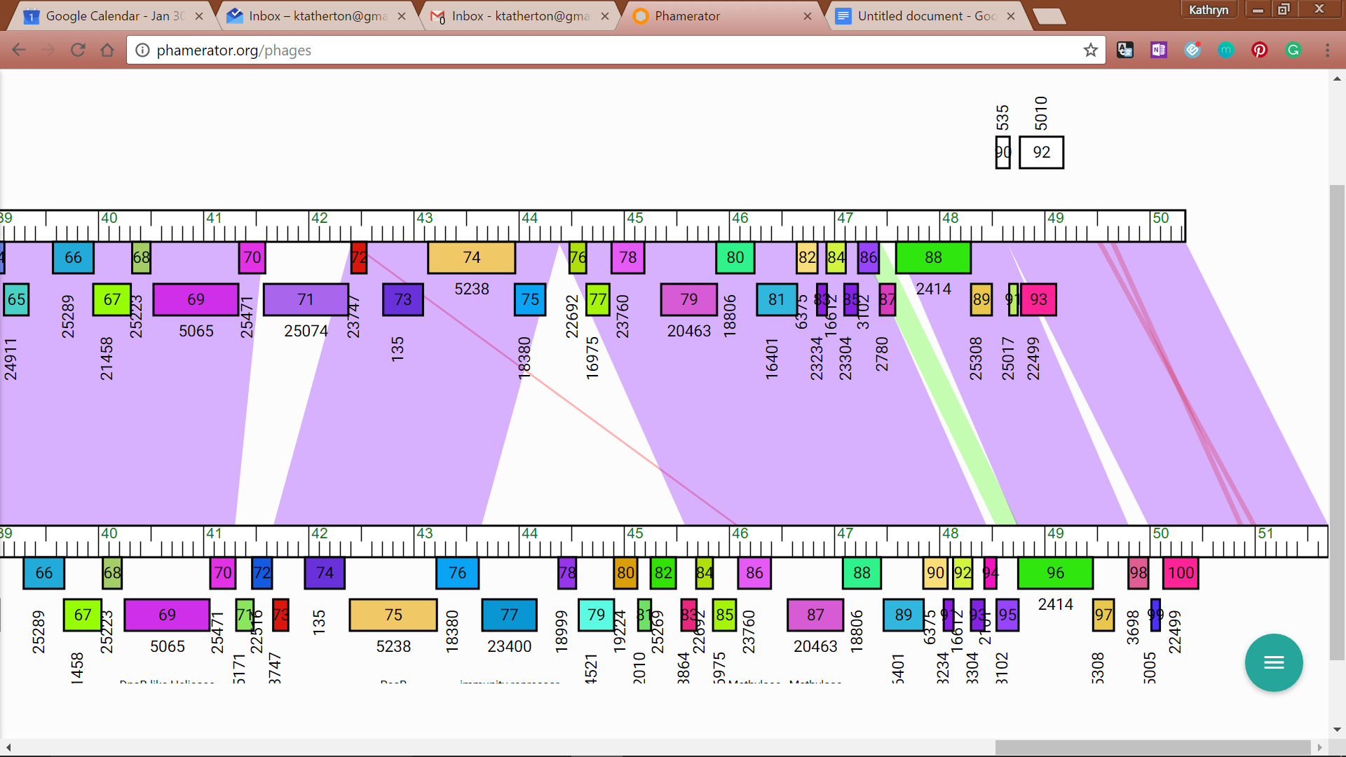

**Figure 158: Feature 77, JewelBug vs. EricB Phamerator Map**

The above image shows JewelBug on the topline with EricB on the bottom line since the top BLAST match is a part of EricB.

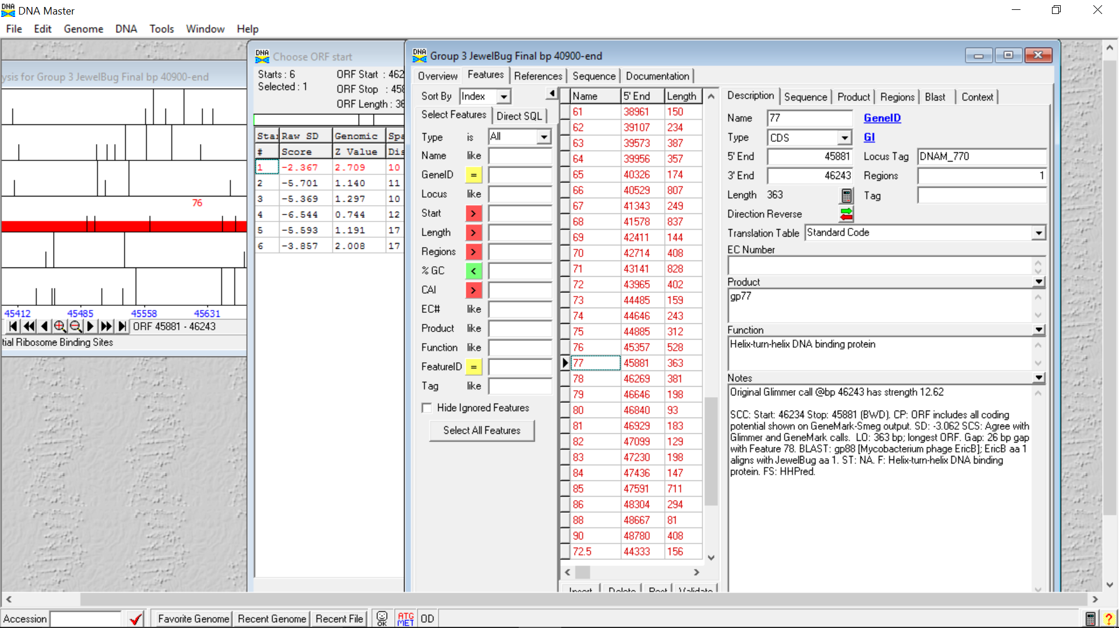

**Figure 159: Feature 77, Feature Window**

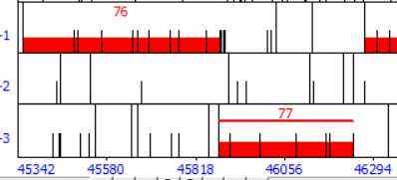

**Figure 160: Feature 77, Frame Window**

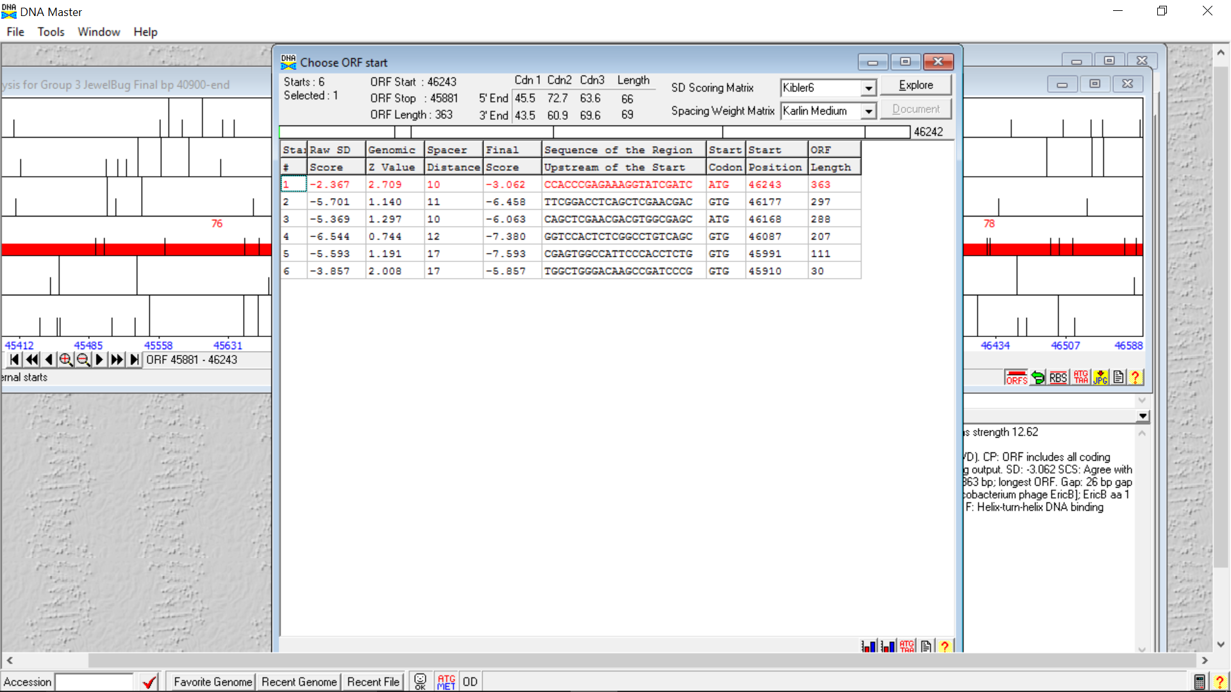

**Figure 161: Feature 77, Choose Start Window**

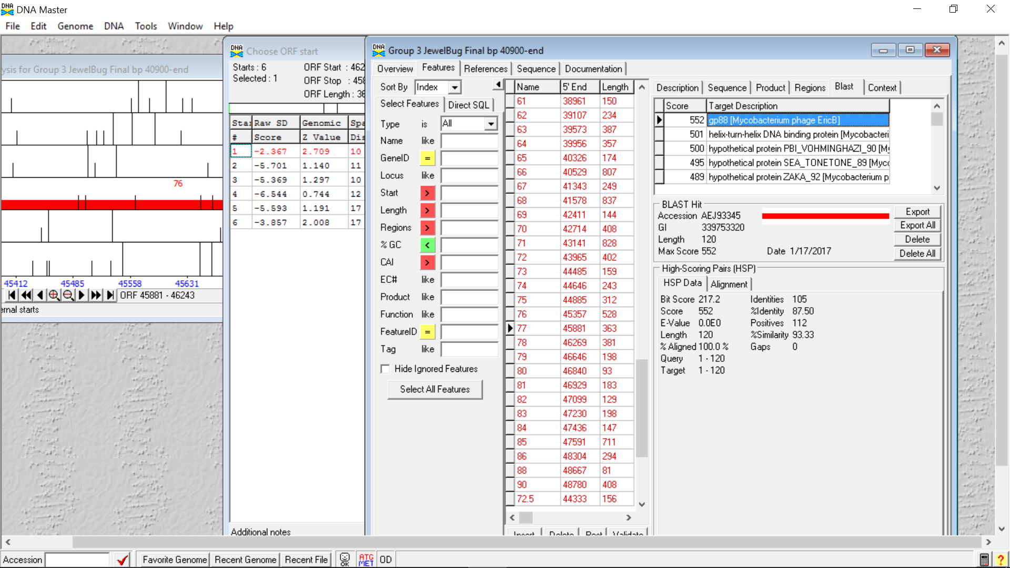

**Figure 162: Feature 77, HSP Data**

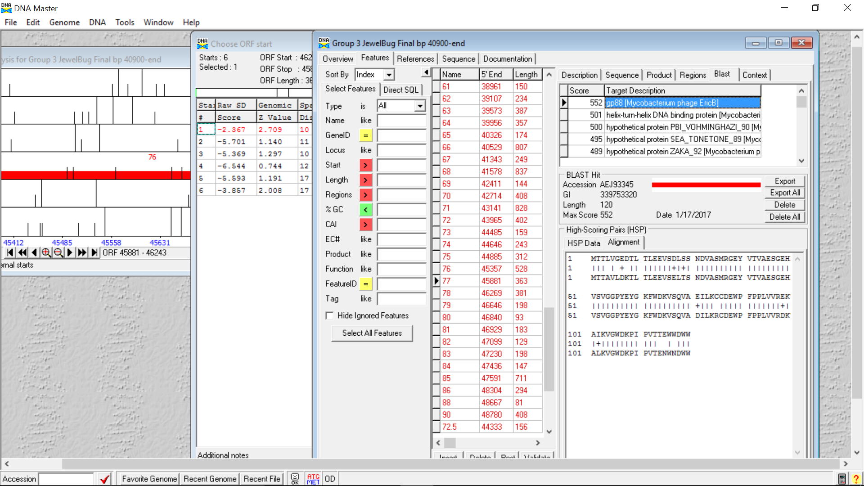

**Figure 163: Feature 77, Alignment**

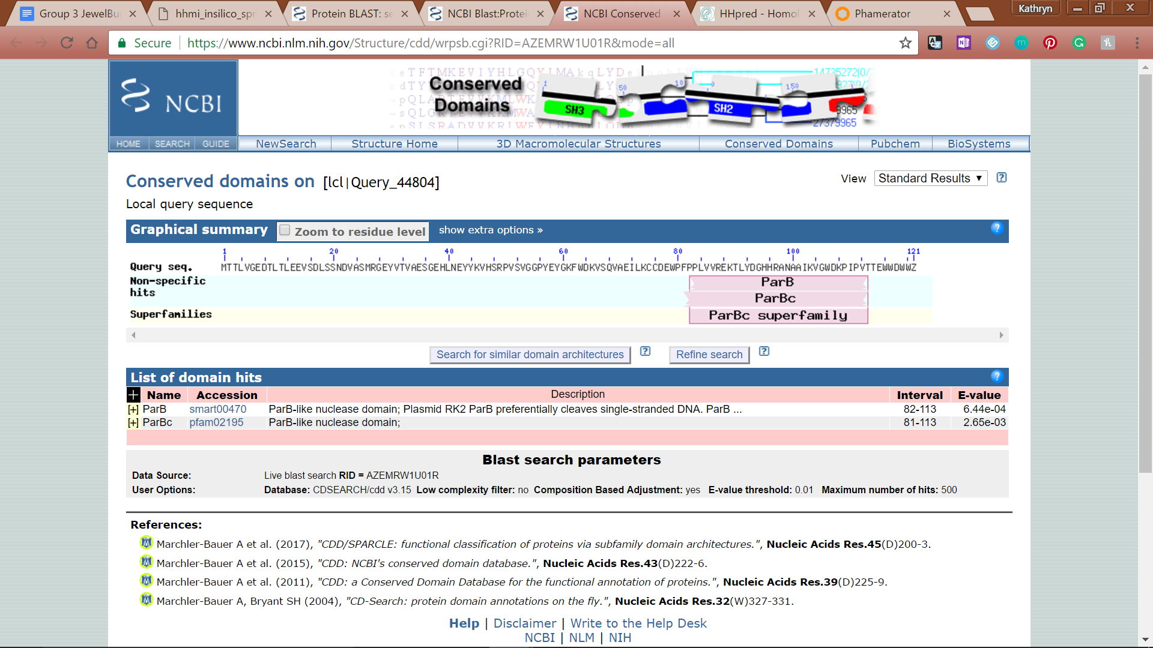

**Figure 164: Feature 77, Conserved Domain**

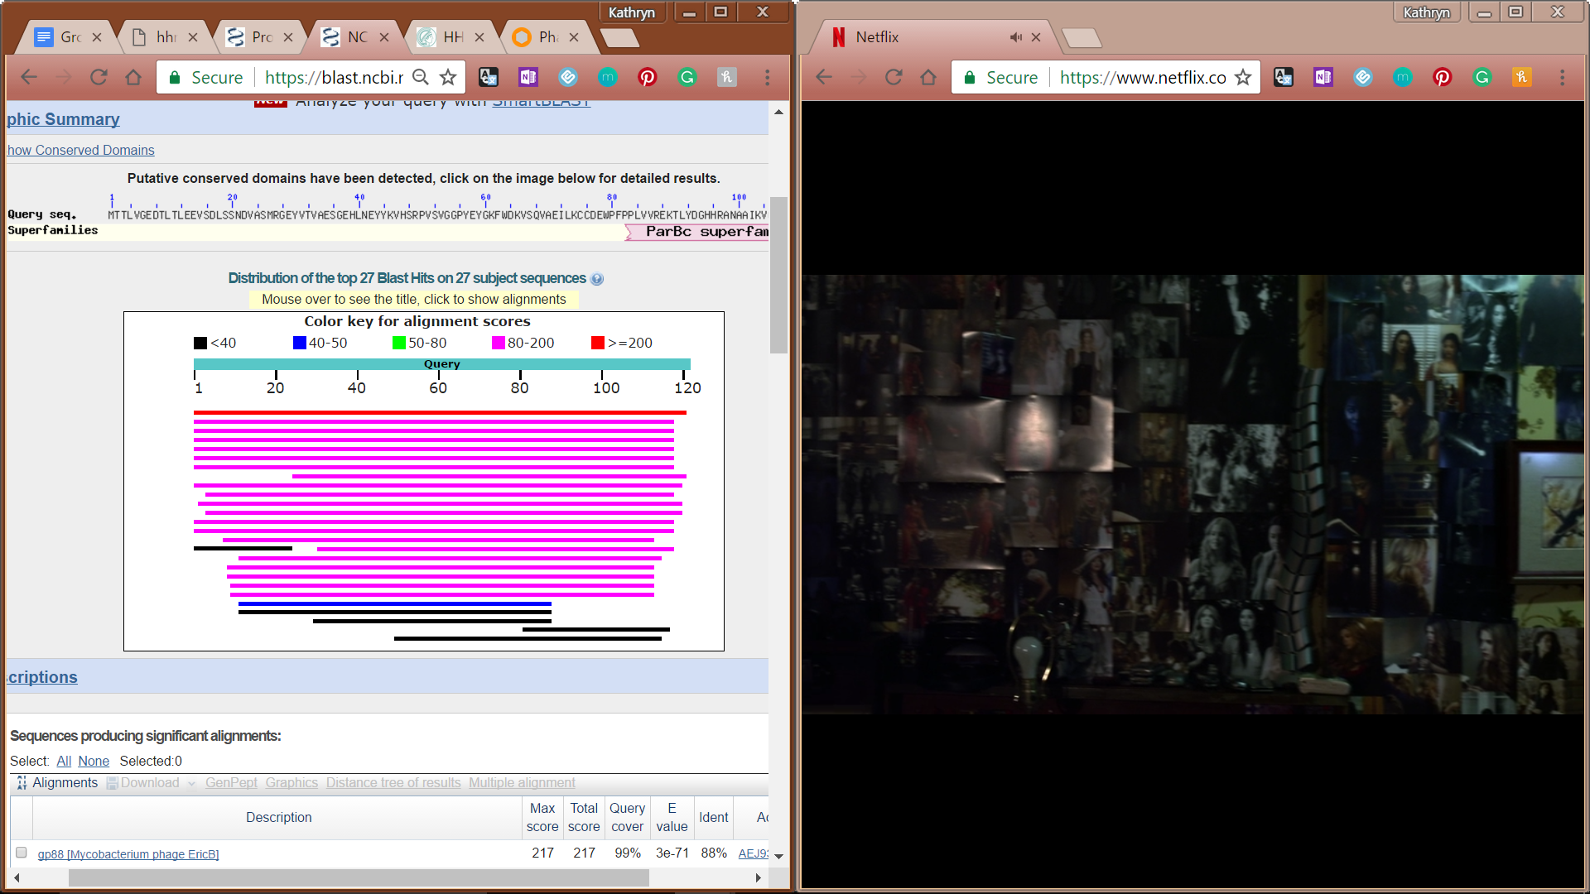

**Figure 165: Feature 77, BLASTp Hits Distribution Table**

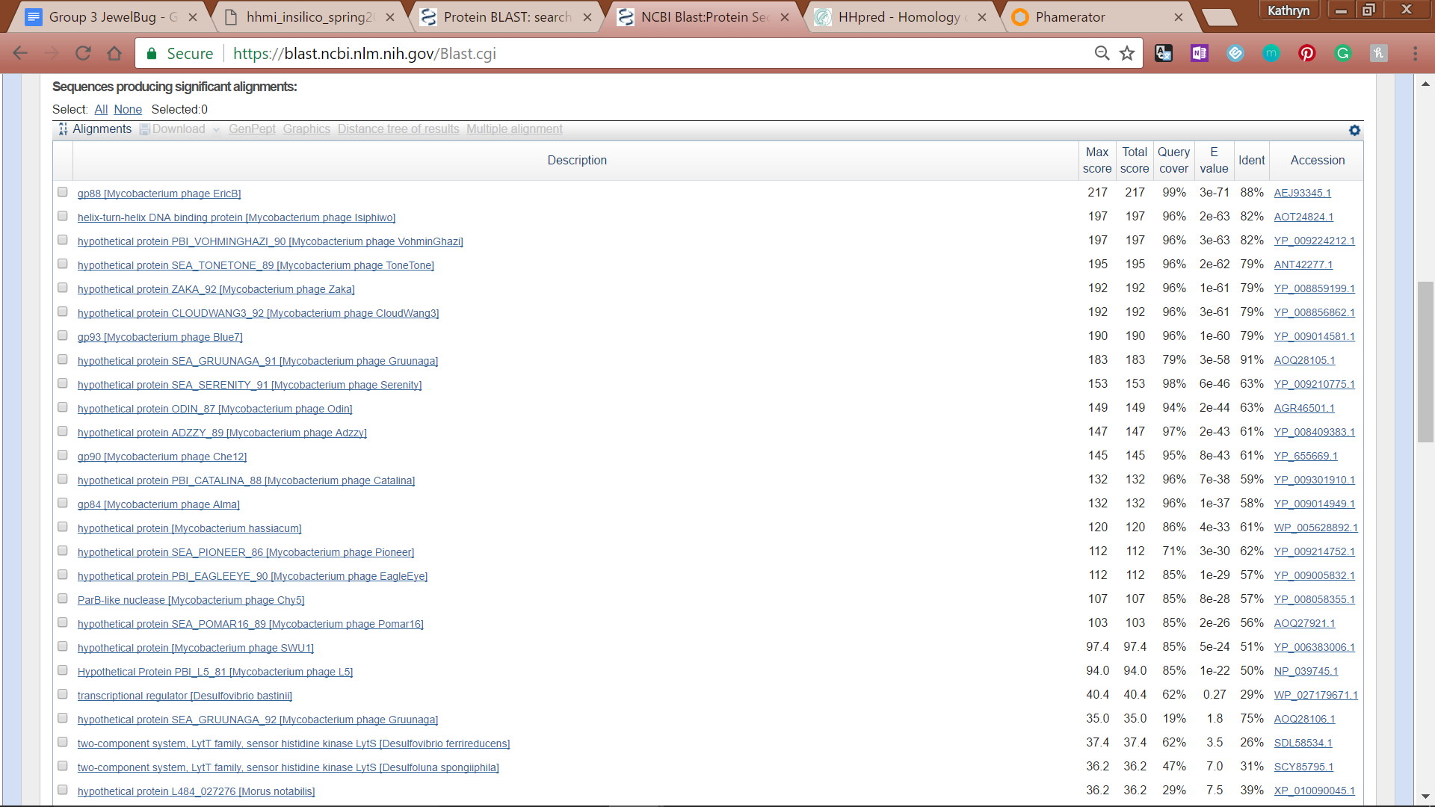

**Figure 166: Feature 77, BLASTp E-Values**

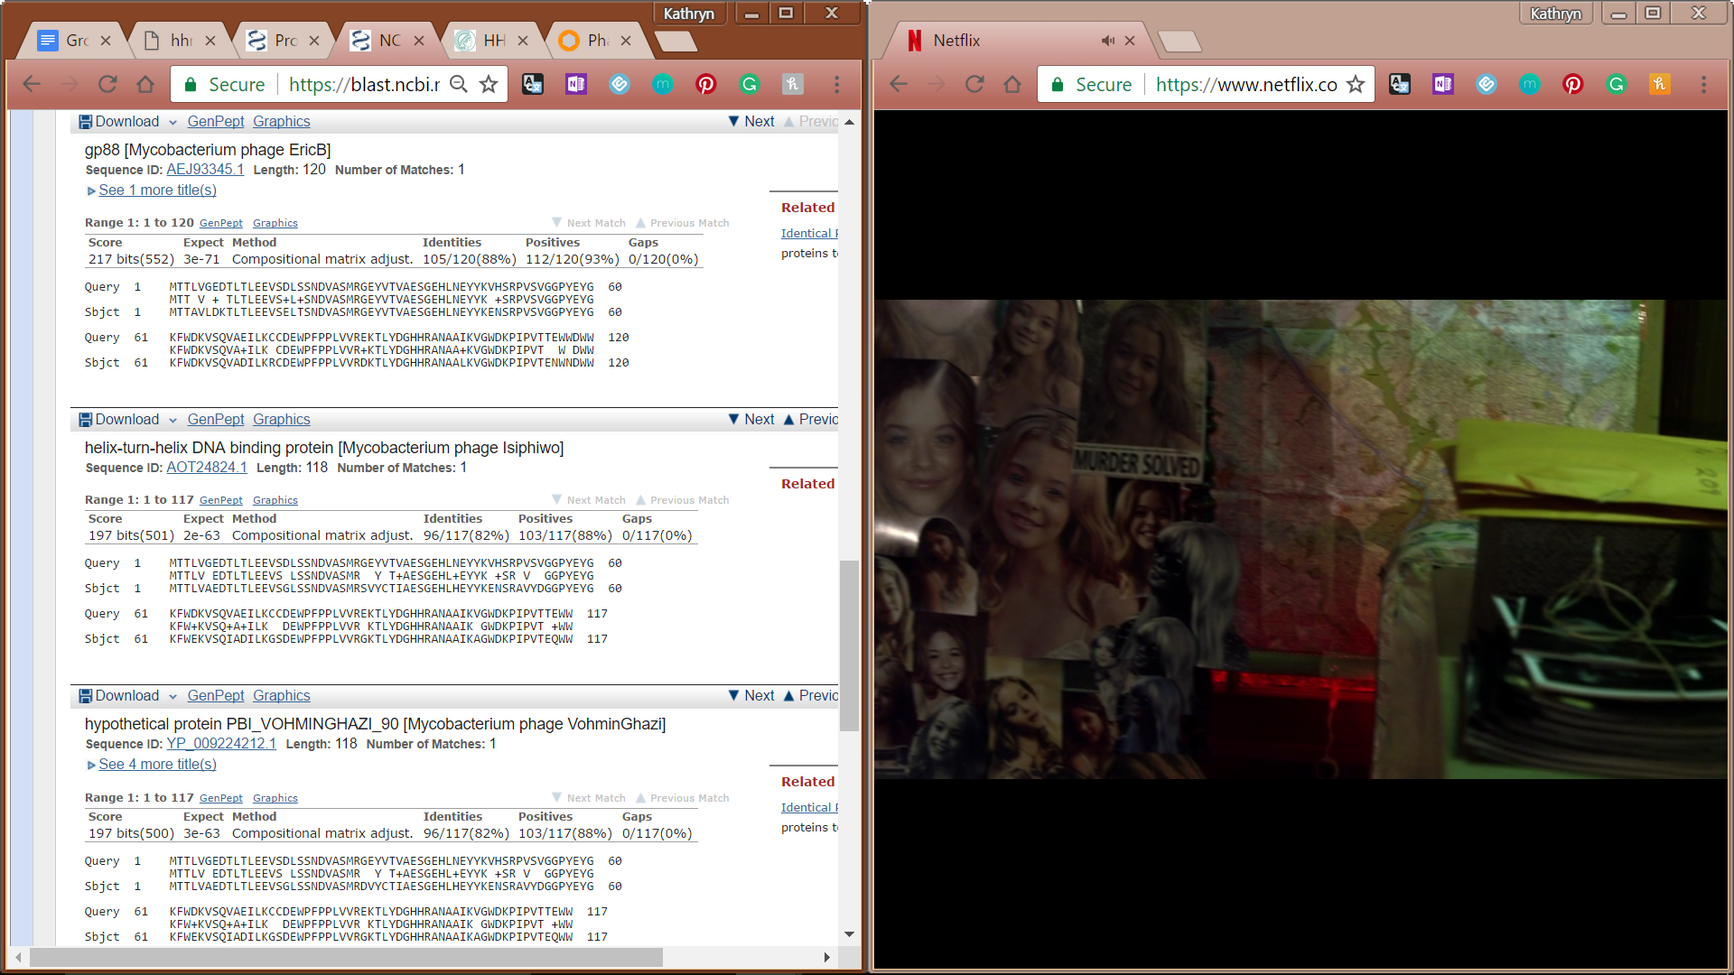

**Figure 167: Feature 77, BLASTp Alignments**

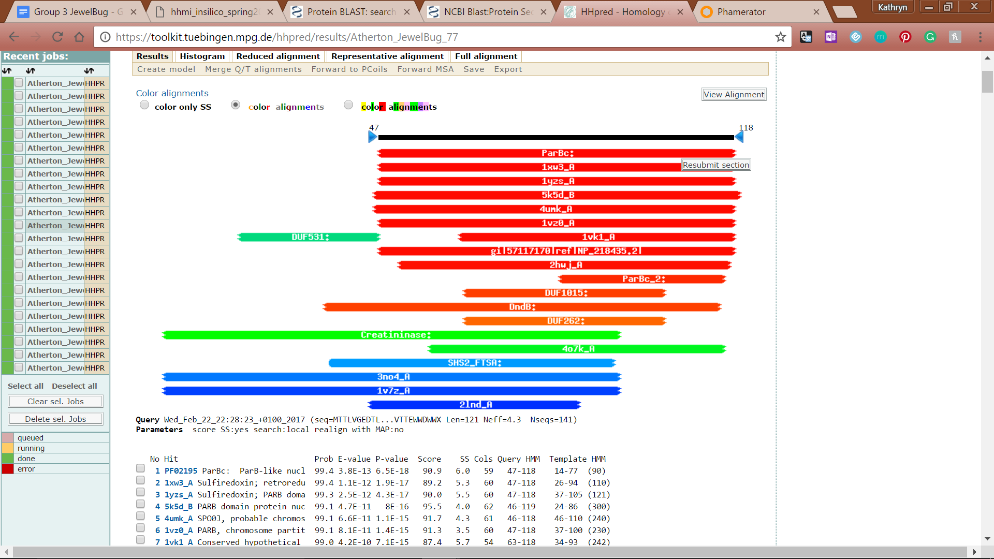

**Figure 168: Feature 77, HHPred Distribution List**

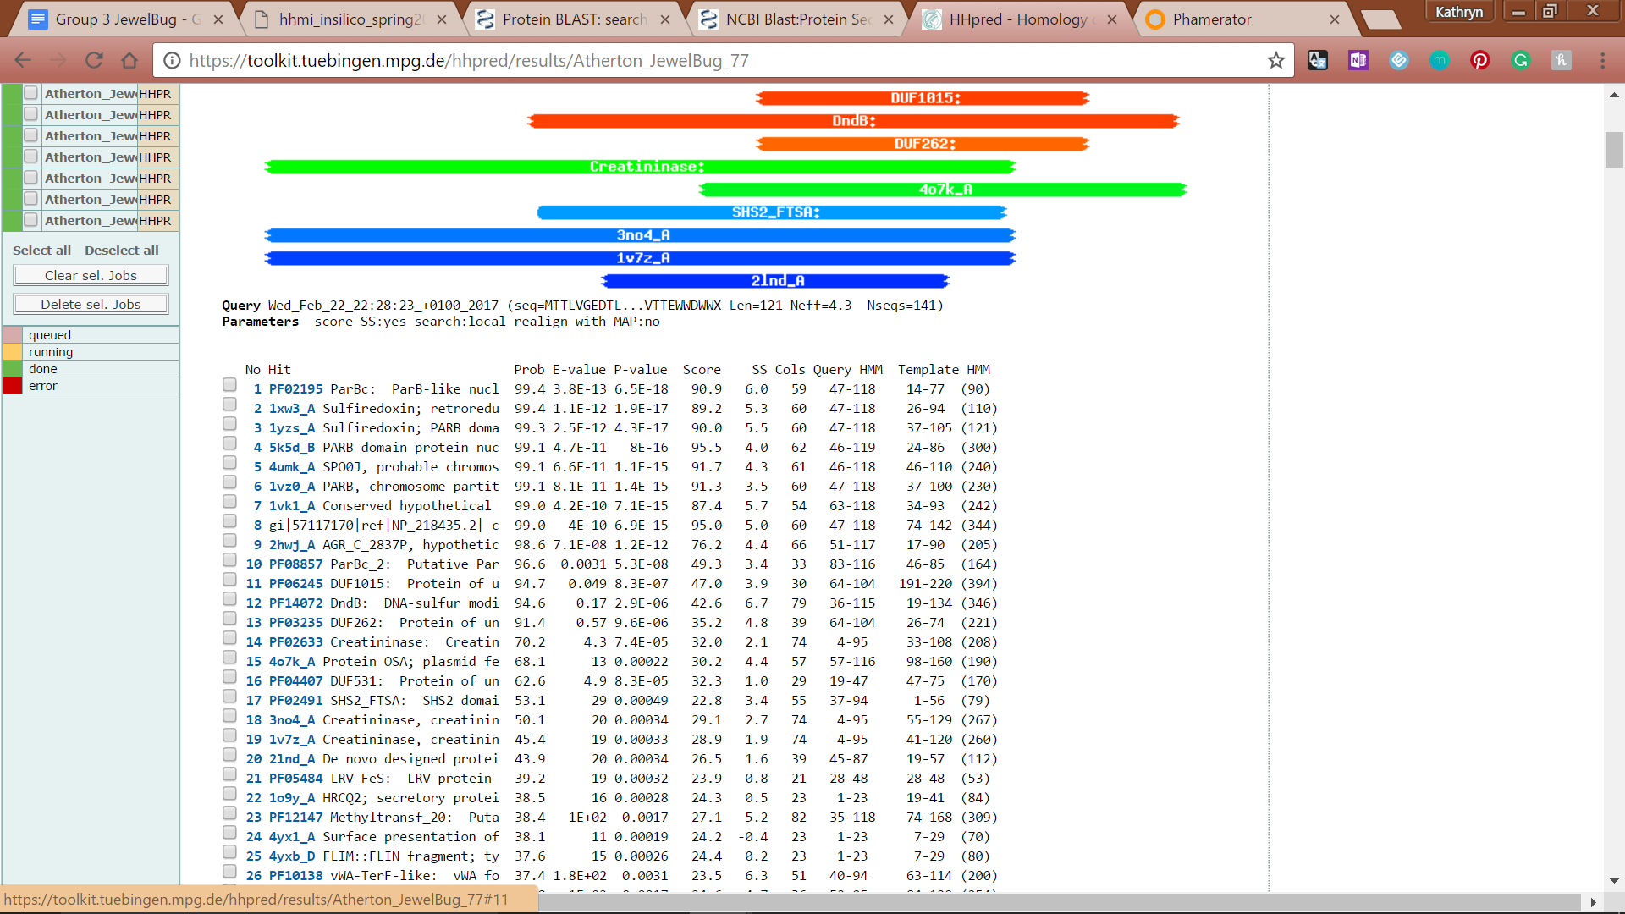

**Figure 169: Feature 77, HHPred Probabilities and Descriptions**

# 

# 

# Feature 78

**Table 13: Feature 78 Data**

|  |  |  |  |  |  |  |  |  |  |
| --- | --- | --- | --- | --- | --- | --- | --- | --- | --- |
| **Feature:** 78 | **3' End:** 46269 | **5' End:** 46649 | | | **Length:** 381 | | **Original Call:** | **Glimmer:** 46649 | |
| **GeneMark:** 46649 | |
| **Start / Stop Codon (SSC):** | | | | | | **Start:** GTG | | | |
| **Stop:** TGA; REV | | | |
| **Longest Open Reading Frame (LO):** 483 bp | | | | | | | | | Not Longest |
| **Shine Dalgarno (SD):** -2.165 / -3.767 | | | | | | | | | Not Highest |
| **Start Choice Source (SCS):** | | | | **Called by Glimmer:** Yes, 46649 | | | | | |
| **Called by GeneMark**: Yes, 46649 | | | | | |
| **Coding Potential (CP):** all covered | | | | | | | | | |
| **Gap / Overlap:** 3 bp overlap with feature 79 | | | | | | | | | |
| **BLASTp:** Hypothetical protein PBI_MCFLY_91, bp 1 aligns with bp 1 | | | | | | | | | |
| **Function (F):** No known function | | | | | | | | | |
| **Function Source (FS):** | | | **Phamerator:** No noted functions in similar phages | | | | | | |
| **BLASTp:** gp89 from EricB (no known function) | | | | | | |
| **HHPred:** no significant results found | | | | | | |
| **Comments:** The original start site at 46649 was kept as it had the lowest SD scores beside one start site that had an ORF of only 36bp. The only start site with a longer ORF would have too much overlap with gene 79. | | | | | | | | | |

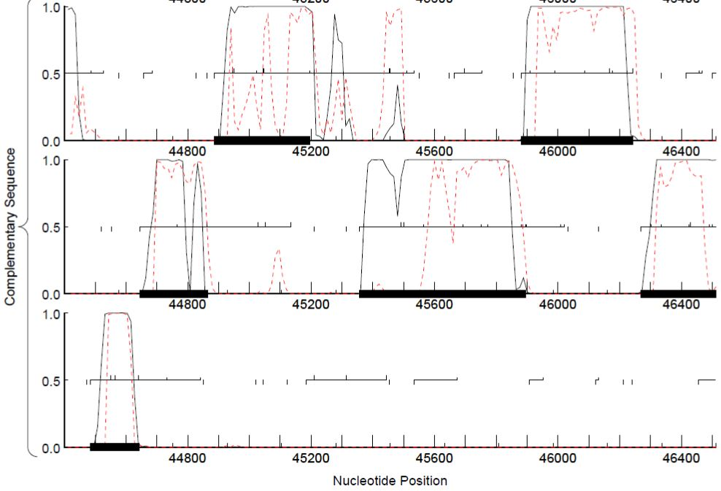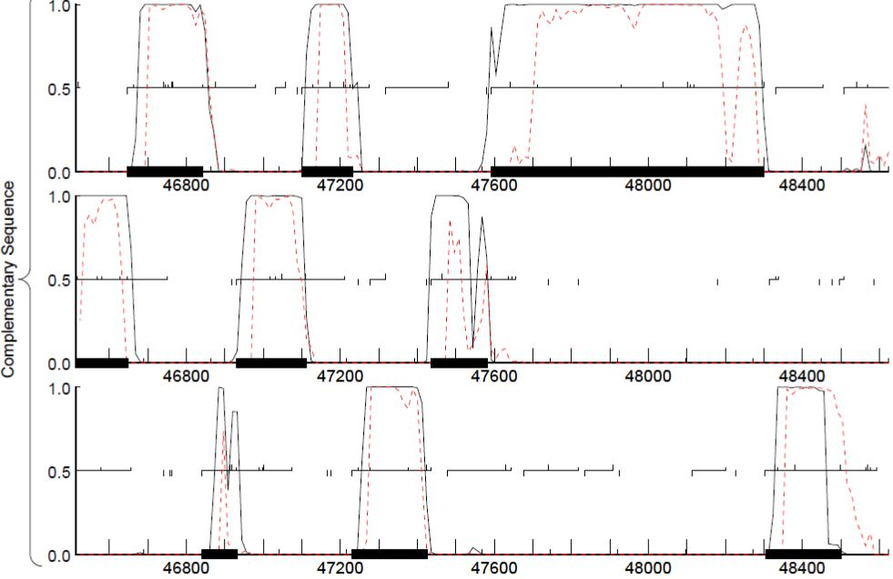

**Figure 170: Feature 78, GeneMark Map**

The middle frame of the complementary strand (broken over two screens) shows coding potential being very high around start 46649.

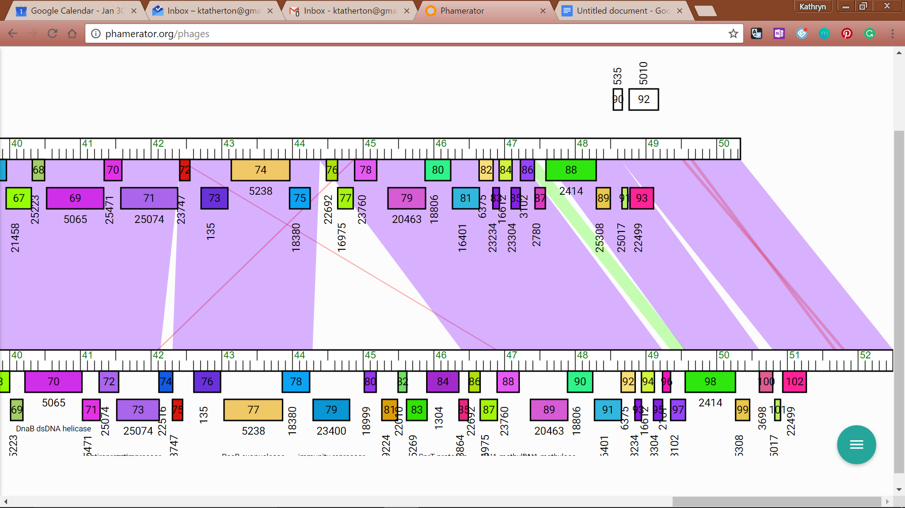

**Figure 171: Feature 78, JewelBug vs. McFly Phamerator Map**

Feature 78, Phamerator: The above image shows McFly on the bottom and JewelBug on top since the top BLAST result was a 100% match with McFly.

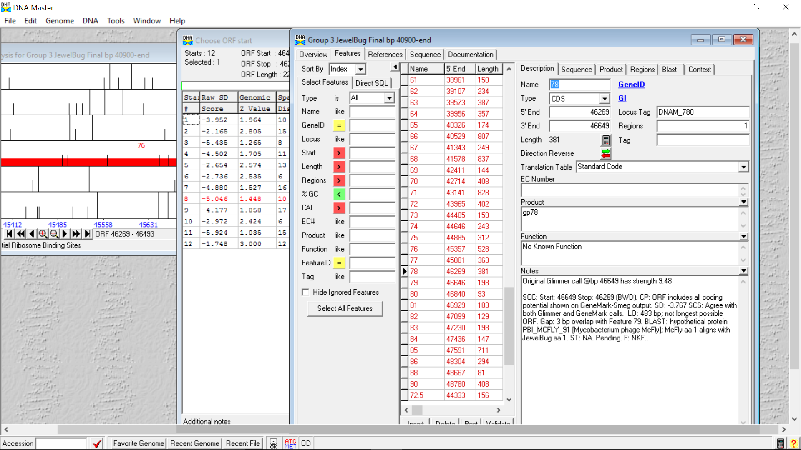

**Figure 172: Feature 78, Feature Window**

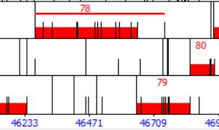

**Figure 173: Feature 78, Frame Window**

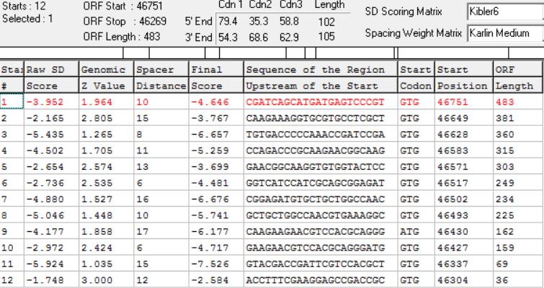

**Figure 174: Feature 78, Choose Start Window**

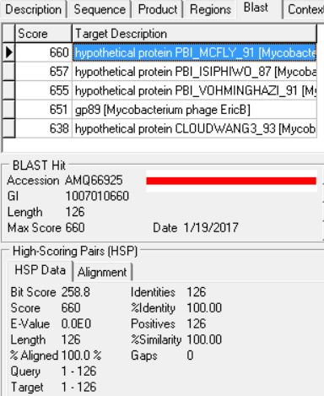

**Figure 175: Feature 78, HSP Data**

The top result shows 100% alignment, identity, and similarity to a hypothetical protein also found in McFly.

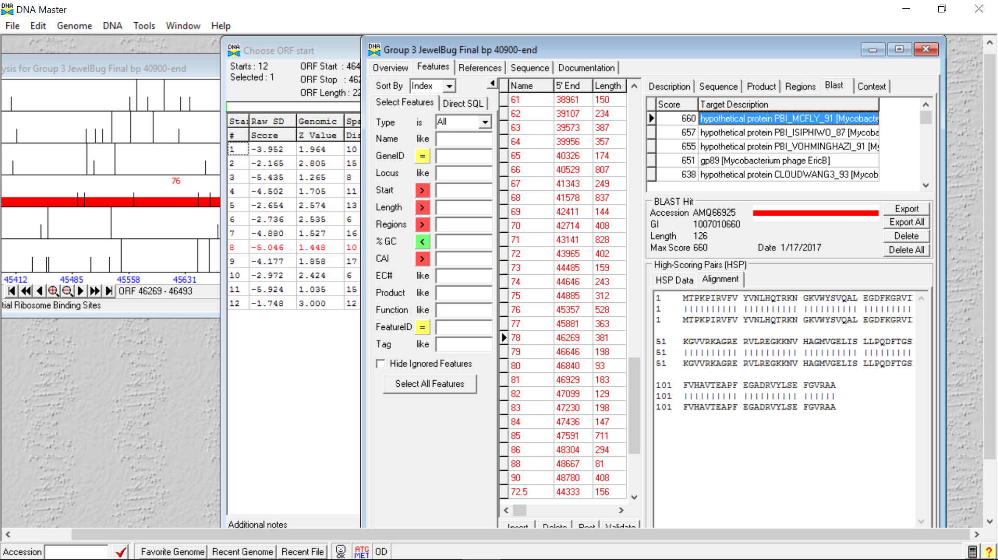

**Figure 176: Feature 78, Alignment**

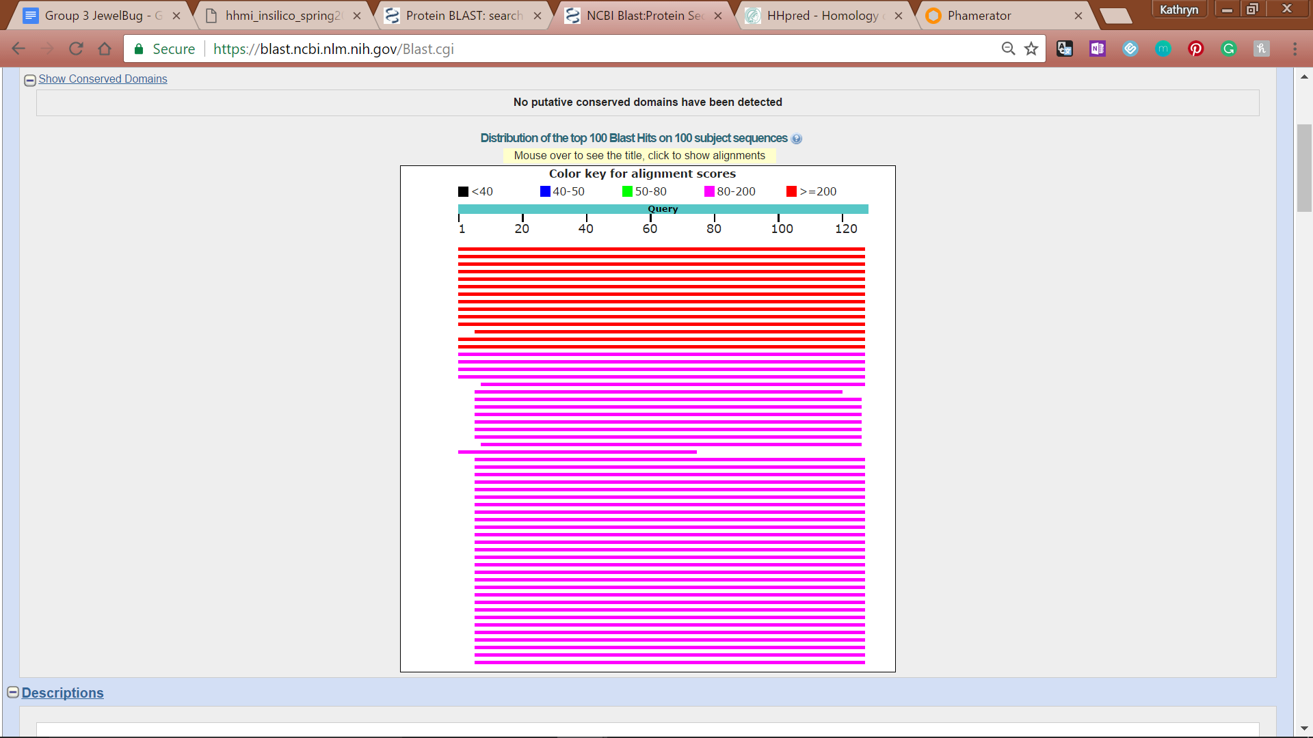

**Figure 177: Feature 78, Conserved Domain**



**Figure 178: Feature 78, BLASTp Hits Distribution Table**

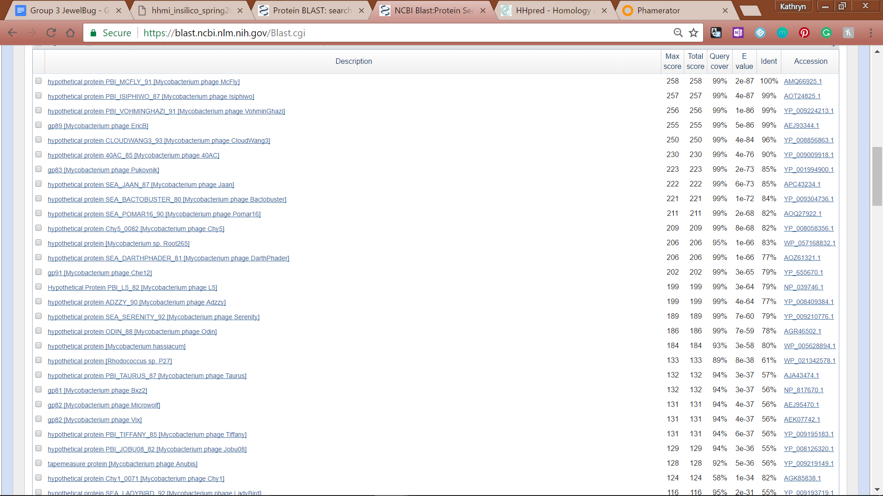

**Figure 179: Feature 78, BLASTp E-Values**

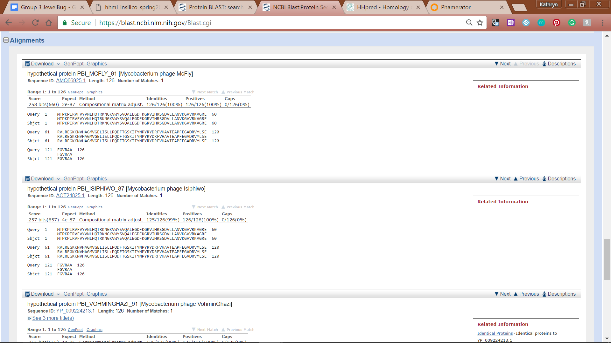

**Figure 180: Feature 78, BLASTp Alignments**

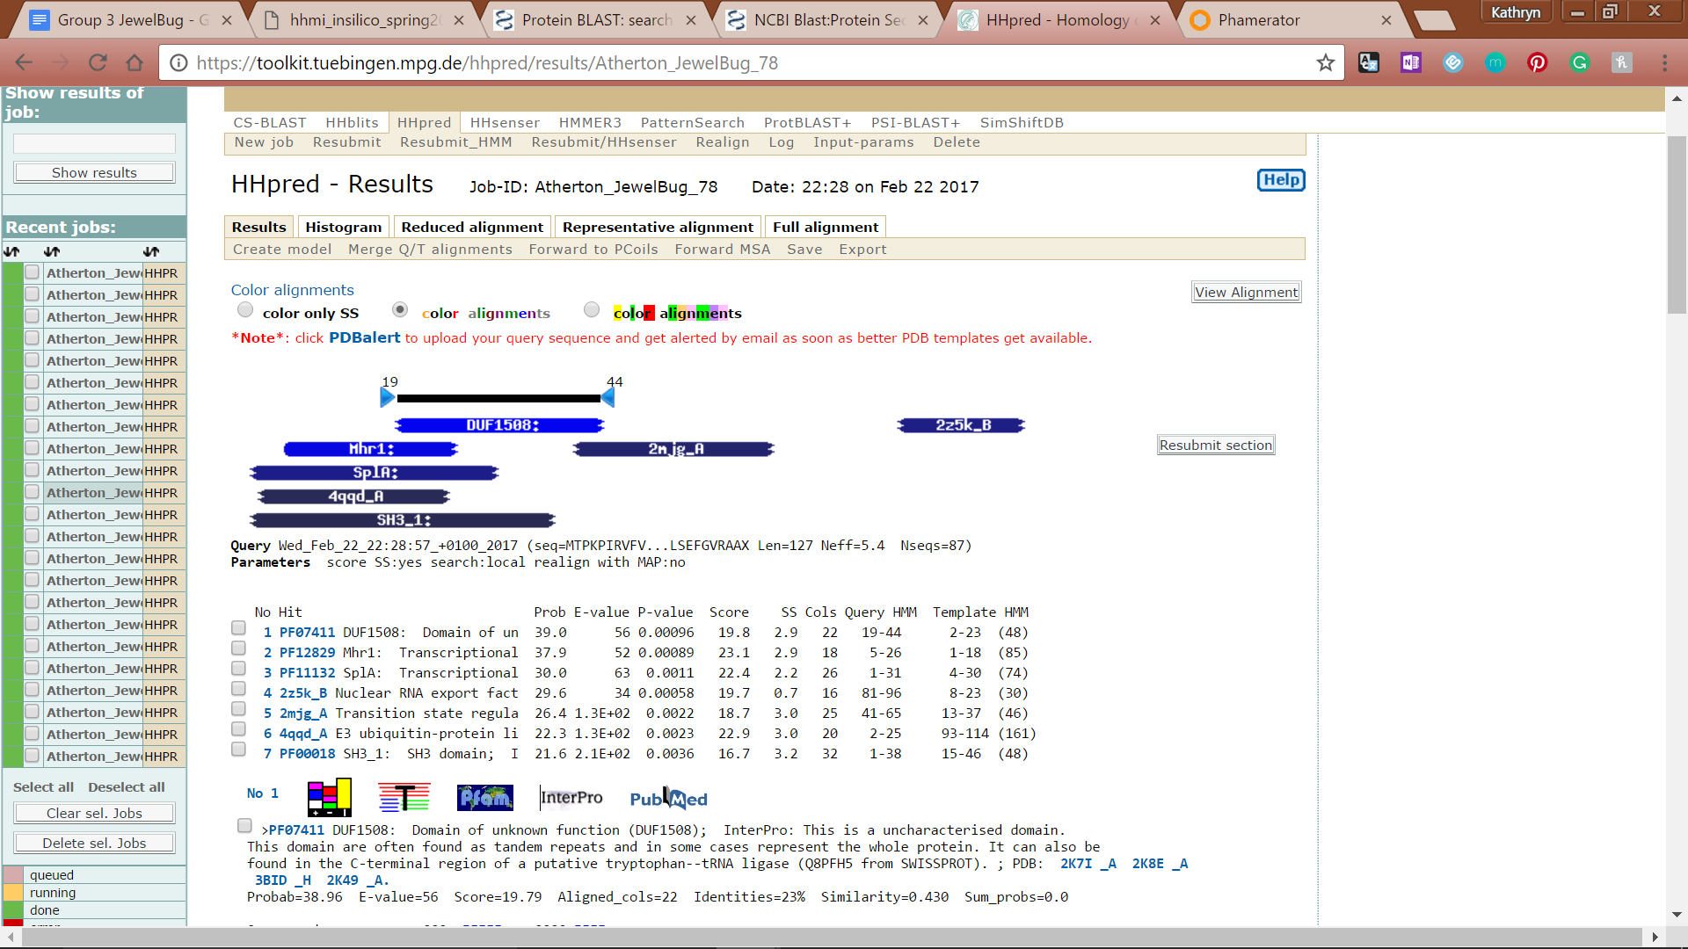

**Figure 181: Feature 78, HHPred Distribution List**



**Figure 182: Feature 78, HHPred Probabilities and Descriptions**